Engels on the Worker's Condition Under Free Competition
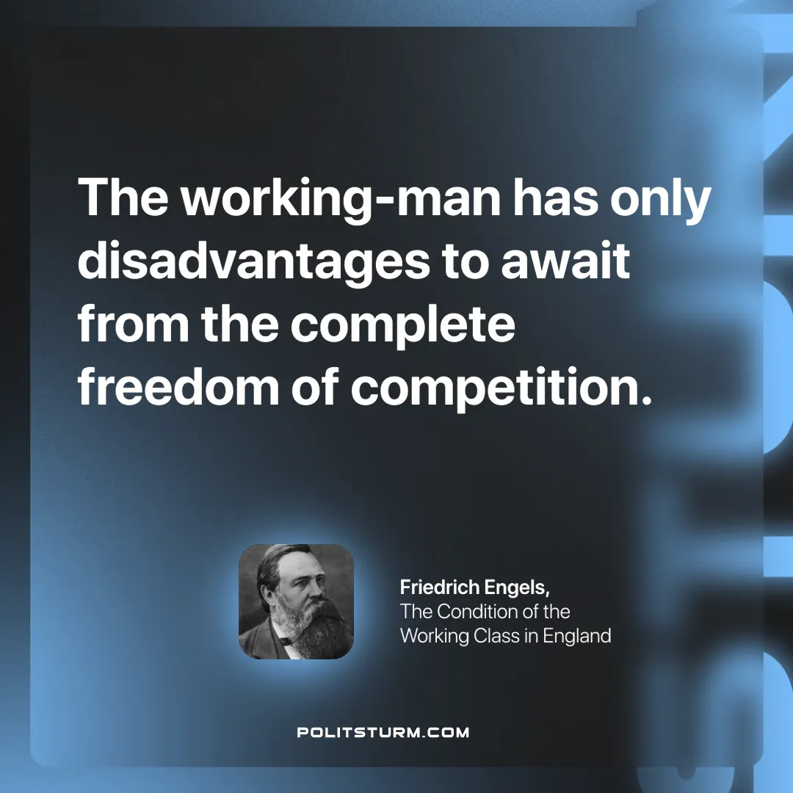

Original article
2024-12-05

“The working-man has only disadvantages to await from the complete freedom of competition.”
Friedrich Engels, The Condition of the Working Class in England

Original article

