Engels on the Combined Interest of the Workers
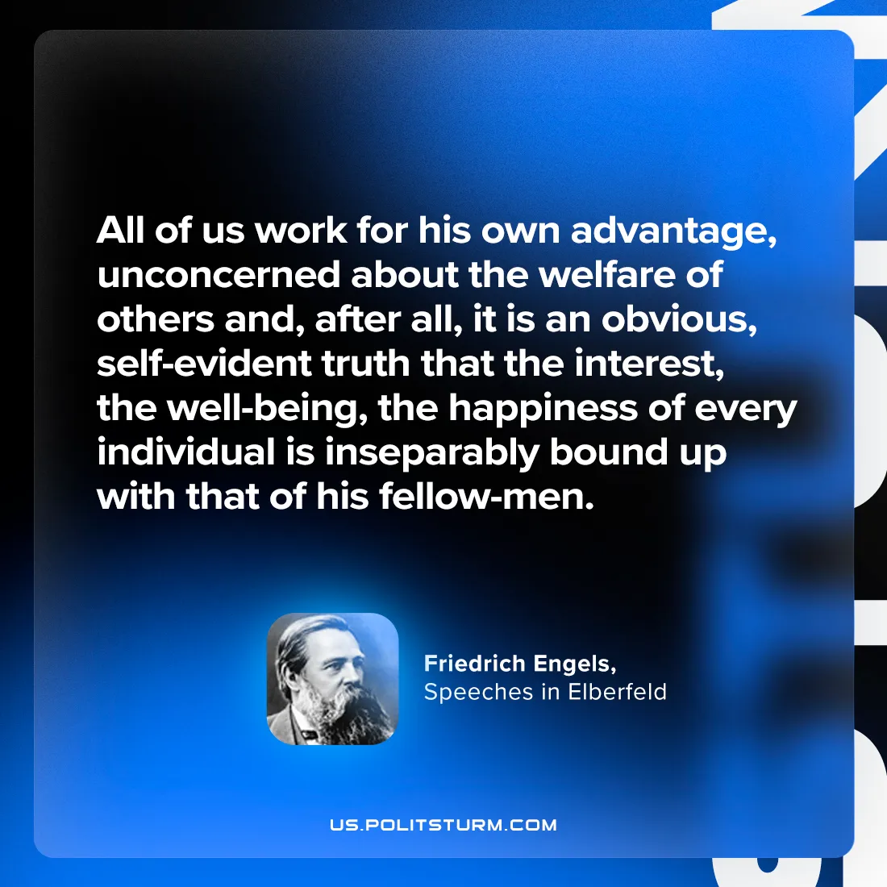

Original article
2024-09-15

“All of us work for his own advantage, unconcerned about the welfare of others and, after all, it is an obvious, self-evident truth that the interest, the well-being, the happiness of every individual is inseparably bound up with that of his fellow-men.”
Friedrich Engels, Speeches in Elberfeld

Original article

