Enforcing Dependency: A View on Civil Unrest and Intervention in Haiti
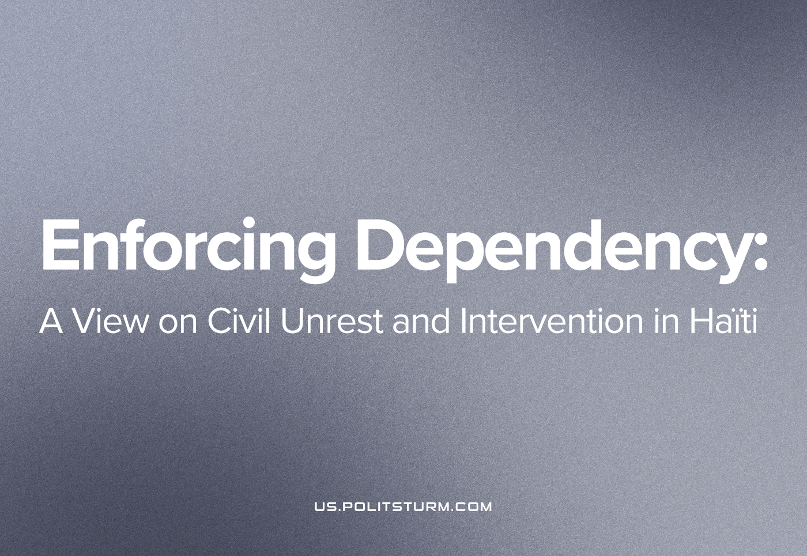

Original article
2022-10-20
7 min read

Over the last decade, the World Economic Forum (WEF), the International Monetary Fund (IMF) and the World Bank have all coerced poor countries to stop subsidising fossil fuels, in a futile attempt to reduce emissions – a measure that demonstrates the utter folly of capitalist environmentalism. Last month, the Haïtian government ended fuel subsidies leading to large scale protests, riots, looting and an escalation of gang violence. Now, an international foreign intervention is being called to enforce the terms of an imperialist peace – truly, to enforce a situation of imperial chaos.
Last year, the previous president, Jovenel Moïse, was assassinated after a devastating earthquake. Armed gangs have blockaded ports, roads, as well as food facilities and have organised kidnapping rackets. Hundreds have been killed and thousands have been displaced. The most powerful Haïtian gang, “G9 family” seized a major fuel storage facility in a total undermining of official state power in Haiti [1]. The leader of this opposition force, Jimmy Chérizier, has demanded the resignation of the current president, Ariel Henry, and government positions for members of his gang, additionally proposing a political solution to the current crisis that engulfs the country. The “G9 family” gang and its allies are at war with the “G-people” gang and its allies in government, leading to a de-facto state of armed civil war in many cities. Throughout the country, protests are joining calls for the end of the Henry government.
Inflation in Haiti is at its highest level in a decade, in line with the global downturn, but with 40% of the country dependent on food aid for their survival. Deliveries of what little food is grown domestically are held up in highway robbery and shot at. Many of those who undertake the dangerous journey to flee the country to the US are turned away at the border by horsemen armed with whips and shotguns, deporting tens of thousands of arrivals at record speeds. With no opportunities, and starvation as the alternative, the capitalist architects of this misery have engineered the consent of many to the rule of the gangs in exchange for a small livelihood and basic safety.
Even before the end of fuel subsidies, the situation of Haïtian workers was deteriorating rapidly. Over the past year Haïti’s garment and textiles industry (one of the country’s main industries) saw thousands of layoffs, as predominantly American cartels cut production due to the world capitalist recession. Haïtian workers went on strike in February and despite facing lethal state repression [2], they won an increase of the minimum wage to (equivalent in USD) $6.63 a day. These modest gains are submerged under an inflation rate which is still growing past 30% [3]. Haïtian workers have recently gone on strike again [4] for higher wages, lower fuel prices and to depose the current president.
Ruling President Henry, a stooge of American imperial interests, has suspended elections indefinitely. He came to power when the previous president, Jovenel Moïse, was assassinated by men paid by the US [9], acting on behalf of the American capitalists’ interest. Moïse had links to the “G9 family” gang [10] which is the predominant one wreaking havoc in the streets of Haïti in opposition to the covert coup d’etat of their man.
Last week, President Henry called for foreign assistance after several protestors were shot by government forces [5], sparking further outrage and demonstrations against the prospect of foreign occupation. It seems like this call is being answered [6] by the Canadian state, and the US state will likely soon join in as well, per. their proposal which seeks a ‘non-UN’ international force for the invasion.
To examine the reasons for the Haïtian people resistance against this particular foreign “assistance”, as well as how foreign capitalists are able to subjugate the country, it is necessary to examine the country’s history.
Haïti’s condition today emerges from its former life as a slave plantation colony of France, which, under the name Saint-Domingue, and would end up taking two thirds of its total colonial profits from the island. “Cash crops” grown and harvested by Haïtian slaves provided a greater source of income for France than all thirteen of the original American colonies would for Britain. It was the greatest individual market for the European slave trade and elevated the French bourgeoisie to incredible heights. In 1791, after two years of revolution in France, the slaves of Saint-Domingue revolted. The slaves found themselves fighting against British, Spanish, and French troops all sent to snuff out the largest slave rebellion since Spartacus in a brutal war lasting 13 years. William Pitt the Younger and Napoleon Bonaparte would lose 50,000 troops to restore the bonds of slavery, but ultimately the former slaves were victorious and established the state of Haïti in 1804 in a humiliating defeat for the colonial powers.
It was clear that Haïtians would rather die fighting than be forced to live again as slaves, so France changed its tactics. They enforced a total embargo on Haiti, as well as organising naval raids on the fledgling Haïtian state. With this new strategy, the French brought Haiti to total economic ruin. In order to lift the embargo, Haiti was forced to sign a treaty agreeing to pay a crushing debt with an essentially unpayable interest rate nominally to compensate the former slave owners for loss of property – but in reality, this treaty transformed Haiti into one of the first neo-colonies or dependant capitalist countries, ensuring de facto French control and domination of the island for many more decades. In order to provide France with what was effectively an annual tribute, Haitian peasants were forced to grow and harvest many of the same “cash crops” desired by France, the same commodities that their enslaved ancestors produced. What France failed to do directly with the cannon and sword, they succeeded with their financiers and merchant capital (also supplemented by the cannon and sword).
After the Second World War, a reformist government that threatened to put the smallest dent in the profit margins of American monopolies was elected, causing the US to instigate a coup and supported the repressive autocracy of the infamous François “Papa Doc” Duvalier and his son. The Duvalier’s would go on to murder 50,000 people and increase the national debt as well as Haïti’s position of dependence relative to the US. They would eventually be ousted by a popular uprising. During this extremely reactionary rule, the US instigated it’s Caribbean Basin Initiative, a “food aid” program for Haïti among others – in reality a program designed to cripple Haiti’s domestic food production and force the country further into dependence on the US. Rice grown by US monopolies flooded the Haïtian market, ruining the Haïtian peasantry who were unable to compete. After the end of the Duvalier’s rule, the US funded the Front for the Advancement and Progress of Haiti (FRAPH), a terrorist gang to weaken the Haïtian state. This was the first major instance where the US used gang violence as a tool of political control in Haïti.
Following in the spirit of French colonialists, the IMF then used the enormous national debt to force a further reduction in wages (which were already at starvation level), various privatisation schemes, to produce more “cash crops” and to eliminate import tariffs. This program was enforced by a UN occupying force. Following the 2010 Earthquake which killed 300,000 people, the smell of blood attracted many more imperialists who, like vultures, began to circle their wounded prey. The IMF granted Haïti another loan of $144 million supposedly to assist with recovery. In reality, around 99% of the money went to UN agencies, NGOs, and military organisations.
Haiti was cholera-free in 2010, up until when some UN occupiers dumped their infected sewage in a river [7]. Since then, 10,000 Haitians have died of this disease which has infected a total of more than 800,000. Despite the fact that this discovery was made by a UN appointed panel the UN has refused any legal responsibility or payments of compensation for the victims of this disease. The UN has pledged $400 million to eradicate this disease, however the cholera epidemic is still ongoing 12 years later, making it reasonable to assume that this fund was also squandered to line the pockets of corrupt officials and especially predatory capitalists.
In addition, when not spreading cholera, or protecting the investments of foreign oligarchs, many UN occupiers busied themselves with the mass rape of Haitian women and girls – some of them as young as 11 years old [8]. This phenomenon had become so widespread that the babies fathered by UN occupiers have been given the nickname “Petit MINUSTAH”, after the acronym for the UN mission. The majority of rapes committed were not coerced by physical violence but done in exchange for small amounts of food or money.
Haiti’s current crisis is intricately linked with its history under various imperial jackboots. It is a great tragedy that one of the first countries to liberate itself from colonial slavery is now so horribly shackled by imperialist capitalism. Gang violence, which bourgeois media seeks to portray in a racist and materially ambiguous light, is truly a form of political violence as rival gangs fight for the interests of their domestic and foreign capitalist sponsors – the inevitable result of this level of competition being stagnation and instability in Haiti, cementing Haiti’s dependence on the US. The current Henry government presents itself as powerless without foreign intervention doing little itself to halt the crimes of the gangs, yet finds itself perfectly willing and able to shoot striking workers and those who protest against his calls for foreign military occupation.
Currently the struggle for Haitian society is dominated by two main ‘blocs’:
First is the current Henry government and their “G-people” gang (which is directly funded by Réginald Boulos – one of Haïti’s richest capitalists and a close ally of the US state department [11]), which represents the interests of the comprador Haïtian bourgeoisie, and its allies and the foreign imperialists that rule the country.
The second bloc is the “G9 family” gang and its allies, including the former assassinated President, which represents the interests of the nationalist Haïtian bourgeoisie.
Caught in between are the masses of the working people – those protesting and on strike struggling for the interests of the Haïtian proletariat, including the trade unions. The vacillating petty bourgeoisie is largely split between the two blocs, shifting their allegiance and their contribution to the civil development from alliance with the ruling gangs to alliance with the resisting gangs. Presently, the movement resistant to the foreign imperialists’ intervention consists of the latter bloc, and the working people will thus gravitate towards it without a real proletarian ideology of their own. Within this broad movement, the working people’s struggle against the “G9 family” gang and its allies, who are out in the streets against the state, grows in importance due to the need to resist the dominance of petty-bourgeois ideology and bourgeois nationalism in the movement, cementing the Haïtian proletariat’s subordinate position for many more decades. As history has shown it is not enough to oust and drive away this or that imperialist occupier. It is only by strengthening the Haïtian working class itself, not the G9 bloc, that national enslavement can be put to end, not by bourgeois liberation, but by the elimination of the capitalist system under which either bloc will sell its people to one foreign monopolist or another.
Sources 1, 2, 3, 4, 5, 6, 7, 8, 9, 10, 11

Original article

