End of the UK Strikewave?
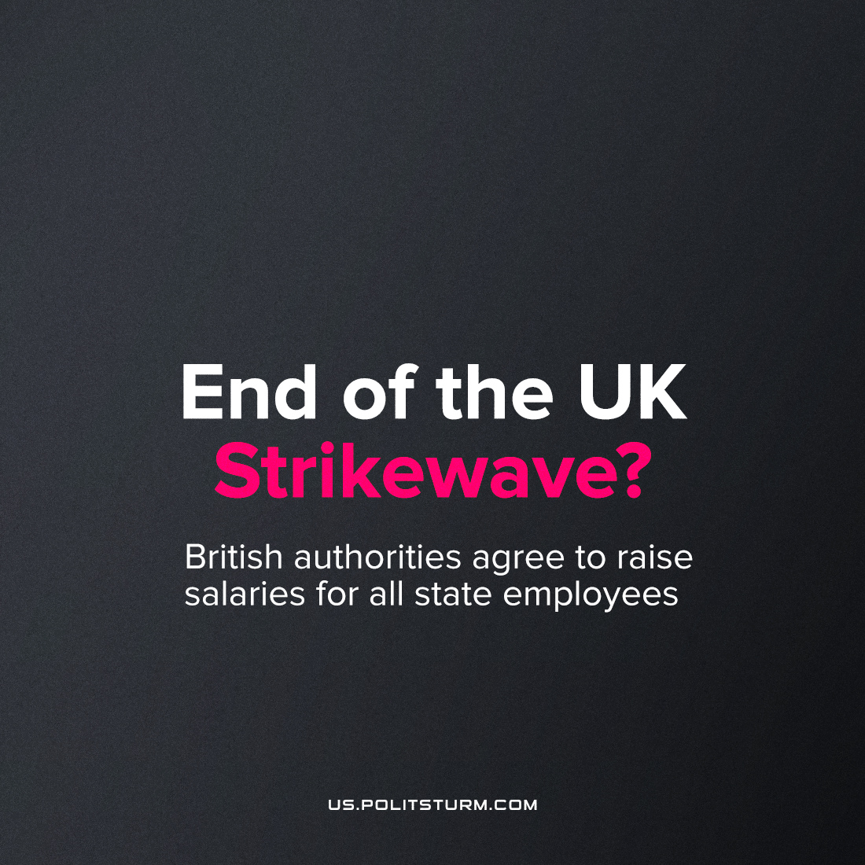

Original article
2023-07-20
2 min read

U.K. Prime Minister Sunak announced increases in the salaries of public sector workers, differing across sectors. The unions have been pushing for this since the spring of 2022, with numerous historic strikes. The proposal affect more than a million state employees.
The following wage increases have been announced:
- Police - 7%
- Prison officers - 7%
- Teachers - 6.5%
- National Health Service - 6%
- Junior doctors - 6%
- Armed Forces - 5%
Sunak added that this is the "final" offer and there will be no further wage growth regardless of the number of strikes. He also called on the unions to cancel the planned strikes and accept the increase.
The increase in salaries will be financed by additional fees: work and tourist visas will rise in price by 15-20%, and the advance payment of migrants for access to the healthcare system will rise to £5,175 over 5 years.
Four education unions said the deal would allow them to end the dispute and recommended their members accept the deal.
But the British Medical Association took this decision as an insult. Moreover, trade union representatives consider indexing by 35% to be fair. In this figure, they estimated the real deterioration of their financial situation and announced further strike dates on August 24 and 25. Whether the rest of the British workers will join the strikes is still unknown.
We remind you that the main requirement is to index wages to the level of inflation, which in 2022 amounted to 10.5% in the UK making the current offer from the government being, therefore, still a pay-cut in real terms.
The figures also demonstrate where the ruling-class’ priorities lie; policemen and prison wardens respectively shall receive 7% (the highest increase) whilst teachers, junior doctors and other health professionals shall only receive 6/6.5% This may not be a substantial difference, but considering the importance of teachers and doctors in comparison to prison wardens, such an offer is clearly a slap in the face to overworked and underfunded educators and medical professionals; it also reveals the importance of the police as state enforcers of capitalism: the ruling-class needs to give the police more money as they are the force that defends the status quo.
The government “wisely” decided to split the trade union movement and pit various groups of workers against each other in order to cause the strike movement in the country to fail.
By shifting costs to immigrants, the government is trying to create an artificial confrontation between local workers and immigrants, inciting national and ethnic tensions. This division helps the government to divert attention from the main cause of the protests, which is the exploitation of workers and decreasing wages, and the most important thing is to transfer all the costs of raising the salaries of state employees from the bourgeoisie class to the proletariat, in this case to immigrants.
The division of workers on a national basis serves the interests of the bourgeoisie, as it helps to maintain the status quo and prevent the unification of the working class in the struggle for their rights and interests.
Such attempts to divide on the basis of nationality must be overcome through class solidarity and organization. The working class must realize that workers of different nationalities have nothing to quarrel with, because what is truly indigenous is that the immigrant workers are equally exploited by the bourgeois class.
In order to resist such tactics of the ruling class, a workers' party is needed, which, guided by Marxist-Leninist theory and the interests of the workers, will dispel such “difficult” decisions of government and show the true face of the ruling class.
Source: 1

Original article

