Employment Rises as Living Conditions Drop
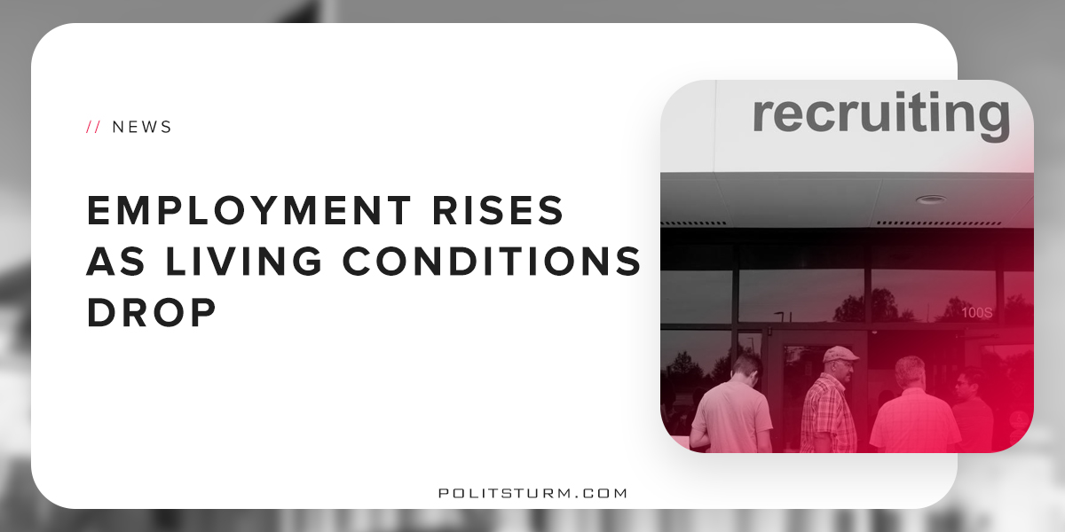

Original article
2018-06-07
2 min read

Both the Trump administration and the media have joined in boasting and celebrating the nations 3.8% unemployment rate. According to Reuters, this is an 18 year low; and ABC News noted with glee that we’re only a stone’s throw away from the employment rate during height of the American automotive industry, 1969. However, these sparkling reports fail to take into consideration the actual costs of living which workers today are subjected to.
No matter what the numbers say, life for the working class is not what it was. In the healthy post-WWII economy ABC harkens back to, someone with a fulltime job could support themselves and their family. Today, 43% of American families can’t afford a basic necessities such as food, housing, transportation, healthcare, and child care. 44% said they couldn’t afford a $400 emergency expense without having to sell things or go into debt. Literally half of all Americans are in or near poverty. And unlike the optimistic generations of the fifties and sixties who could afford to buy their homes outright and live unencumbered by debt, homeownership among millennials is at an all time low and 82% of millennials are in debt.
This is due largely to wage stagnation. The federal minimum wage ($7.25/hr) is simply unlivable by with today’s rate of inflation. According to Aaron Pacitti, an economists professor at Siena College, if the minimum wage grew with the cost living since 1969, it would be roughly $16/hr. That’s more than twice what it actually is. That’s why, according the Bureau of Labor Statistics, the same people bragging about how low unemployment is, there are over 7 million Americans working two or more jobs. Worse than that, the rise of employment is all thanks to the rise of “alternative work.” These “alternative” jobs include part time employment, freelancing, and “gigs” such as driving for Uber or renting out your home for Airbnb. These jobs are rarely secure and come with few to no benefits. Since 2005, 94% of all jobs created have been “alternative.”
Moreover, unemployment has lowered largely because people are leaving the workforce. The BLS does not take into account things like retirement, death, or disability claims. So less jobs are being created than it seems.
What this rise in employment shows us is that it doesn’t get better from here. Though the economy has technically recovered from 2008 crash, it has only done so due to the same reckless deregulation which caused the crash and more viscous exploitation of the working class. The capitalist class is the exclusive benefactor. Workers are worse off than ever. The rise of employment is ultimately meaningless for us as we are so detached from the fruits of our labor. All the fanfare in the news should be viewed with derision. The stock market may be healthy the people are starving. Until the working people claim the full value of their labor, we can expect further degradation that only worsens with every inevitable recession.

Sources
1, 2, 3, 4, 5, 6, 7, 8, 9, 10

Original article

