Elon Musk Joins “Department of War”
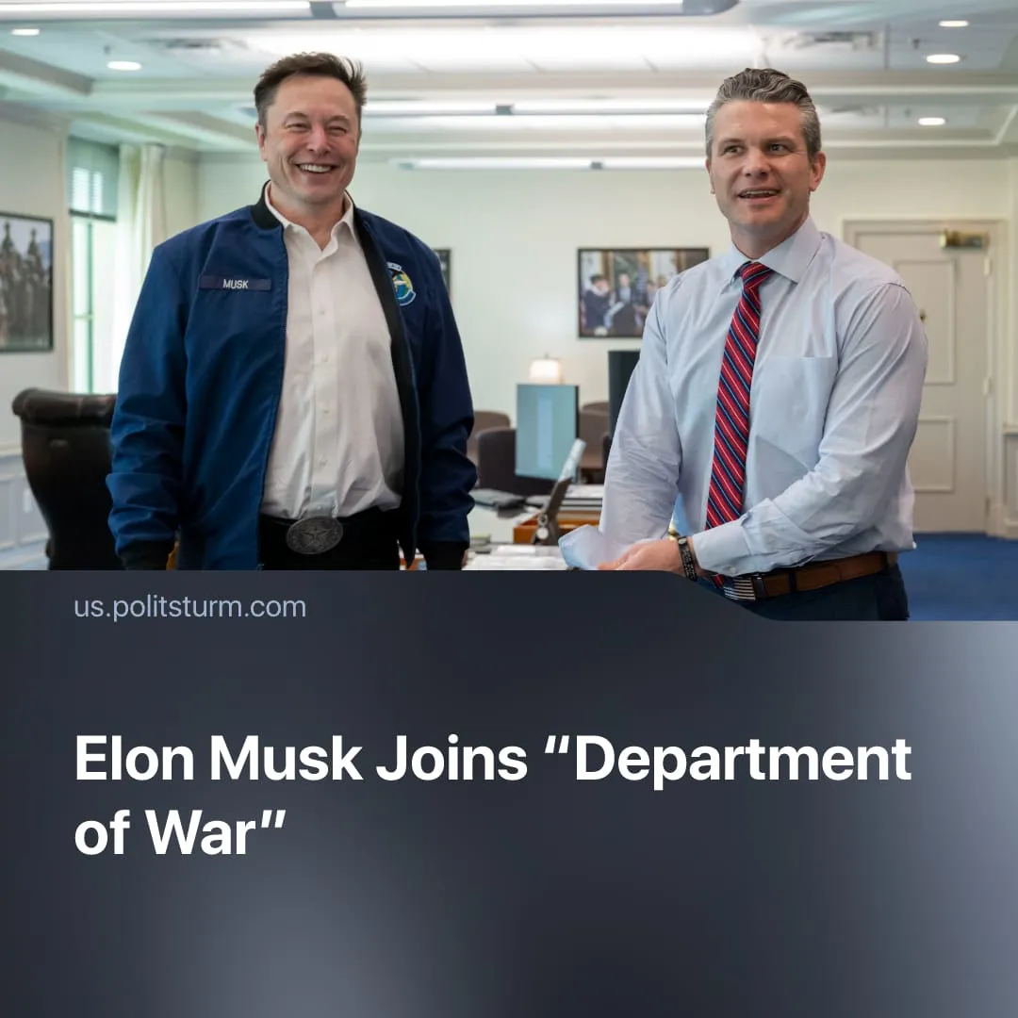

Original article
2026-10-14
1 min read

Elon Musk joins a Pentagon project on future warfare, showing the growing integration of monopoly capital into US military planning.
Details. On September 30, US “Secretary of War” Pete Hegseth announced Project Meridian, a 120-day project to study future warfare. It will be co-led by SpaceX CEO Elon Musk, Anduril founder Palmer Luckey, and former Republican House Speaker Newt Gingrich.
► The project will study emerging military technologies, including artificial intelligence, autonomous systems, robotics and biotechnology, as well as operations in environments such as underground areas and the Moon. It is expected to propose “actionable solutions” for developing, testing and deploying these technologies, with Hegseth saying such research is necessary “to maintain global dominance”.
Context. Project Meridian shows the close integration of monopoly capital and the capitalist state, particularly in directing military affairs. Musk previously led DOGE, while other technology executives were commissioned into the US Army.
► In 2024, SpaceX held $22 billion in US government contracts, with additional contracts secured in 2026. In March 2026, Anduril was awarded a 10-year US Army contract worth up to $20 billion. The CEOs of both companies will now shape future military priorities that drive procurement decisions.

Original article

