Economy Stagnant Under Trump
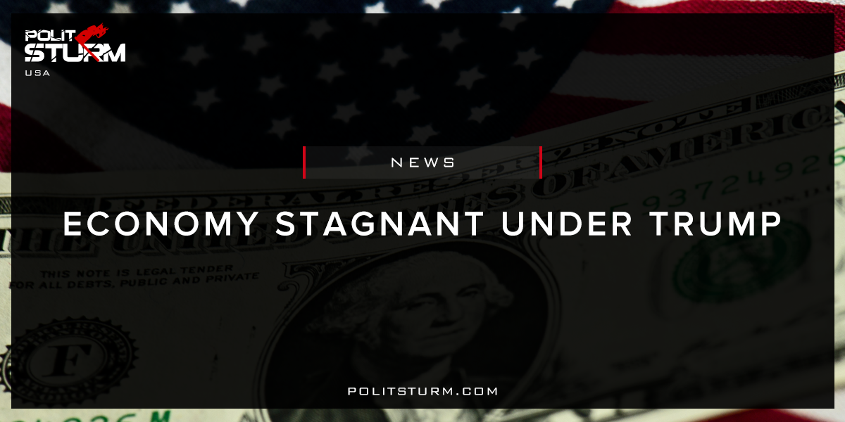

Original article
2017-11-18
1 min read

The U.S. economy isn’t on course for a bump from President Trump’s policies over the next couple of years, a new economic analysis showed on Thursday.
Growth is expected to remain modest through 2019 even with stronger consumer and business sentiment, a roaring stock market and tax reform teed up by Republicans in Congress.
“We don’t see very much of a Trump effect for the U.S. economy over the next two years,” said Gabriel Ehrlich, director of the Research Seminar in Quantitative Economics at the University of Michigan.
The report reflects expectations that Congress and the Trump administration will eventually pass a tax-reform package that includes corporate tax cuts.
Politsturm: Despite the narrative portrayed by the mainstream media, there is no evidence suggesting that the economy has drastically improved under Trump. This type of idealist analysis of the economic conditions is fundamentally flawed. Capitalism is a system of production for profit in which one man cannot change the fundamental course of its development. There has not been and there will not be any return to economic “prosperity” in the United States. What is the reason for this?
The reason is that there are different class relations at play. Only the bourgeois class will benefit from the Trump presidency. They will benefit from the rising stock prices which are skyrocketing on the expectation of lower corporate tax rates. They will benefit from the repeal of the estate tax which allows the elites to pass their massive accumulated wealth to their heirs. The working class, however, will always suffer under the capitalist mode of production. Capitalism delivers to the workers a precarious work environment, a lack of public health care and social services, and declining prospects for a better future. It would be foolish to think that one man can change the entire structure of the capitalist economy. To think otherwise is solely to the benefit the bourgeois exploiters.
Source

Original article

