Economy Projected to Contract by 3% in 2020
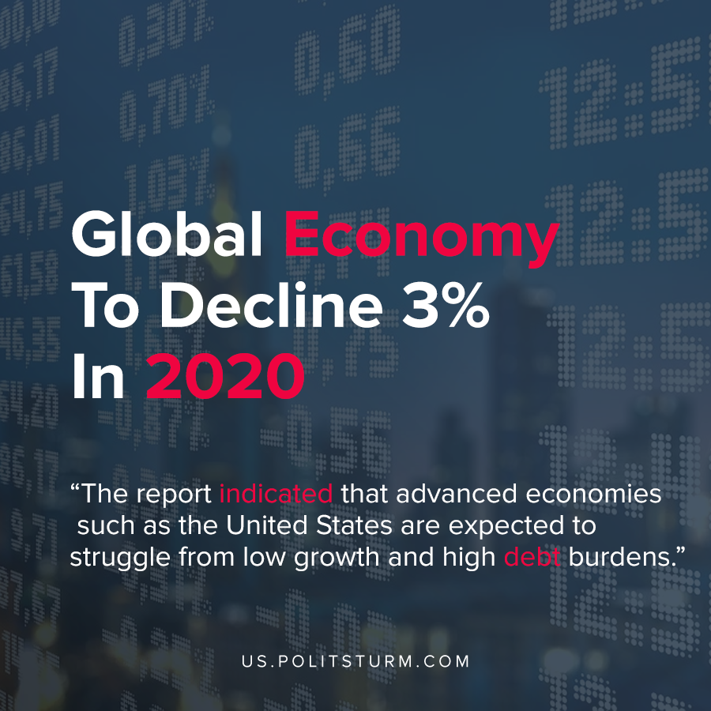

Original article
2020-06-12
1 min read

According to a recent release by the International Monetary Fund (IMF) the economy is expected to have a sharp contraction of 3% in 2020. The report indicated that advanced economies such as the United States are expected to struggle from low growth and high debt burdens.
In the midst of high debt and low growth, the inevitable policy prescription of austerity policies and reactionary movements from bourgeois politicians in response appears as a practical inevitability.
The Marxist analysis presents us with the ability to foresee the tendency of such reactionary movements to appear. Rather than mere stochasticity, such reactionary response is born out of late-stage capitalism where the world is divided among monopolies and the only means of extracting capital now would be to increase the levels of exploitation both at home and abroad.
In order to achieve the desired outcome at home, austerity measures will be implemented while initially being filled with promises of nationalism and short term relief.
In order to remove such a tendency in capitalism, capitalism itself needs to be destroyed. The socialist mode of production in its essence removes wage labor and removes the private accumulation of capital, and instead resolves the contradiction that capitalism had initially posed, where there would be socialized production while private accumulation.
Today, capitalism acts as a ticking time bomb that poses an open threat to humanity. As we face the next crisis of overproduction a looming threat of war once more stands before humanity.
Source: 1

Original article

