Economic Crisis Hits Low Income Workers Hardest
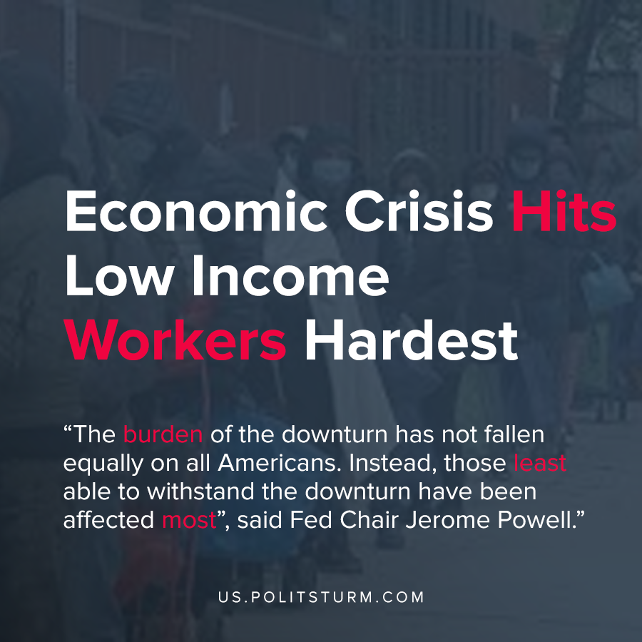

Original article
2020-06-17
1 min read

In testimony to the United States Congress, Chairman of the Federal Reserve Jerome Powell indicated that the U.S economy is in a dire state. Powell expressed concern that the economy has lost 20 million jobs since February, and the unemployment rate has increased to over 13%.
The negative consequences of the economic crisis have not, however, fallen equally upon all Americans. The sharp decline in economic activity has disproportionately hurt low-income Americans.
“The decline in real gross domestic product (GDP) this quarter is likely to be the most severe on record. The burden of the downturn has not fallen equally on all Americans. Instead, those least able to withstand the downturn have been affected most.”, said Powell.
In addition to the current state of the economy, Powell also referenced future implications that the U.S economy will suffer in the long-term as businesses are closed permanently.
Even the Chairman of the Federal Reserve Bank acknowledges that the burden of capitalist crisis falls upon the most vulnerable of the working class. The capitalist economic system is based on the exploitation of the workers, which provides profit to the capitalists who own the means of production.
As such, the interests of the workers and the capitalists are diametrically opposed, yet the capitalists control the state apparatus and ruthlessly protect their class interests. Socialism, by contrast, would not be subject to periodic crises of overproduction and would serve the interests of the class of workers.
Source: 1

Original article

