Putin’s Easter Truce and False Capitalist Peace
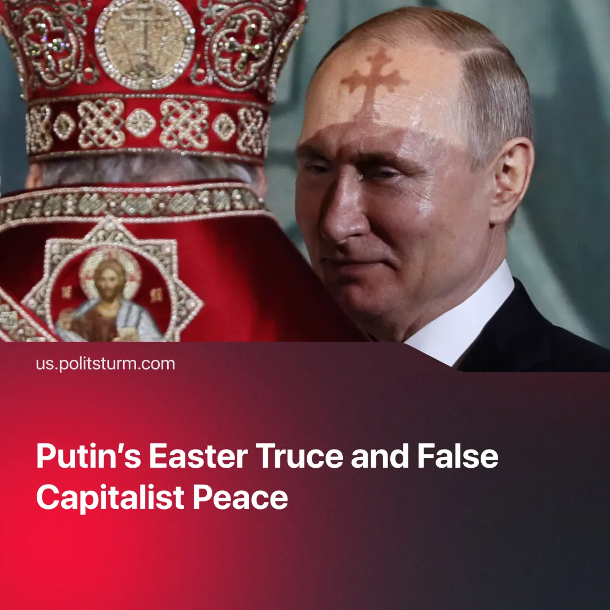

Original article
2025-04-23
2 min read

Russia's attempted "Easter Truce" failed to bring about a ceasefire.
Details. On Saturday Vladimir Putin unilaterally declared an "Easter Truce" as a supposed humanitarian gesture for the Orthodox Easter holiday.
► The ceasefire lasted for 30 hours, from 18:00 on Saturday. Putin declared that "for this period, I order to stop all fighting. We assume that the Ukrainian side will follow our example. At the same time, our troops should be prepared to reflect possible violations of the truce and provocations by the enemy, any aggressive actions."
► Reports indicated that both Russian and Ukrainian artillery fire and drone activity continued during the ceasefire.
► Alongside the ceasefire, a major prisoner exchange took place on Saturday. Ukraine exchanged 246 Russian soldiers for 277 of its own. In addition, the Russian Ministry of Defence announced that it had handed over 31 injured POWs and received 15 of its own wounded soldiers.
Context. The Trump administration previously tried to broker a 30-day ceasefire between the two nations. While Ukraine said it agreed to the deal, Russia rejected it, stating that it needed assurances that Ukraine wouldn't use a ceasefire to resupply itself.
► They then reiterated that any lasting peace should "eliminate the root causes of this crisis". These conditions include Ukraine dropping its NATO ambitions and handing over the four provinces claimed by Moscow (Donetsk, Luhansk, Kherson and Zaporizhzhya oblasts).
► The US has been trying to broker a peace deal between the two countries for its own benefit, but has made little progress recently. Sources say that the US may be willing to recognise Crimea as part of Russia as part of a peace deal, but both President Donald Trump and Senator Marco Rubio have stated that they would "walk away from efforts to broker a Russia-Ukraine peace deal unless there are clear signs of progress". The US has also been in talks with various European leaders about a possible peace framework.
Important to know. As the US grows increasingly frustrated with the lack of progress towards a peace deal, the Russian capitalists are trying to signal a willingness to continue negotiating and manage international perceptions.
► The US pressure is not driven by humanitarian concerns. The US has been trying to secure access to Ukraine and Russia's rare minerals — a need that has only increased since China restricted its own exports of said minerals.
► A peace deal that puts both countries on more favourable terms for the US would also help it to contain China's growing influence. But any peace deal would only be a temporary respite for forces to regroup and prepare for a larger confrontation between the major imperialist blocs.
Conclusion. The Easter truce only shows how difficult it is to achieve a real and lasting peace under capitalism, because any agreement means that one side wins and another loses, and so the parties involved will attempt to maintain the conflict until the balance shifts in their favour, with little mind paid to how many workers must be sacrificed.

Original article

