East Asian Powers Consider Cooperation Amid U.S. Uncertainty
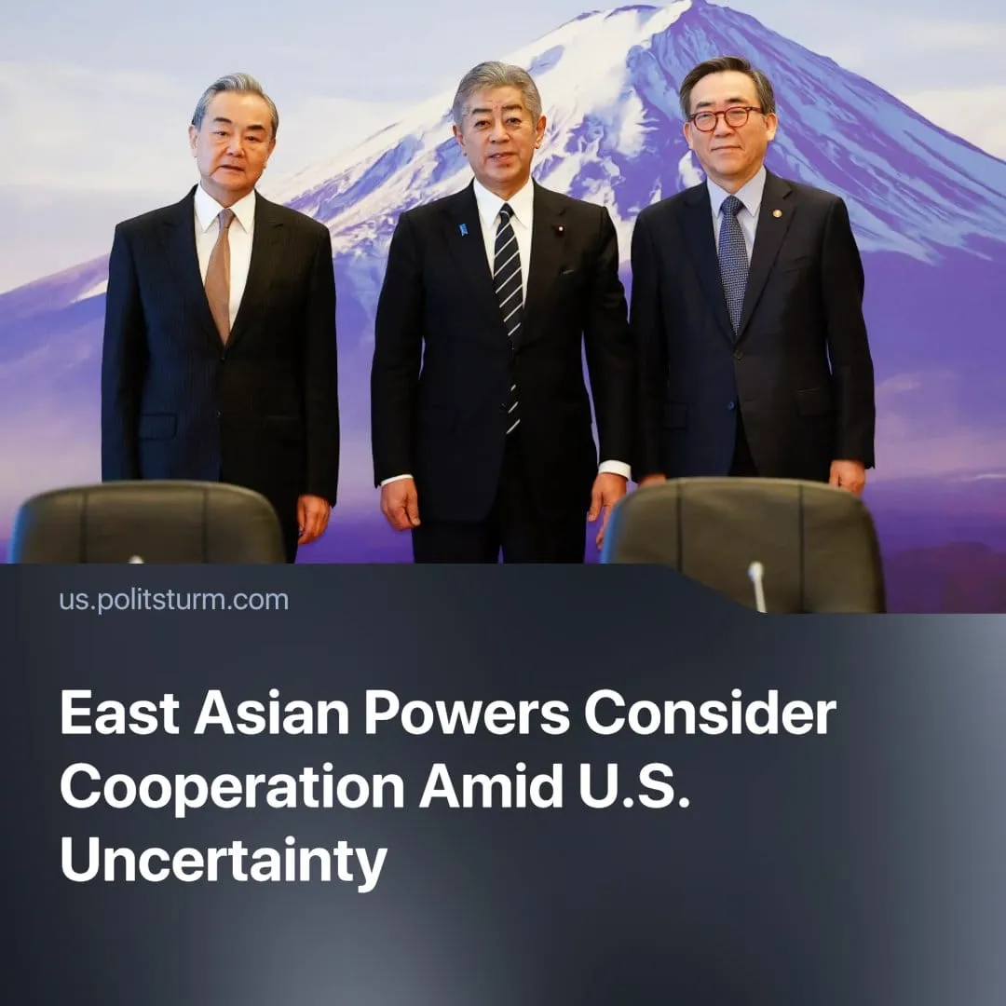

Original article
2025-03-30
2 min read

For the first time since 2023, Japan, China, and South Korea have gathered to negotiate terms of trade and investments. Public discussions addressed not only economic cooperation but also long-standing historical rivalries and questions of regional leadership.
Details. Foreign Ministers came to Tokyo to address potential partnerships and make it known to potential economic hostiles.
► The meeting included a discussion of a ban on Japanese seafood imports imposed by China after the release of wastewater from the destroyed Fukushima nuclear plant in 2023.
► South Korea was concerned with Russia and North Korea’s military cooperation and requested China's assistance in persuading Pyongyang to abandon its nuclear weaponry.
► China’s foreign minister stated, “Our three nations have a combined population of nearly 1.6 billion and an economic output exceeding $24 trillion. With our vast markets and great potential, we can exert significant influence.”
► China called for the resumption of free trade talks between the three countries and increased “cooperation.”
Context. Behind the diplomatic language of trade and cooperation, the summit reveals sharpening contradictions between regional imperialist powers, each vying to pause conflict temporarily, regroup, and realign in the face of intensifying rivalries.
► China and Japan remain in a standoff over disputed East China Sea islands, with Chinese patrols breaching Japanese waters — actions Beijing calls routine. In response, Japan and South Korea strengthened ties, backed by U.S. efforts to assert regional dominance.
► South Korea faces Chinese maritime claims in the Yellow Sea and ongoing nuclear threats from North Korea, yet remains economically tied to major partners like China, the U.S., Qatar, Brazil, and Kazakhstan. Recent diplomatic efforts with Saudi Arabia indicate Seoul’s search for new strategic alliances.
► In 2024, the U.S. and Japan signed new defense agreements aimed at countering China. Around the same time, the U.S. and South Korea negotiated a cost-sharing deal for the 28,500 U.S. troops stationed there, easing tensions after earlier demands for a 400% increase under the first Trump administration.
Important to know. China’s ambitions in the region are longstanding, rooted in its bid to secure regional dominance and expand capital influence. What makes this summit notable is not China’s influence, but why its rivals — historically U.S. allies — are now willing to negotiate.
► Japan and South Korea, historically dependent on American security guarantees, are increasingly aware of how Washington leverages this dependence. The renewed Trump administration’s approach to Europe — demanding more in exchange for protection — signals what may soon be expected in Asia. Fearing similar treatment, both states are now hedging their bets and exploring a cautious rapprochement with China.
► China will continue to pressure its neighbors through both economic and political means. Its regional assertiveness reflects a strategy to benefit from the rapidly changing world order — seeking not only new markets to exploit but also opportunities to challenge U.S. military dominance in the region.
Conclusion. As contradictions between competing national monopolies sharpen, the dominant imperialist powers — chiefly China and the United States — leverage trade, military pacts, and economic coercion to secure new footholds and bind weaker states to their orbit. Japan and South Korea, caught between these giants, seek strategic flexibility, but whatever alignment their ruling classes choose, the burden will fall on the working masses. These summits may posture as diplomacy, but they merely redraw the battle lines of a global conflict.

Original article

