Engels on the Common Interest of Humanity Under Communism
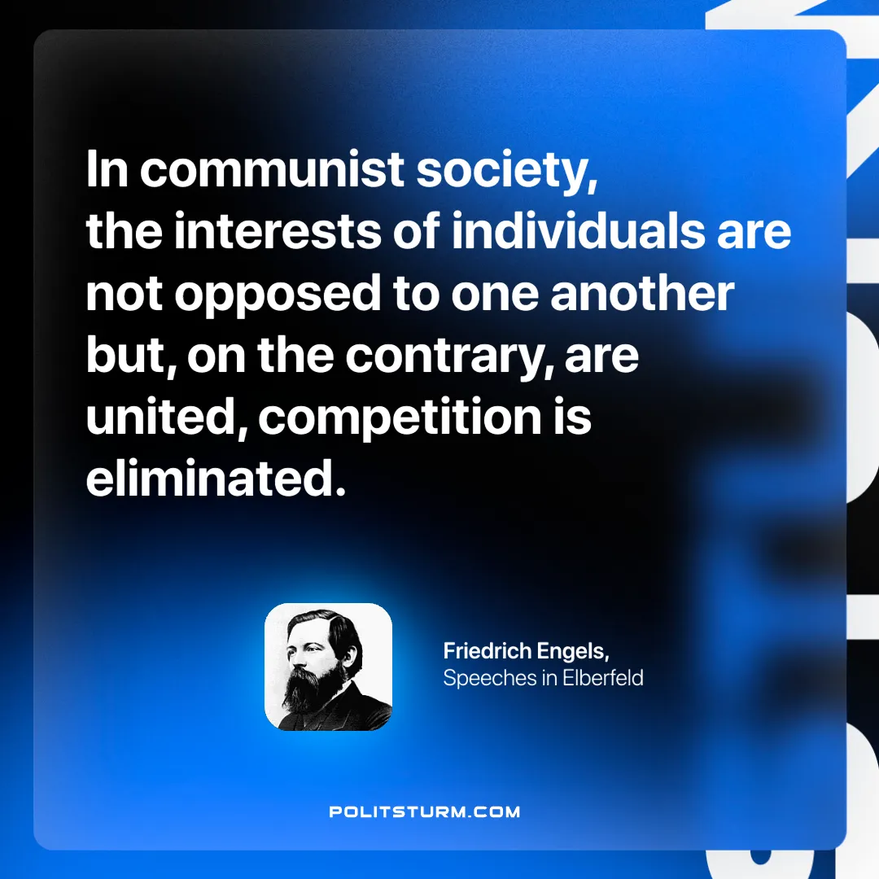

Original article
2025-01-05

“In communist society, the interests of individuals are not opposed to one another but, on the contrary, are united, competition is eliminated.”
Friedrich Engels, Speeches in Elberfeld

Original article

