Dzerzhinsky on the Struggle
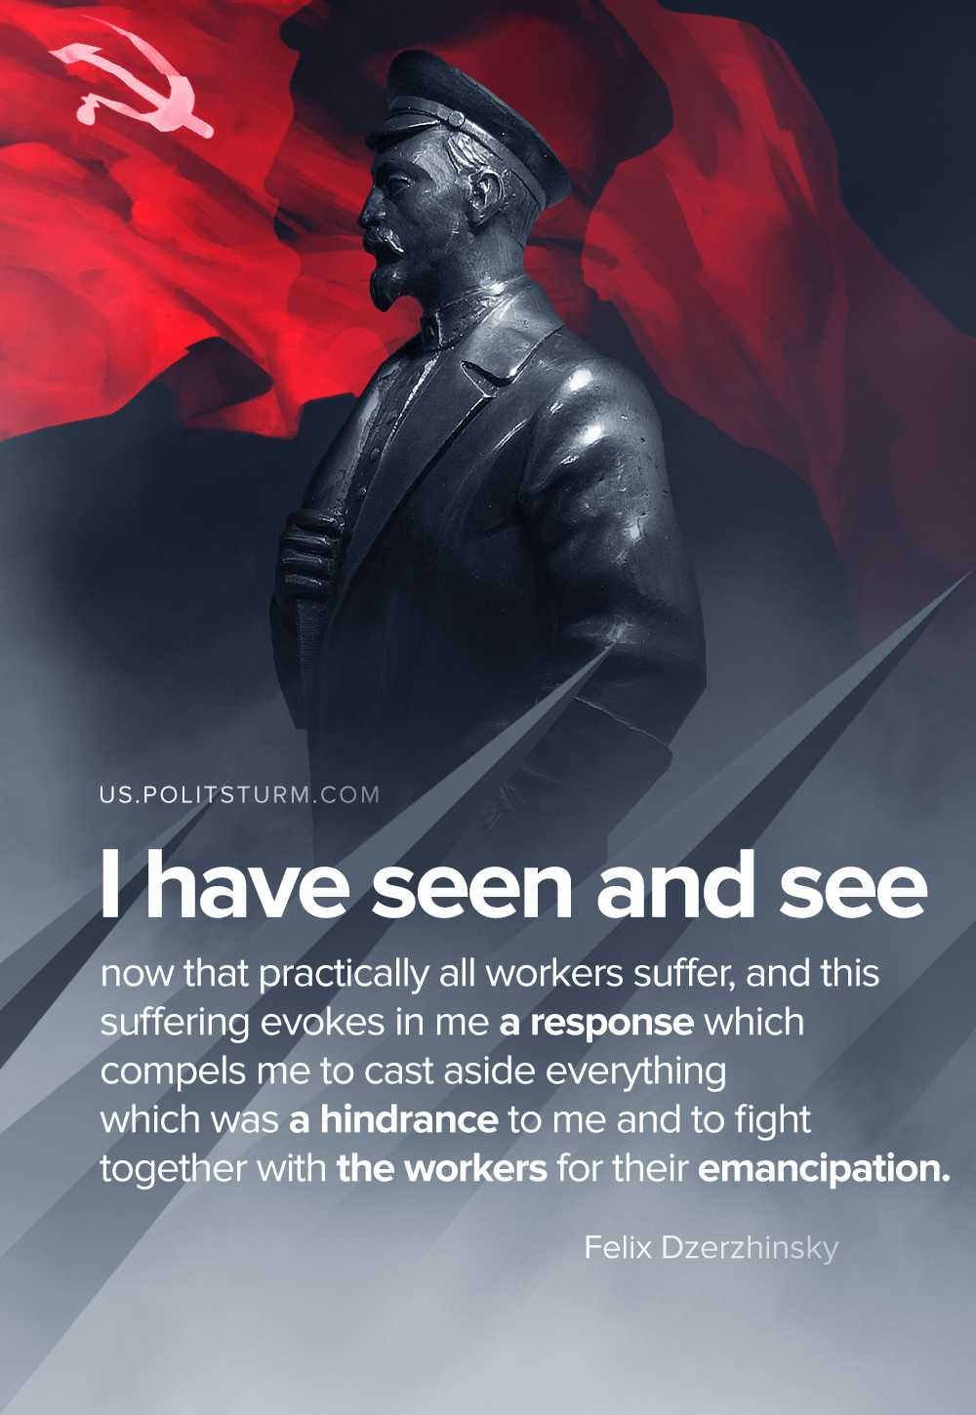

Original article
2020-08-01

The society in which we live today is divided into different classes with opposed interests. The result is that
happiness for one signifies misfortune for another. Take, for example, the famine which follows crop failure.
For the masses of the people this is misfortune. But there are those who utilize this misfortune in order to stuff their pockets with money (grain merchants).

Original article

