Dying To Work: The Connection Between
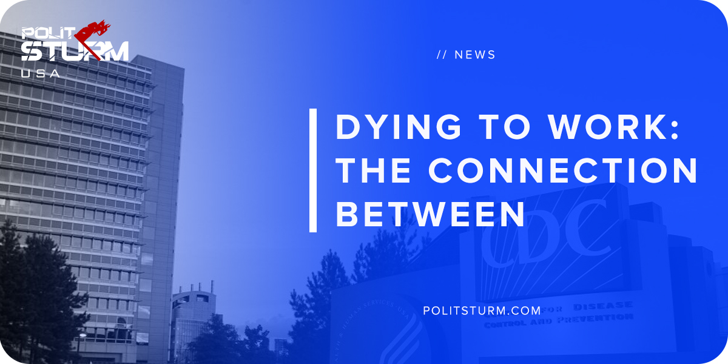

Original article
2018-05-22
1 min read

A study conducted by the Center for Disease Control has confirmed what most workers already know, namely that increased stress leads to poor mental and physical health. It found that problems at work are even more likely to cause health-related complaints than financial or familial problems.
Extended shifts, increased workloads, and poor and abusive management all contribute towards the degree of stress endured by the working class. These tactics allow for the increased exploitation of the working class and the increased profits for the capitalist class. While longer hours and increased intensity of labor are beneficial to the capitalist, they are harmful and dangerous for workers.
When the body experiences stress for extended periods of time it loses the ability to repair and defend against illness over time. As a result, workers have to spend more time and money recuperating from workplace-related injury and sickness.
The absurdity of the capitalist system becomes readily apparent when you consider the long-term implications of stress for the working class. Increased risk of cardiovascular disease, musculoskeletal disorders, and psychological disorders are all related to increased levels of workplace stress.
The solutions presented by mental health experts often include prioritizing family and friends over work, finding personal fulfillment through labor, and living a healthy lifestyle. These solutions ignore the objectively precarious position of workers, the alienating nature of wage labor, and the lack of money and resources for workers.
The capitalist system is by nature exploitative, stress-inducing, and alienating. It is not the workers who are doing anything wrong, quite the opposite. It is rather the parasitical capitalist class that is in need of change.

https://www.cdc.gov/niosh/docs/99-101/
https://health.usnews.com/health-care/for-better/articles/2018-05-17/5-reasons-your-job-is-bad-for-your-health

Original article

