During Pandemic Workers Putting in Extra Labor Hours
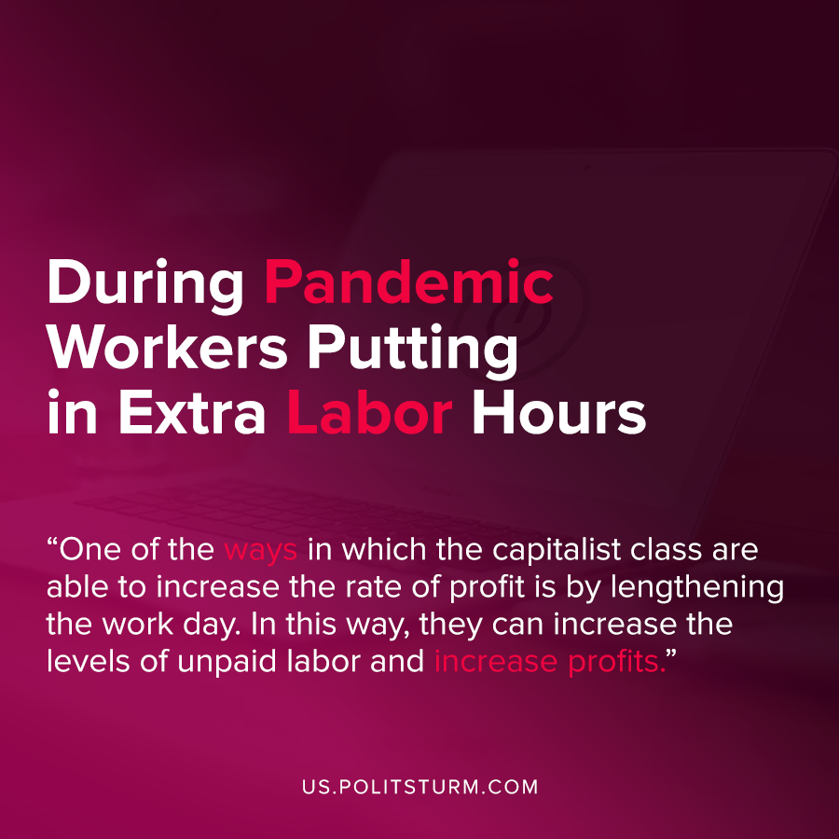

Original article
2020-08-18
1 min read

Not only are Americans taking less vacation time during the pandemic, but data from NordVPN shows that Americans are actually putting in extra hours of work every day.
Workers are spending more time on the job by working through breaks and lengthening the working day before and after the typical working hours.
“The data has also revealed that the UK seems to start work an hour later than before the quarantine, but both the US and UK tend to work late. We also see that there is no significant drop in the usage of business VPNs during lunchtime, which might suggest that lunch breaks have become shorter,” Juta Gurinaviciute, Chief Technology Officer at NordVPN Teams, said in a statement.
The base of the wealth of the capitalist class, profit, is rooted in the unpaid labor of the working class. One of the ways in which the capitalist class are able to increase the rate of profit is by lengthening the work day. In this way, they can increase the absolute levels of unpaid labor and increase profits.
The capitalist class can opportunistically benefit from the conditions of the pandemic and the concurrent crisis of overproduction. In addition to the massive unemployment, the current conditions have also immiserated the workers by lengthening the working day. The capitalist system will constantly benefit the interests of the exploiting class, and this is yet another clear example of this fact.
Sources: 1 , 2 , 3

Original article

