The State Duma Advised Schoolgirls to Have Children
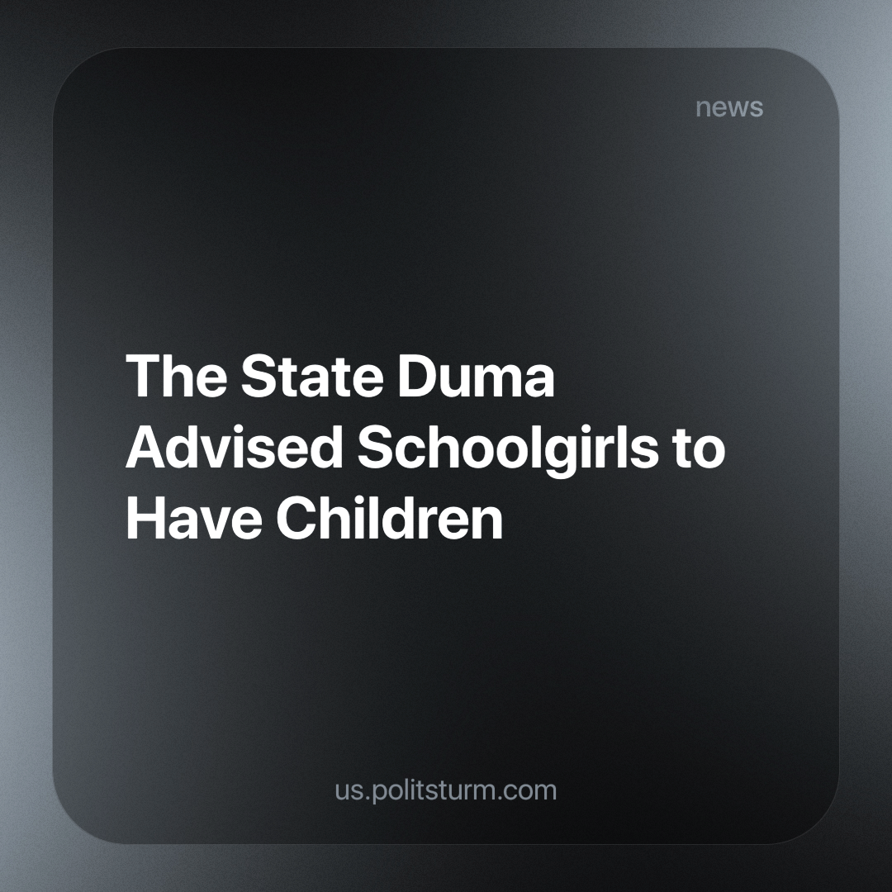

Original article
2024-03-27
2 min read

Deputy Tatiana Larionova criticized the practice of discussing contraception with schoolchildren, stating,
“The outcry for 'give me a condom to avoid pregnancy' was unnecessary.”
Veronika Vlasova, a member of the State Duma Committee on Health Protection, highlighted that the state actively supports every pregnancy, noting that up to 50 per cent of young girls begin sexual activity at the age of 15.5 years. She argued that the issue should neither be ignored nor sensationalized by associating it with “bringing condoms to school.”
Doctors present at the meeting noted that today's teenagers are not sufficiently informed about the consequences of abortion, including medical abortion, which can be induced using drugs.
Earlier in the Irkutsk region, a priest expressed the need to increase the number of children born among Russian women in order to ensure the future protection of the country, noting that these children will be able to defend the “Russian world.” He also emphasized the importance of changing public attitudes towards issues of fertility and sin.
These statements from high-ranking officials and clergy shed light on the acute demographic problem. However, the proposed methods to address the declining population trend remain aggressive and utterly useless. Merely imposing restrictions and prohibitions will not effectively address the underlying issues that determine the societal conditions necessary for life and development; they will not change the material basis.
Attempting to achieve population growth within an economy predominantly driven by private interests, where the state's role is primarily that of a law enforcer and tax collector, is absurd. The official policy of the market state, cutting social spending, exacerbates the population decline.
With a populace burdened by debt and poverty, whose needs and dreams are routinely dismissed by an indifferent state, the path to extinction and decay seems inevitable. Who in their right mind would contemplate starting a family in such a bleak landscape, devoid of present support and future certainty? Especially amidst a backdrop of economic decline, crises, and upheavals! The mere handouts tossed from the “masters' table” resemble scraps to a starving dog, doing little to address the plummeting birth rate.
Should we underscore the fact that in a society where profit and business reign supreme, ordinary women bear the dual burden of being both laborers, generating surplus value for profits, and domestic caretakers, responsible for nurturing and raising future laborers? Due to this latter role, when needed for demographic reasons, their rights and securities are violently attacked by bourgeois officials.
Only a privileged minority, graced with sustained high incomes, can envision the possibility of a sizable and content family amidst such circumstances. The majority find themselves trapped in an unending cycle of survival, trading their time for mere sustenance.
A planned economy is necessary to provide rational solutions to demographic issues, such as the rapidly ageing population seen in many developed capitalist states of Europe.
Source: Lenta.ru - “The State Duma advised schoolgirls to give birth” from February 02, 2024

Original article

