DPRK Hands Over Migrant Workers to Russia for Super-exploitation
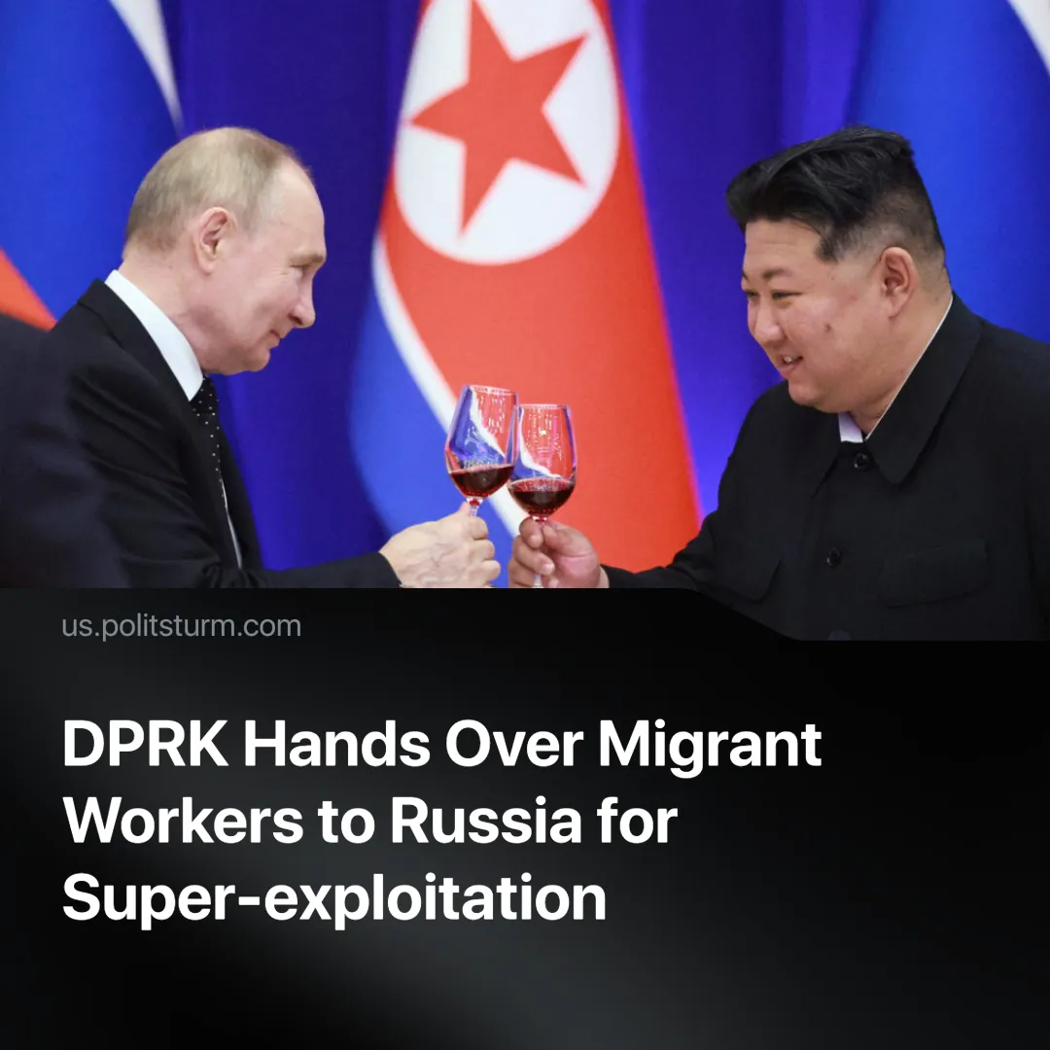

Original article
2025-05-09
2 min read

North Korea has reportedly increased the number of workers it is sending to Russia, amid confirmation that Democratic People's Republic of Korea (DPRK) troops are also fighting in Russia against Ukrainian forces. The strengthening of ties with and praise for imperialist Russia reveal the true nature of what is often claimed to be one of the last socialist countries left.
Details. South Korean intelligence, which had already correctly reported that DPRK soldiers were being sent to fight in Russia, has also reported that some 15,000 North Korean workers were exported to Russia in 2024, mainly on student visas.
► This figure represents a twelve-fold increase on the previous year.
► The North Korean government is said to pocket up to 90% of these workers' earnings, leaving them with a salary of $100 or $200. Workers are also described as working up to 12-hour shifts.
► According to a UN report in March 2024, around 120 Russian companies currently employ North Korean workers. This comes at a time when Russia is facing a severe labour shortage which we have analysed.
Context. In 2019, the United Nations banned countries from employing North Koreans. This was an attempt to cut off funding to the DPRK and curb its nuclear programme. The recent increase in labour exports to Russia shows a return to when Russia hosted up to 30,000 North Korean workers in 2018, prior to the ban.
► This also comes as it has been confirmed by both North Korea and Russia that DPRK troops have been sent to fight in the Kursk region of Russia. North Korea has also expressed its support for the so-called “Special Military Operation” in Ukraine since its beginning. Furthermore, the two nations signed the December 2024 DPRK-Russia Strategic Partnership Agreement, cementing deeper economic and military ties between them.
► Since the 1990s, the DPRK has been opening Special Economic Zones (SEZs), similar to those in China. SEZs increase economic ties between capitalist countries and facilitate the flow of international capital into a given nation — these are employed by many capitalist countries, such as the United Arab Emirates or South Korea. This signals deeper integration into global capitalist markets and the true nature of North Korean "socialism".
► Following this, the DPRK’s private sector has now grown larger than its state sector. It follows that capitalist market logic is predominant, and labour power appears as a commodity for private individuals to purchase and exploit.
Important to Know. Sending troops to participate in Russia's imperialist conflicts demonstrates that the export of soldiers and workers is not done out of "anti-imperialism" but out of a growing dependence on its allies.
► In addition, as tensions rise between the various imperialist powers preparing for an attempt to redivide the world, North Korea must consolidate its relations with Russia and China. Their dependent nature leaves them vulnerable should they not receive support. The US has 28,500 military personnel stationed in South Korea, with frequent joint military exercises. They also benefit from an extensive bilateral trade—although Trump’s tariffs might be pushing South Korea closer to China.
► North Korean workers are a super-exploitable labour force that the capitalists in Russia and China can use for attaining super-profits.
► The DPRK can also extract foreign currency from these workers, its own working class, which is useful and necessary for its goal of deepening capitalist economic relations with other nations, as well as for procuring weaponry.
► Despite North Korea's socialist rhetoric, this development highlights how the growing DPRK-Russian relationship is simply an inter-capitalist deal. Russian capitalism is suffering from labour shortages and is struggling to maintain its imperialist ambitions. This deal allows the Russian Federation to continue its imperialist aims and North Korea to deepen its economic ties with global capitalism at the expense of its working class.

Original article

