Doordash sued for pocketing workers tips
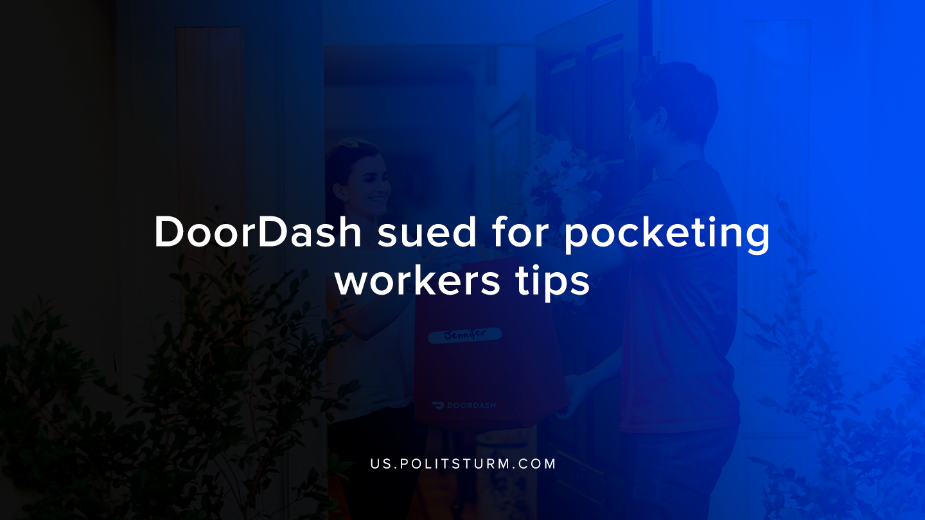

Original article
2019-11-21
1 min read

Food Delivery company Doordash was sued on Tuesday by the District of Columbia Attorney General over deceptive practices relating to how workers were tipped. According to the suit, when customers tipped workers through its application, the tip was essentially subsidizing workers wages.
For example, say a customer orders food through Doordash and chose to give a tip of $9. A worker who accepts to deliver the food to the destination would receive a guaranteed amount for completing the delivery, for instance, $10. In this instance, the tip would serve to reduce the amount that Doordash would need to pay in wages to $1 for this delivery.
Since most users of the application would think that their tip was being given in addition to the base pay of the worker, the Attorney General is bringing a lawsuit against the company for deceiving its users and not paying these tips to the employees who were doing the work.
The capitalist economic system is predicated upon capitalists privately appropriating the unpaid wages of workers. In this case, the owners of Doordash are able to reap profits while they exploit their workers and deceive their customers.
The exploitation of workers is not unique or specific to this particular company or its practices. Doordash is only being sued due to the fact that its business practices were particularly deceptive and misleading to consumers. However, the theft from the working class occurs on a daily basis due to the structure and economic relations under capitalism. Only through the understanding of Marxist-Leninist theory can we fully unmask the exploitation of capitalism in general that is so obvious in this particular instance.
Source

Original article

