DOL Ruling Attacks Tipped Workers
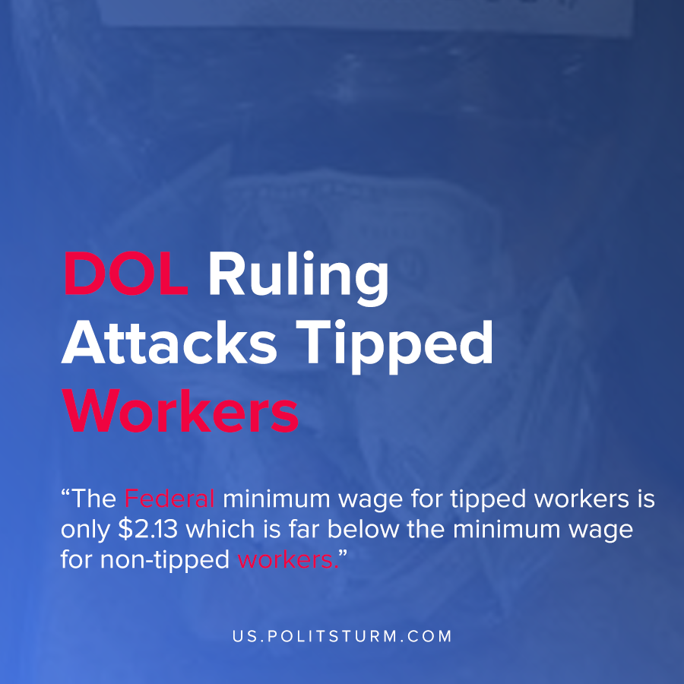

Original article
2020-12-25
1 min read

A new ruling by the Department of Labor is targeting the wages of tipped workers. As we have previously reported, the federal minimum wage for tipped workers is only $2.13 which is far below the minimum wage for non-tipped workers.
The ruling in particular requires tipped workers to pool together their tips and share them with non-tipped workers such as cooks and dishwashers. Tipping allows the capitalists to push labor costs onto customers who subsidize the profits of the business owners. As a result this ruling will take money out of the pockets of tipped workers such as servers and bartenders to benefit the capitalists.
Also, the ruling targets the amount of time that tipped workers can spend during their day performing work that does not earn tips. Previously, there was a 20% cap on the amount of non-tipped work that tipped employees could do during a shift. This ruling has eliminated this standard allowing tipped workers to work longer periods of time earning only the $2.13 tipped minimum wage.
The ruling by the Trump administration Department of Labor is another clear indication that this federal agency represents the interests of capital over labor. By effectively reducing wages, the capitalists can increase the exploitation of these workers and their profits.
Only by understanding Marxist-Leninist theory is it possible to expose the theft by the capitalist class and their representatives in bourgeois parliament.
Source: 1 , 2

Original article

