DOL Proposal Eases Classifying Workers As Independent Contractors
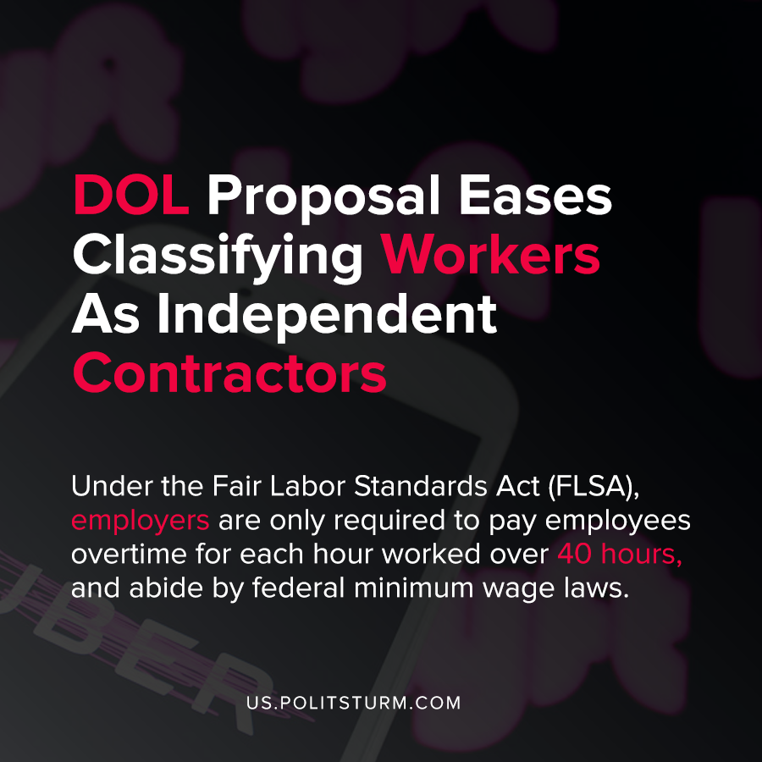

Original article
2020-09-25
1 min read

The Department of Labor released their proposal that would clarify the distinction between employees and independent contractors. Under the Fair Labor Standards Act (FLSA), employers are required to pay employees overtime for each hour worked over 40 hours, and abide by federal minimum wage laws.
The Department of Labor under Eugene Scalia made clarifications that would make it easier to classify workers as independent contractors.
There are now two “core factors” in determining whether a worker is an employee which are “the nature and degree of the worker’s control over the work; and the worker’s opportunity for profit or loss based on initiative and/or investment”.
This reclassification is yet another example of the capitalist class using the regulatory and legal framework for their own benefit. By classifying workers as independent contractors as opposed to employees, employers are able to avoid legal requirements such as the federal minimum wage and overtime benefits.
It may appear ironic that the Department of Labor is proposing rules that would harm the wellbeing and jeopardize the benefits afforded to working Americans. However, there is no contradiction as the entire edifice of bourgeois politics serves the interests of the capitalist class. By classifying workers as independent contractors it will help employers to reduce labor costs and bolster profits, while simultaneously hurting the workers.
Source: 1 , 2 , 3 , 4

Original article

