The European Working Class: Does It Exist, and Why Is It Not Fighting for Socialism?
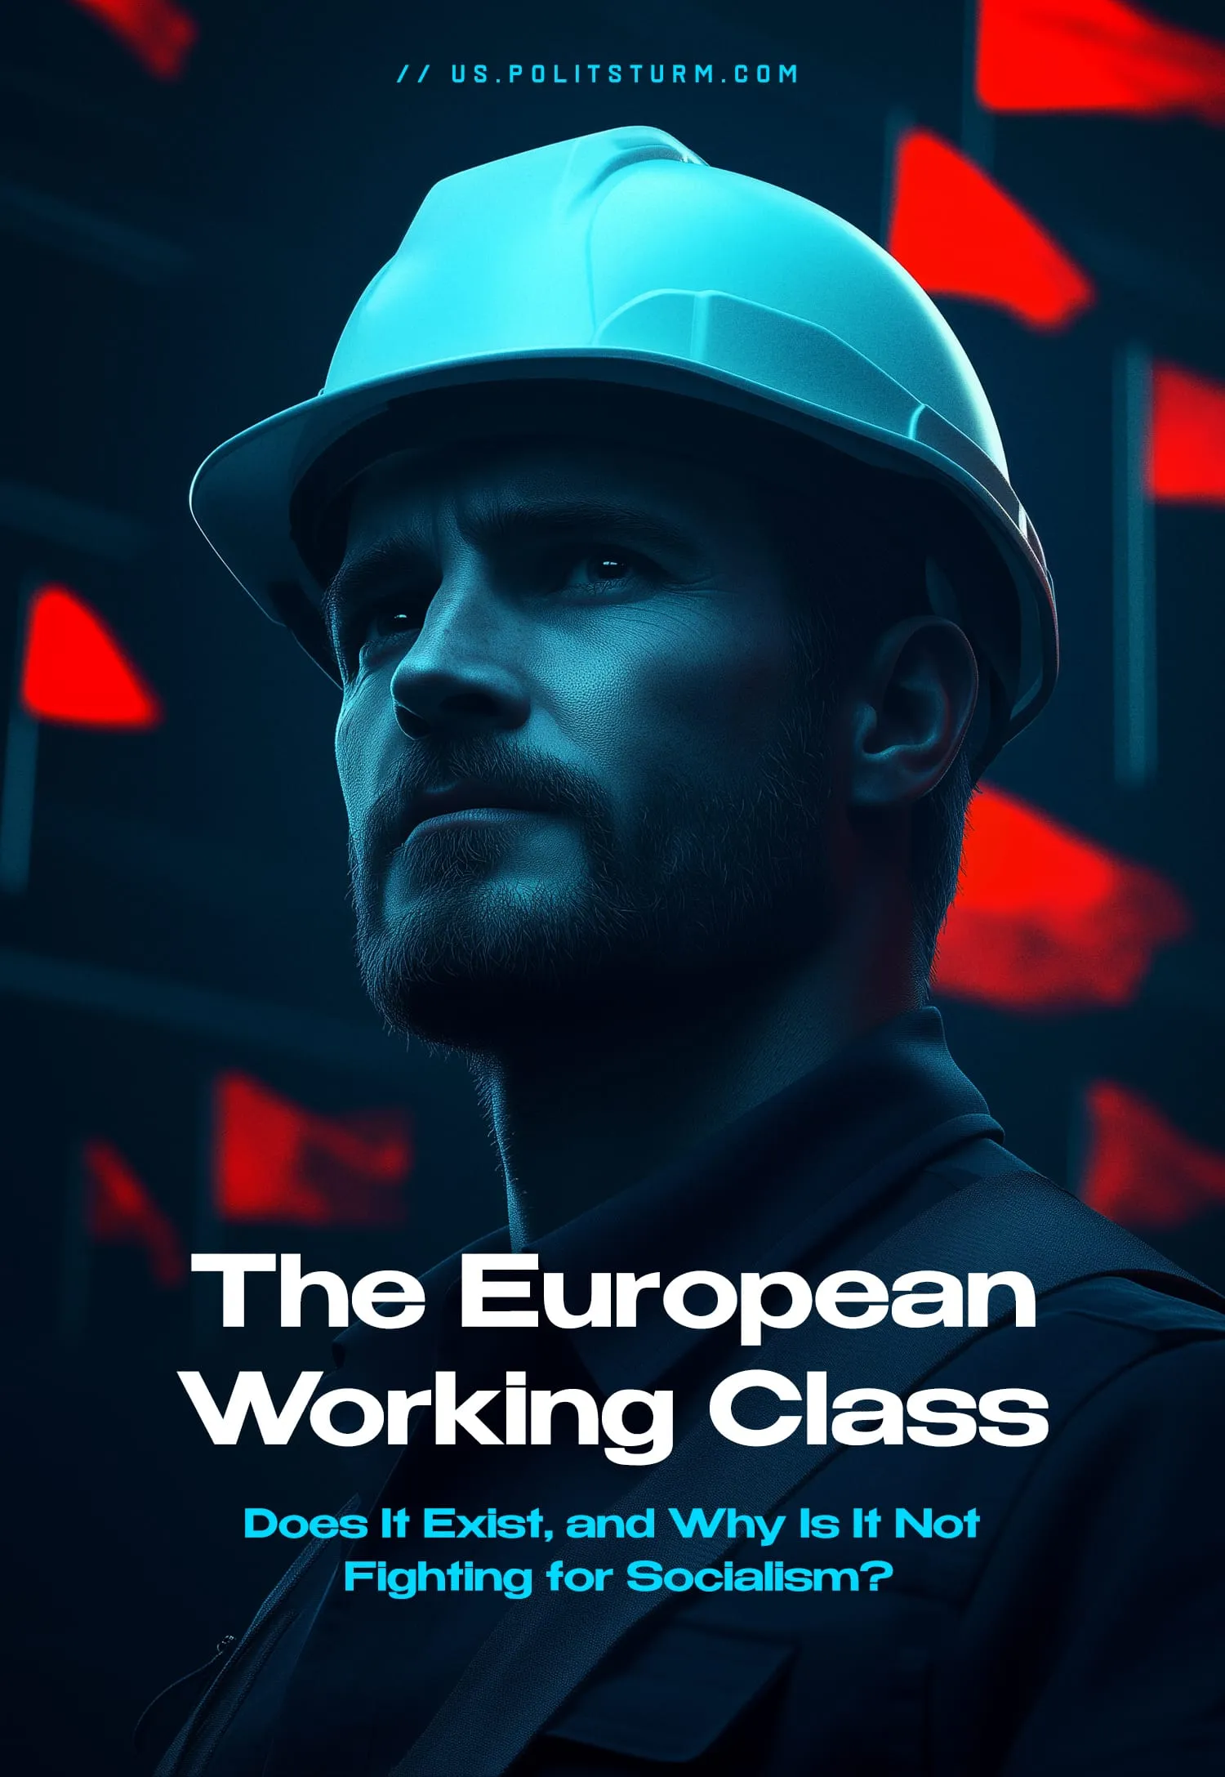

Original article
2025-01-11
51 min read

The European Union has long been known as a territory with a high level of social development and comfortable living conditions. At the same time, European propaganda portrays this situation as if class contradictions have been eliminated and as if the “traditional” working class no longer exists.
- Contemporary society remains capitalist and class-based, with inevitable class contradictions. European authorities perpetuate the myth of a prosperous, contradiction-free Europe.
- Many on the "left" promote theories that the working class is obsolete and that class contradictions no longer exist or relegate them as a “secondary” concern. Such theories include ideas such as post-industrial society, world-systems analysis, simulacrum theory, and three-worlds theory.
- The working class, or proletariat, includes all wage laborers who do not own the means of production and exist by selling their labor power. This class provides all the benefits of society in exchange for minimal material compensation.
- The majority of Europeans belong to the working class. Of the 200 million workers, only 25 million are small business owners and 1% are owners of medium or large businesses. There is considerable social inequality in Europe, and the wealth gap between the different social classes has reached colossal proportions. It is home to 6% of the world's population and 15% of the world's oligarchs.
- Europe has an active workers' movement, but it is infected with opportunism. Unions and left parties prioritize class peace or electoral politics without advancing a communist agenda. The creation of genuine European communist parties is urgently needed.

I. On the "Disappearance" of the Working Class
Official propaganda actively promotes the myth of the disappearance of class differences. EU authorities, paid ideologues, mainstream economists, and "leftist intellectuals" all claim that the working class as a unified entity has vanished, dissolving among a multitude of managers, freelancers, farmers, small entrepreneurs, bloggers, programmers, bartenders, and others in the so-called "middle class." They suggest that the proletariat and class struggle in Europe are relics of the past century.
European officials portray Europe as a society of “social justice,” a utopia where class contradictions and struggle have no place. This is evident, for example, in statements by the European Union’s high representative for foreign affairs and security policy, Josep Borrell:
“Europe is a garden. We have built a garden. Everything works. It is the best combination of political freedom, economic prosperity and social cohesion… The rest of the world is not exactly a garden. Most of the rest of the world is a jungle, and the jungle could invade the garden”. [1]
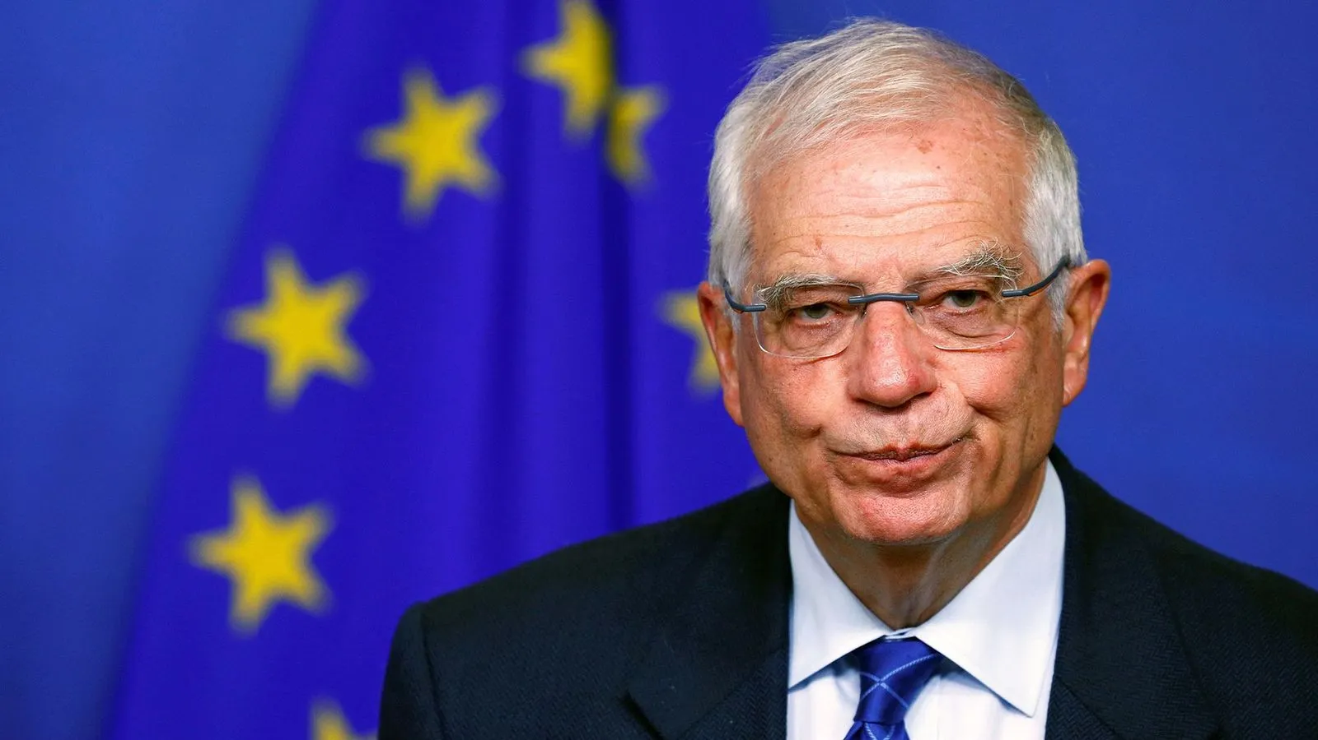
Josep Borrell
Such populist statements are rooted in theoretical frameworks.
For instance, Daniel Bell, the author of the post-industrial society theory, argued that ideologies are a thing of the past. He believed the transition to a "post-industrial society" would bring significant social changes: the gradual replacement of the working class by "highly skilled specialists" and "technocrats," the easing of social and class contradictions, the separation of power from property, and the establishment of "social peace and order in abundance."
The implication is that if there is no working class, there are no class contradictions. Bell concludes:
"The principal divide in modern society is not between the owners of the means of production and a homogeneous proletariat but is defined by bureaucratic and power relations between those who have decision-making authority and those who are deprived of it. This applies to all organizational units—political, economic, and social. The task of the political system is to manage these relations in response to various pressures aimed at redistributing national wealth and ensuring social justice" [2].
Some "leftist" theorists echo this sentiment.
For example, in the works The Consumer Society (1970) and The Mirror of Production (1973), French philosopher and sociologist Jean Baudrillard argued that Marxist concepts such as "socialism" and "capitalism," tied to "commodity production" and "exploitation," are supposedly insufficient to explain modern society. According to Baudrillard, class-based society is replaced by a "mass society," no longer governed by class interests but by "simulacra" and sign systems. There is no longer an objective concept of the "working class"; only individuals identifying as its members exist.
Baudrillard elevates the role of consumption and the abstract, classless consumer in contemporary society. This provides an ideological foundation for equating communism with capitalism, as both supposedly prioritize abundance and high consumption. Consequently, Marxism and class division appear as outdated theories.
The classical world-systems analyst, Immanuel Wallerstein, outright declared Marxism obsolete:
Orthodox Marxism is mired in the imagery of nineteenth-century social science, which it shares with classical liberalism: capitalism is inevitable progress over feudalism; the fac­tory system is the quintessential capitalist production process; social pro­cesses are linear; the economic base controls the less fundamental political and cultural superstructure [3].
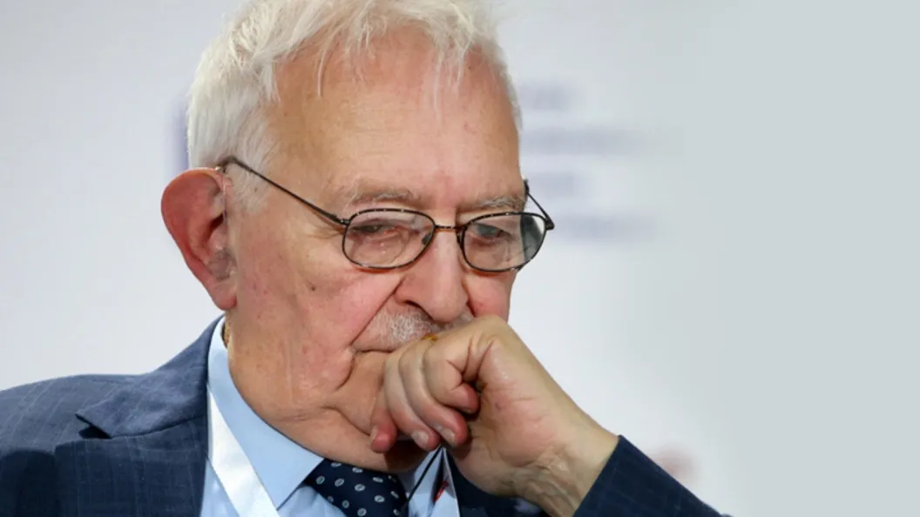
Immanuel Wallerstein
Even representatives of seemingly ultra-left currents like Maoism abandoned class analysis. Maoists "refined" Marxism-Leninism by dividing the world into three parts. The "First World" included only two countries—the USA and the USSR [4], based on their wealth and vast military power, symbolized by nuclear weapons. The "Second World" included intermediate countries such as European ones, Japan, and Canada—individually much weaker than the USA and USSR but stronger than other states. Finally, the "Third World" included all other countries.
This approach ignored the existence of two antagonistic classes within each country, regardless of the "world" it belonged to. For instance, in the USA, Japan, or Mexico, class conflicts remain inevitable due to the capitalist mode of production.
This methodology was applied in practice. At a 1974 UN meeting, Deng Xiaoping harshly criticized the USSR and the USA (labeling them as social-imperialist and imperialist, respectively) while supporting "Third World" countries in their struggle against oppression [5].
Third World nations were declared unconditionally virtuous allies of China, while First World nations were deemed evil super-imperialists. The working class of the First World was conflated with the bourgeoisie and regarded as an adversary. Conversely, Third World countries were broadly seen as allies of "socialist" China.
Thus, the working class as a concrete social group was replaced with abstract concepts such as "the people," "the world," and "oppressed nations."
As we can see, both right- and left-wing opportunists align with European bourgeois propagandists in declaring the working class to have disappeared, transformed into another class, or erased class distinctions altogether. Regardless of the ideological nuances, they all conclude that the working class has vanished or receded into the background and that the class struggle has subsided. If not worldwide, then at least internally within "advanced" Europe.
Are these critics of communist theory correct? Does the working class exist in developed nations? And if it does, is there a trend toward its disappearance?
The answers to these questions directly impact the strategy of communist forces. Can the proletariat still be considered the most progressive class in the 21st century; the one that holds the key to the future and should be the basis for societal transformation?
Answering these questions requires analyzing concrete data, facts, and statistics—in short, studying the social structure of modern European countries.
But first, we must clarify the concepts involved.

II. Key Concepts Of Class Theory

2.1 Class
Before we begin directly analyzing the class structure of the European countries and answering the posed questions, it is necessary to define the concepts: what we mean by "classes," who we identify as the "proletariat," the "bourgeoisie," and so forth.
V.I. Lenin gave a classic definition of the term “class”:
“Classes are large groups of people differing from each other by the place they occupy in a historically determined system of social production, by their relation (in most cases fixed and formulated in law) to the means of production, by their role in the social organisation of labour, and, consequently, by the dimensions of the share of social wealth of which they dispose and the mode of acquiring it. Classes are groups of people one of which can appropriate the labour of another owing to the different places they occupy in a definite system of social economy.” [6]
It should be noted that the last sentence refers exclusively to antagonistic societies since the classes of socialist workers and collective farmers that existed in the USSR did not exploit each other.
According to Lenin's definition, classes are differentiated:
- by their place in the system of social production;
- by their relation to the means of production;
- by their role in the social organization of labor;
- by the size and the mode of acquiring their share of social wealth.

2.2 The Working Class
The proletariat (working class) is a class in a capitalist society that does not own the means of production and lives by selling its own labor power, i.e., through wage labor. It is the main producer of social wealth. However, the share of this wealth that the proletariat receives as a result of its labor is kept as low as possible by the capitalist and it is enough only to meet basic needs.
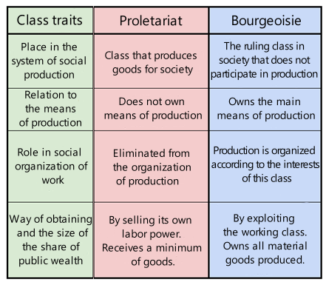
Characteristics of the main classes of capitalist society
Often, workers who do not directly participate in the sphere of material production are excluded from the working class. For example, Professor M.V. Popov classifies only “urban, factory workers” as the proletariat [7].
This statement is an error, because:
A. The production of goods is impossible without the mental laborers.
Together with the physical laborers they form what Marx termed the "collective worker":
“In order to labour productively, it is no longer necessary for you to do manual work yourself; enough, if you are an organ of the collective labourer, and perform one of its subordinate functions. The first definition given above of productive labour, a definition deduced from the very nature of the production of material objects, still remains correct for the collective labourer, considered as a whole. But it no longer holds good for each member taken individually.” [8]
Many of the workers who directly produce the product are involved in more than just manual labor. Modern production facilities require a high level of education. For example, a worker's job at a machine is no longer exclusively physical - if it ever was.
B. The main characteristic of the proletariat is its social position: it is a class of wage-earners exploited by the bourgeoisie for profit. Whether a particular worker produces material goods or performs mental labor is secondary. As Marx observed:
“That labourer alone is productive, who produces surplus-value for the capitalist, and thus works for the self-expansion of capital. If we may take an example from outside the sphere of production of material objects, a schoolmaster is a productive labourer when, in addition to belabouring the heads of his scholars, he works like a horse to enrich the school proprietor.” [8]
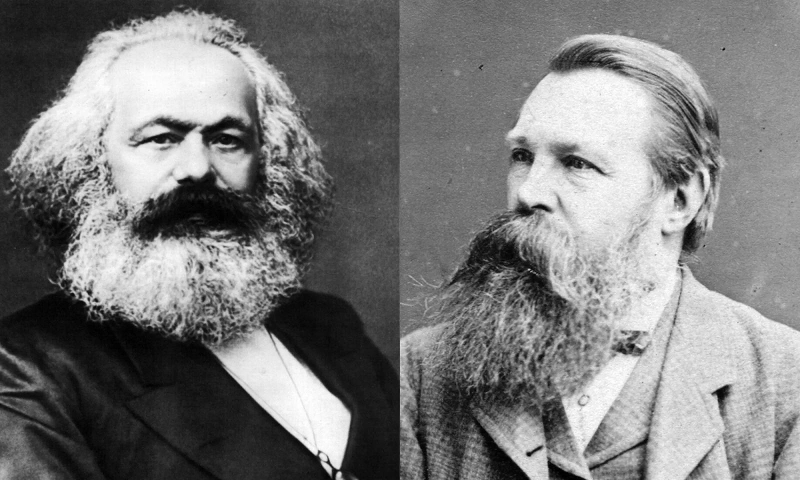
Karl Marx and Friedrich Engels
Most teachers, doctors, and programmers working for capitalists are exploited for profit just as welders, loaders, and drivers are. These groups also form trade unions, belong to labor parties, and take part in the class struggle.
Addressing the International Congress of Socialist Students on December 19, 1893, Engels said:
“May your efforts succeed in developing among students the awareness that it is from their ranks that there must emerge intellectual proletariat which will be called on to play a considerable part in the approaching revolution alongside and among their brothers, the manual workers.” [9]
To conclude, the working class includes all those who are alienated from the ownership of means of production and thus live by selling their labor power, including those in non-material production.
Such representatives of the working class are usually classified as employees.

2.3 Clerks And Intellectuals
Clerks are a stratum of wage workers engaged in intellectual, non-physical labor, such as technical staff, bank and government employees, salespeople, and managers. It is important to note that this definition does not have clear criteria, because clerks are distinguished not by class, i.e. economic criteria, but by the nature of their work. Therefore, some categories of workers belong to the working class, others are very close to the bourgeoisie, and others are in between.
Representatives of the upper stratum of clerks, such as top managers, high-ranking officials, and highly paid specialists, are very close to the bourgeoisie class in their positions and interests. Sometimes people from this stratum become company owners, profiting from others' labor.
The majority of clerks are part of the working class. While the category of intellectual workers was relatively small and had a more privileged position at the end of the 19th and the beginning of the 20th century, the position of employees and workers has been equalized now. The clerks have become mass workers, and their standard of living is the same as that of manual workers. The clerks are now exploited similarly to "classical" proletarians, serving the same profit-driven goals.
It is wrong to consider only factory workers as the working class just because, a hundred years ago, the working class consisted mainly of them. Modern technology requires a much more educated and cultured worker and needs more clerks, thus depriving them of their privileged status. The working class is changing along with the productive forces. Technological progress blurs the line between non-physical and manual workers.
This does not mean the disappearance of the working class and the refutation of Marxism, as some opportunists say. On the contrary, reality confirms the provisions of scientific communism about the future disappearance of the opposition between physical and mental labor — a tendency currently developing. However, only socialism can realize this tendency fully.
The category of intellectuals has a similar meaning to the category of clerks.
Intellectuals:
“A social stratum consisting of people professionally engaged in mental labor (scientists, engineers, teachers, writers, artists, doctors, agronomists, the majority of employees, etc.). Being a stratum, not a class, and is unable to play an independent political role in public life.” [10]
Like clerks, intellectuals are classified not by economic criteria but by the nature of their work, leading to a heterogeneous class composition. For this reason, they are considered a stratum rather than a distinct class.
Technological progress and the spread of education have deprived this stratum of its former elitism. Over the past century, intellectuals have grown in number, with the majority transitioning into the category of hired workers. Teachers, doctors, and others are now employees, often earning less than the average manual worker.
A significant part of intellectuals are in the position of petty bourgeoisie – private lawyers, doctors with their own clinics, technical specialists with their companies, bloggers with their studios, etc.
At the same time, intellectuals are considered to be of a higher strata than clerks. It is generally believed that intellectuals are engaged in more complex mental labor, such as creative artistry or scientific work. However, there are no clear class boundaries between these concepts.
The division of people into a separate category – intellectuals – based on "particularly complex" mental labor is now outdated. This category has remained from the times when intellectual workers were rare, thanks to which they had a privileged position. Now, the mass of such professionals engaged in creative or scientific work has deprived them of their elite status. Most representatives of this stratum are now in the position of ordinary employees.
It can be concluded that the intelligentsia, as a distinct stratum of modern society, has practically disappeared.
Employees of the state administration and law enforcement agencies should be mentioned separately. On the one hand, there are no small owners among them – they are all wage earners. On the other hand, due to the nature of their work, they are often excluded from the proletariat since they serve the bourgeois state directly. This last argument is inaccurate, as all wage earners work directly for the bourgeoisie – otherwise, they would not be proletarians.
Another thing is who exactly a state employee works for. It is one thing to be a petty official of the local administration and another to be an agent of the secret services, trained to maintain political order. This raises an apparent contradiction: a wage-earner, a representative of the proletariat, is employed to oppress others of their class.
This apparent contradiction is resolved by considering two key points:
- The bourgeoisie is a minority in society, so it needs an instrument to maintain its dominance and regulate its affairs. This instrument is the state and its officials. The capitalists are a parasitic class in society. They have to resort to utilising wage labor also to realize their domination.
- Class status does not determine ideological class position. Among the bourgeoisie and even among the nobility there were great figures of the communist movement, and among the proletariat, there are many adherents of bourgeois ideology. Belonging to one class or another is an economic criterion that serves only as a prerequisite for political views, but by no means determines them completely.
And although, in terms of their economic position, workers in the state apparatus and law enforcement agencies are much closer to the working class than to the bourgeoisie, this does not mean, of course, that representatives of this stratum will unconditionally support the working class's struggle for its rights and for socialism. On the contrary, precisely due to the specifics we have pointed out—working for the capitalist state and the particular ideological training of officials and law enforcement officers—they often act as direct opponents of the working class.
Nevertheless, when analyzing modern capitalist society and the organization of the working class, as well as when planning the activities of the proletariat and the communist party, it is essential to take into account this aspect of the complex dialectical position of civil servants and law enforcement personnel: as wage workers and, at the same time, as servants of the ruling class, defending it against the organized proletariat.

2.4 The Bourgeoisie
The existence of the proletariat implies the existence of the bourgeoisie, and vice versa. Without one class, there is no other class. These are two opposite poles of society, which gradually, in the course of the historical development of society, attract and absorb all other classes and strata.
The bourgeoisie (capitalists) is the social class that owns the main means of production and, consequently, the social wealth produced with the use of these means. Thus, the bourgeoisie is the dominant class of society. It is a minority of society that lives by exploiting the working majority, i.e. the exploitation of man by man. The source of the bourgeoisie's income is the surplus value created by the unpaid labor of hired workers.
This class has a complex structure and consists of different groups: industrial capitalists, bankers, and the commercial bourgeoisie. Despite the differences between them and the different ways of using capital, all of them are united by their belonging to the class of owners and their desire to make a profit at the expense of the exploitation of the workers.
In the modern era of imperialism, it is already difficult to distinguish purely industrial, commercial, or banking capitalists - all types of capital have merged into one - financial. The decisive role is no longer played by individual enterprises but by large corporations that control their monopolized industries and many subordinate enterprises. These processes of concentration and centralization of capital lead to the overwhelming domination of the class of big owners in society.

2.5 The Petty Bourgeoisie
This class occupies an intermediate position because it has the characteristics of both the proletariat and the bourgeoisie. While they own means of production, they still are compelled to work personally and are excluded from organizing social production on a larger scale.
The dual nature of the petty bourgeoisie means that it is constantly disintegrating. Most of them become poorer and become wage laborers, even if some of them continue to nominally own a "business" as subcontractors for larger companies. However, a small part ascends to the ranks of the middle and even big bourgeoisie, exemplified by the common narrative of "garage startups" evolving into billion-dollar corporations.
Despite some periods of rapid growth of the petty bourgeoisie in different sectors and countries, the general tendency of capitalism leads to the disintegration of this class.
This class, as well as the highly paid stratum of the proletariat, is classified as the "middle class", distinguishing this group of people not on the basis of the main class characteristics, but on the basis of the level of income. This approach is subjective: the income level of the middle class varies depending on the speaker's desire to reduce or increase the middle class. Therefore, the category of "middle class" has nothing to do with Marxist class theory.

III. Is there a working class in Europe?
In total, the EU countries are home to about 450 million people, 64% of whom were of working age in 2022 [11].
In total, at the beginning of 2023, 196 million people were employed across the EU, which corresponds to the employment rate of 75% of the working-age population [12]. Moreover, during the last decade, the number of employed people increased by 16-18 million, largely due to recovery from the 2008 and 2014 economic crises.
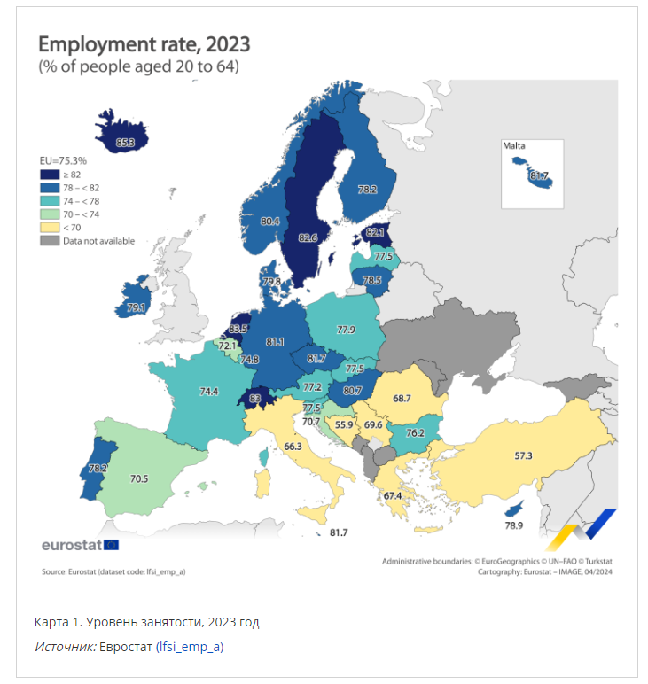
Employment rate by EU countries [12]. The Netherlands is in first place with — 85.3% and Bosnia and Herzegovina is in last place with — 55.9%.
It is worth noting that in “one of the most prosperous places on earth,” millions of people frequently lose their jobs as a result of crises, and even in the relatively calm years between crises there remains an impressive army of unemployed.
The “blossoming garden” of capitalism, even in the 21st century, fails to achieve what the USSR achieved in 1930s: the absence of unemployment.
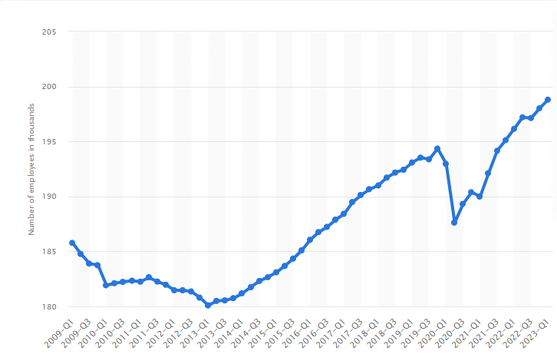
Employment rate in the European Union by year [13]. We can see failures due to the economic crisis of 2008-2014 and the “covid” crisis of 2019-2021. The cyclical nature of development under capitalism can be seen here as clearly as possible
However, the mere number of nearly 200 million workers does not tell us much. What do these people do? And most importantly, are they all wage earners? Could it be that the majority of them are owners of small and medium-sized businesses?
So, we can analyse the distribution of workers in Europe according to industry and class position.

3.1 Distribution of EU employees by employment sector
Let's take a look at how many people are employed by industry.
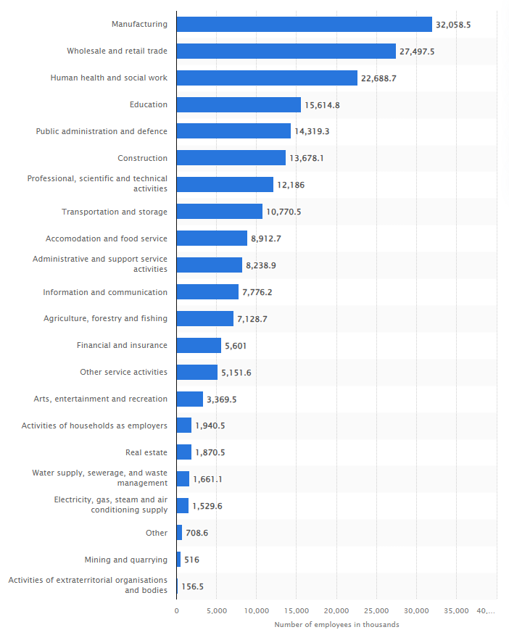
Employment by sector of economic activity in the European Union in Q1 2023, in thousands [14].
The largest share of employment is in manufacturing: 32 million people. Another 13.7 million work in construction, and 10.8 million in transportation and storage. 7.1 million are employed in agriculture and a total of 3.2 million in water, steam, electricity, gas, and sewage services. Another 0.5 million are employed in mining [14].
According to the most cursory and superficial analysis, approximately 70 million workers — roughly one-third of the EU’s employed population — are engaged in manufacturing and related sectors. This is without taking into account the part of commercial workers necessary for distribution, millions of workers employed in food production, etc., etc. But they are not the only ones who are part of the proletariat.
In the structure of employment in the European Union, a large share is represented by workers in the service sector: the second largest number is occupied by trade workers (27.5 million people), followed by health and social workers (22.6 million), education workers (15.2 million), etc.
Thus, the approximate ratio of the division of the European proletariat into production and nonproduction spheres is 1:2, or ⅓ versus ⅔.
Over time, this ratio has changed. Employment in the “real sector” (industry and construction) has declined steadily.
Thus, from 2008 to 2015, the share of those employed in industry fell by 1.7%, and in construction - by 1.6% [15] (see the graph below). Furthermore, between 2019 and 2024, the number of employed in industry declined by 853,000 [16].
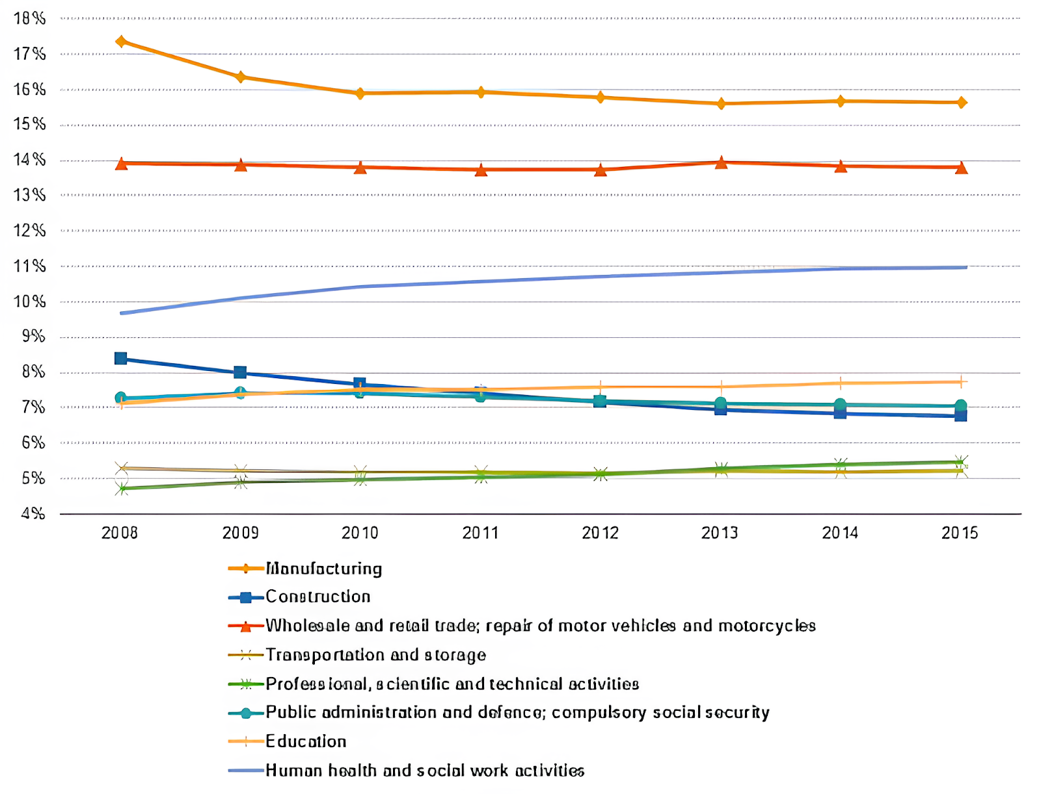
Employment dynamics by activity in the European Union [15]. Despite some decline, employment in industry is dominant. The second largest share of workers is employed in the trade sector.
This redistribution of the working class across spheres of activity is explained by the export of European industrial capital to Asia (mainly China), Africa, and South America. The decline in the number of industrial workers in Europe is accompanied by a transfer of industry to other countries. The extent and nature of this transfer, however, is the subject of a separate study.
For now, let us limit ourselves to a general conclusion: the redistribution of wage earners does not signal the disappearance of the working class. The proletariat is first and foremost a social class, not a category of belonging to a particular occupational field.
Although the number of people employed in the industrial sector has declined over the past few decades, the total number of people employed has increased significantly over the same period. This is clearly shown in the graph below: despite the setbacks caused by the crises, the number of people employed in the EU in the first quarter of the 21st century was about 15% higher than in 2000.
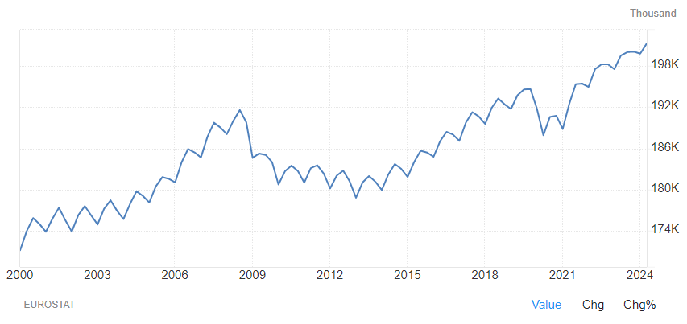
The number of people employed in the EU from 2000 to 2024 [16]. The instability of economic growth under capitalism is reflected in the form of constant employment peaks.

3.2 Class composition of the working people
In addition to the proletariat, the working classes under capitalism also include the petty bourgeoisie. Consequently, a question arises: what proportion of the nearly 200 million workers in the EU belongs to the proletariat, and what proportion belongs to the petty bourgeoisie?
A rough idea of the number of representatives of the petty bourgeoisie class can be given by statistics on small and medium-sized enterprises. In total, there are 26.1 million enterprises in the European Union with up to 249 employees. 24.46 million of these enterprises belong to the category of microenterprises, which employ from 1 to 9 people [17].
While the number of enterprises does not necessarily coincide with the number of owners, even still these statistics suggest that not every employed person has their own “personal business” - such people are around ⅛ of the total number of employed people.
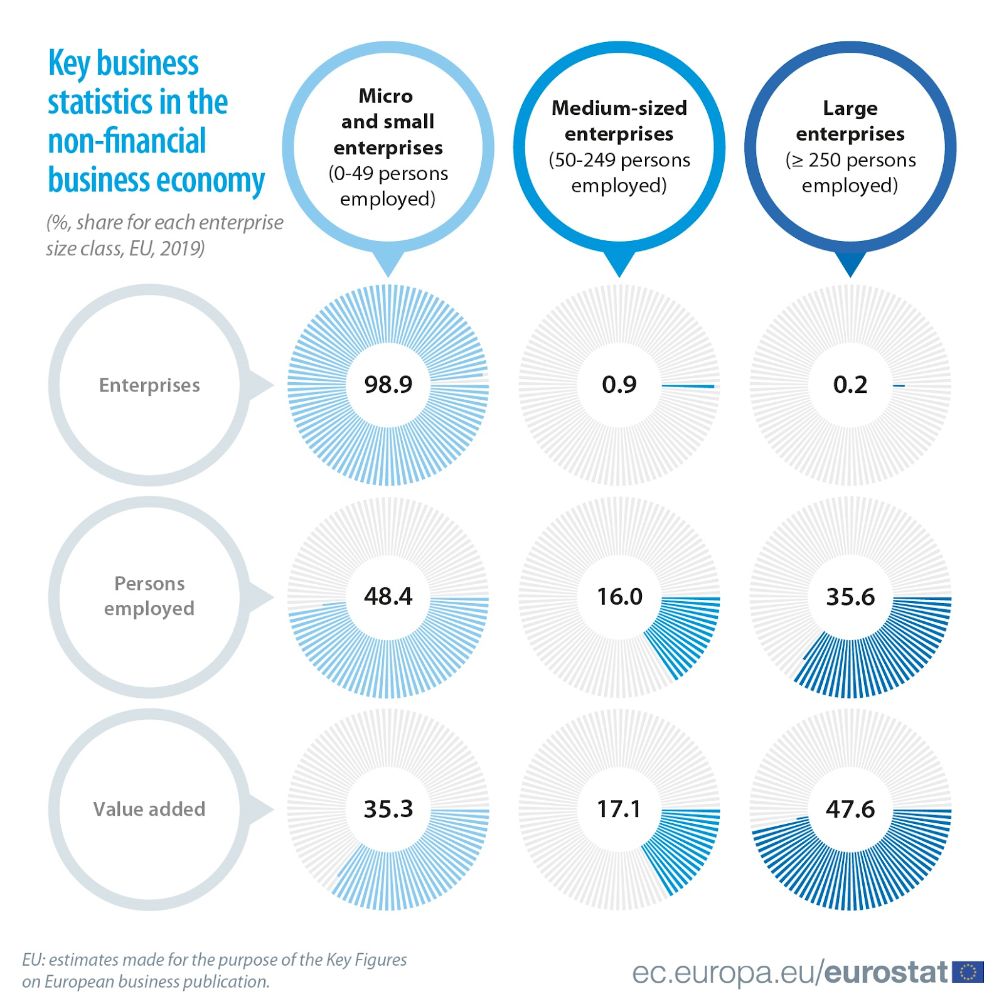
Statistics on EU enterprises [18]. The number of large owners compared to the background of micro-enterprises so much fewer that they could almost be seen as a statistical error, yet they produce almost half of the total value of EU production. Whereas microenterprises, accounting for 98.9 % of all enterprises, produce only one-third of the value.
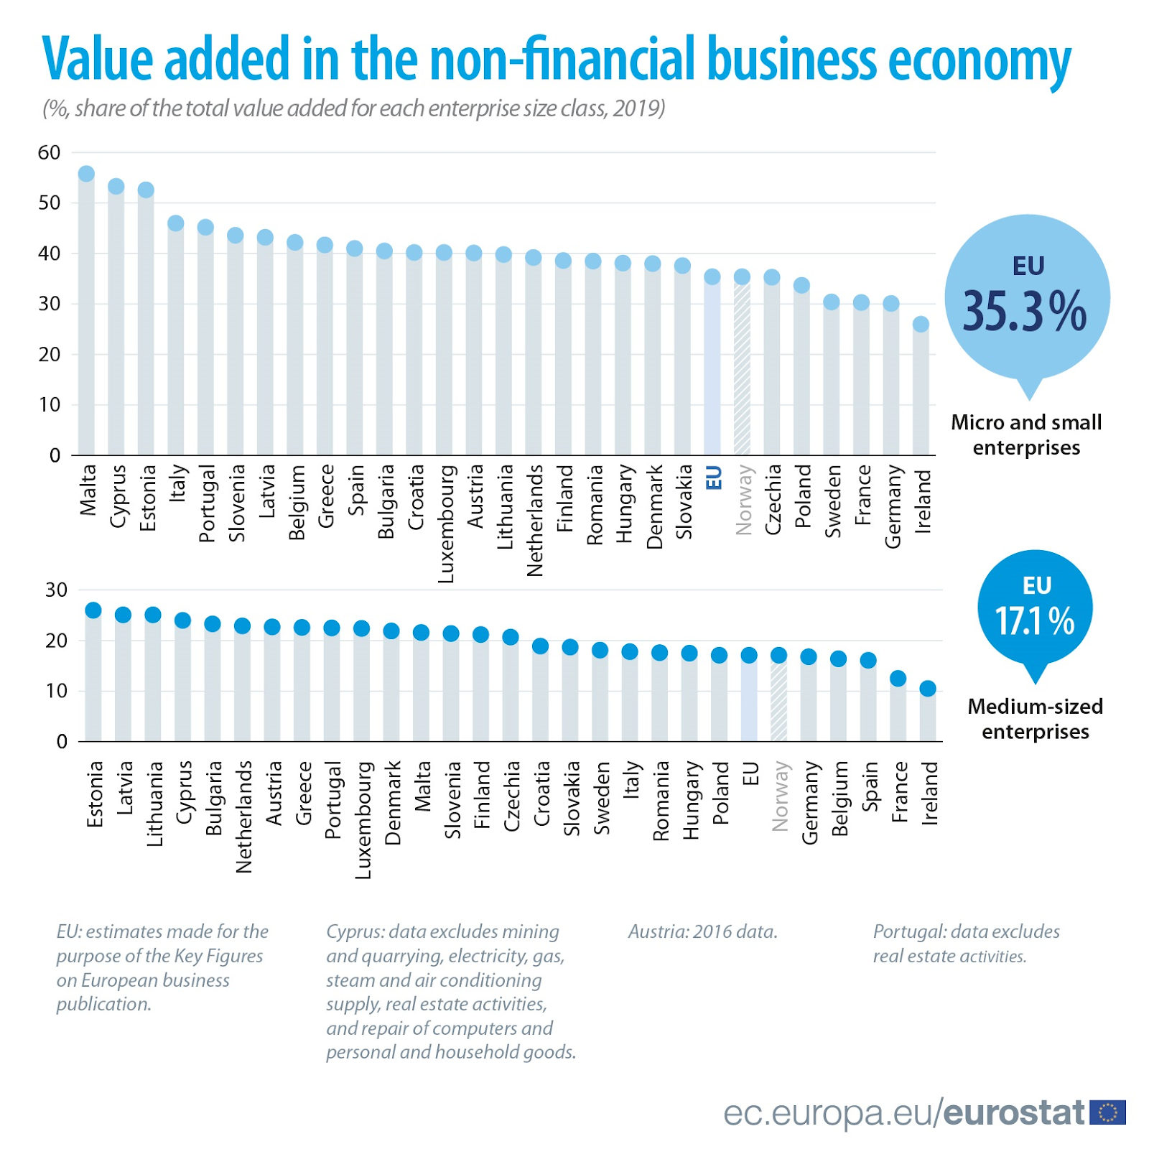
Statistics of small and medium-sized enterprises by EU countries [18]. Interestingly, the largest and most industrialized country of the European Union - Germany - has just about the smallest number of microenterprises
Small owners, accounting for about 25 million of the EU's 200 million working people, form a minority. The majority of workers in the European Union are wage earners — proletarians.
It should be noted, however, that not all wage earners align with proletarian class interests. Highly paid employees and top managers often have closer ideological and material ties to the bourgeoisie, than to the proletariat, even though they formally belong to the working class.
A special position is occupied by police and special services employees who are close to the stratum of employees. Despite their status as hired workers, they are the main instrument for maintaining the dictatorship of the bourgeoisie. Due to their functions and material status, police and special services employees are closer to the bourgeoisie.
Of course, among those who, in their service, defend the bourgeois order with weapons in hand, there are relatively few ideological defenders of capitalism. Such ideological defenders are generated en masse by the environment of the so-called "labor aristocracy".
After all, we know from history that the roots of social chauvinism and opportunism in European social democracy during the First World War came from this very stratum of the so-called “labor aristocracy”.
Can we say that the majority of workers in the EU are simply "bribed" by high wages? This question, though may sound naive, is crucial to understanding the class struggle and the role of workers’ parties in Europe.
Let us now examine the income levels of the European working class.

3.3 Working-class incomes
Let's examine the incomes of EU workers, using the example of the EU's most populous country, Germany.
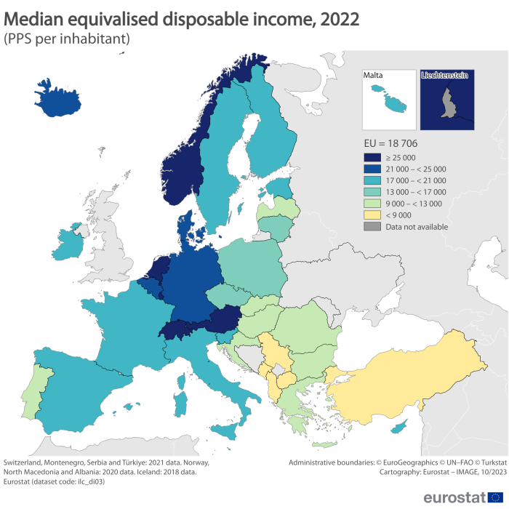
Median annual salaries in the European Union by country, 2022 [19]. Due to inflation, by 2023, salaries increased significantly, but the real income of citizens still fell — prices rose faster than salaries
The average annual salary in Germany in 2023 was 37.3 thousand euros (after taxes). The minimum salary was 24.6 thousand. A salary of 70-80 thousand is considered comfortable [21]. At the same time, only 15% of citizens earn more than 70 thousand euros gross (i.e., before taxes) annually, and 1% earn more than 250 thousand euros [22].
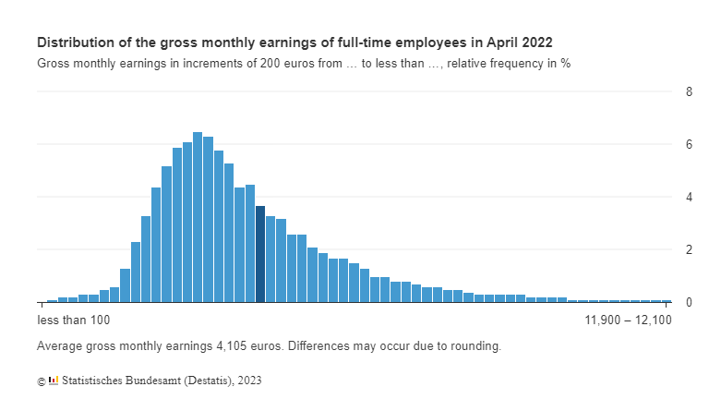
Distribution of monthly wages in Germany as a percentage of the population [20]. The average wage is highlighted. Notably,a large majority of the population earns less than the average wage.
The population with high wages in Germany is relatively small.
In most European countries overall, there has been a steady downward trend in living standards in recent years, although they remain high compared to other countries.
Thus, in 2023, the real incomes of citizens declined in nearly all EU countries due to inflation and despite the growth of corporate profits. In Germany, real incomes fell by 1.3% while corporate profits grew by 1%; in Italy, incomes fell by 2.3% while profits grew by 1.3%; in the Czech Republic, 4.6% and 5.4%, respectively; in France - 0.2% and 1.4%; and so on.
On average, EU citizens' real incomes fell by 0.2% in 2023, while profits rose by 1.9% [22]. What else is this but evidence of irreconcilable class contradictions?
So far, we have been talking about the income gap between groups of wage earners. Now let us find out the size of the gap between the two classes: the proletariat and the bourgeoisie.
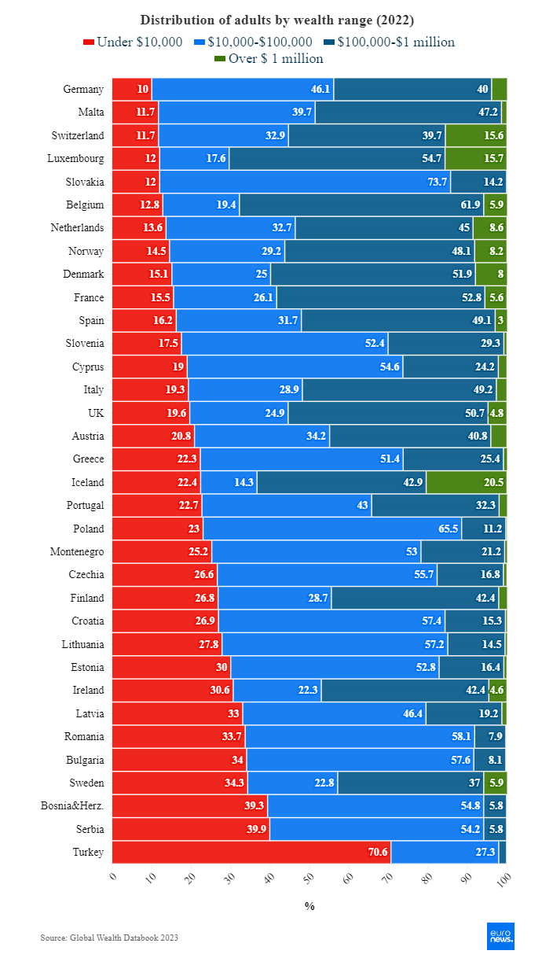
Income distribution among European citizens by country [23]
If we look at not only wage levels but also at property and capital ownership in general, the difference in living standards among Europeans appears to be much greater:
“The richest 10% of people on the continent own a staggering 67% of all wealth, while the poorest half of the adult population owns only 1.2% of that wealth
...
Net wealth — or 'wealth' — is defined as the value of financial assets plus the real property (mostly housing) that households own, minus their debts.” [24].
Half of Europe's population possesses only one-hundredth of the total wealth created with their own labour. If the EU, as part of Europe, is a garden, only a handful of oligarchs thrive in it.
The dominance of big capital and its owners is demonstrated by the monopolization of the European economy: only the 500 largest companies on the Fortune 500 Europe list generate 57% of Europe's GDP [25]. This list includes not only EU countries but also companies from Britain (Shell, BP, etc.) and even two Russian companies (Gazprom and FosAgro).
These monopolies are managed by a small group of individuals to whom the entire economy of the European continent in general, and especially the European Union in particular, is subordinate. To illustrate this point, let's turn our attention to Volkswagen, the leading company among EU corporations.
The company recently announced that it intends to terminate a decades-old agreement with workers that guaranteed job security at six of its plants as part of a 10 billion euro cost-cutting plan [26].
The measure sparked thousands of protests by workers at Volkswagen facilities.
Meanwhile, the Porsche and Piech families, which own the largest stake in Volkswagen, remain financially secure. The 50-member Porsche family has a fortune of $55 billion, and the head of the Piech family, Ferdinand Piech, transferred his administrative and financial affairs to 14 family members before his death in 2019. Among other things, he transferred his voting shares in the Porsche holding company to his 77-year-old brother Michel Piech, valued at €1.1 billion.
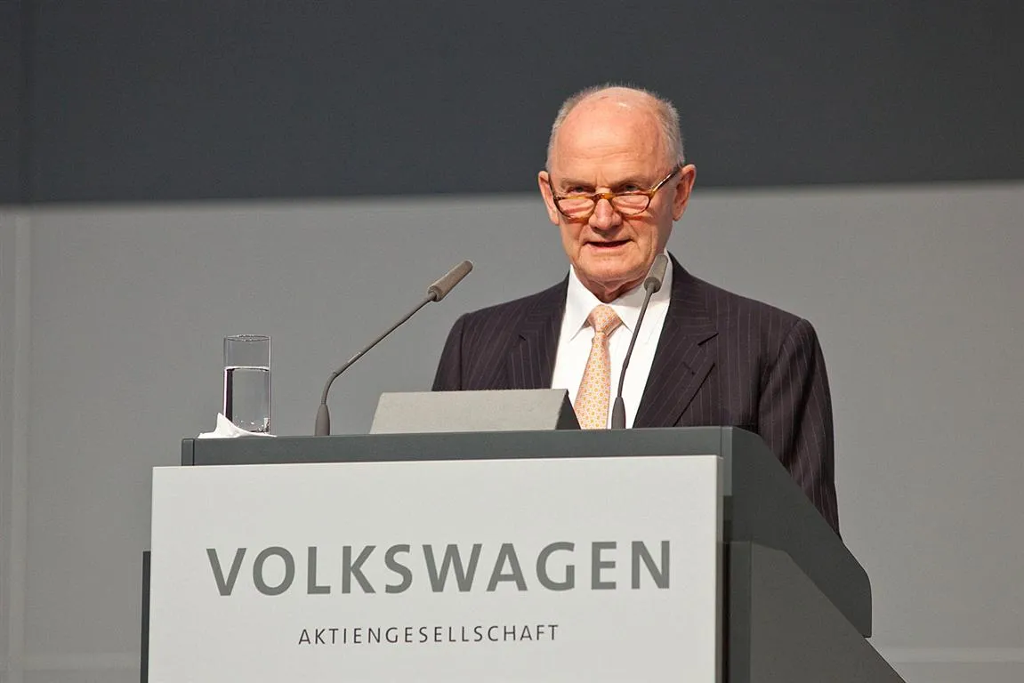
Ferdinand Piëch
More distant relatives were also not excluded:
...many fourth-generation relatives have already taken over his responsibilities and hold key positions on the supervisory boards of VW, Audi, Skoda, and other companies. [27]
Literally just a few families own the automotive industry of the entire European Union.
In general, the EU is a safe haven for oligarchs:
The EU has less than 6% of the world's population, and is home to 15% of the world's billionaires and 16% of the world's billionaire wealth. Since 2020, billionaires in the EU have increased their accumulated wealth by one-third, reaching €1.9 trillion last year. [28]
At the same time, all the wealth owned by these few thousand oligarchs has been created by workers. Hundreds of billions in profits are the product of workers' labor.
The only source of profit for any capitalist is the unpaid labor of the workers. The workers of the productive sphere create new value, part of which is taken by the capitalist who owns the means of production. Then, through the exploitation of the workers in the non-material sphere of production, this value ends up in the pockets of the mercantile and banking capitalists. In the current epoch of imperialism, the capitals are so intertwined that there is no such thing as "pure" commercial, industrial, or any other capital — they are all merged into a single, financial capital, which easily adapts laws, public services, culture, ideology, etc., with a single primary unifying goal: to leave the current state of class relations unchanged.
The objective interest of the working class is to get rid of the capitalist class, which appropriates all that the proletariat has created.
This raises a crucial question: is the working class actively fighting to change its oppressed position? And what form should this struggle take?

IV. Is the working class of Europe fighting for socialism?
We have established that the working class in Europe has not disappeared. The vast majority of workers in Europe are wage laborers, while the petty bourgeoisie makes up a minority of society as a whole.
The incomes of the working class are, for the most part, significantly below the commonly accepted thresholds for a "comfortable standard of living." The disparity in living standards between capitalists and workers has not been eliminated. The fabulously wealthy oligarchs of Europe keep getting wealthier, even as the living standards of ordinary Europeans decline.
This raises a pertinent question: why is there no organized class struggle in Europe aimed at abolishing capitalism? Why are European communist parties so weak, and why do they lack support among the masses?
Today, as in the rest of the world, the communist movement in Europe is in crisis: communists are neither organized in parties nor represent a mass movement, and they engage in minimal theoretical work. Only a shadow remains of the former strength of the 20th-century communists.
Why are there no mass communist parties in Europe or globally?
Often, the answer to this question is to point out the weakness of the spontaneous workers' movement: as long as it is weak, there will be no strong communist parties. An example of this view is given by Alexander Batov of the "Russian Labor Front”:
"As for the Russian left movement, it is weak and fragmented. In my opinion, this is fair: if the labor movement is weak, then the communists cannot have mass support." [29].
Although Batov's quote refers to Russia, the communists in Europe are in a similar state of crisis. Therefore, a similar question inevitably arises concerning them: could the reason for the weakness of the communists in European countries be the weak labor movement?
Let's try to estimate the extent of the labor movement in Europe and trace the connection between it and the communist parties.

4.1 Characteristics of European Trade Union Struggles
Currently, the European Trade Union Confederation (ETUC) represents the interests of approximately 45 million workers across Europe, comprising 94 trade union organizations in 42 European countries, as well as 10 European trade union federations [30].
Contrary to perceptions of weakness, these trade unions — and European workers' organizations in general — have demonstrated considerable strength, especially in light of recent strikes involving farmers, railway workers, healthcare workers, and many others across Europe. According to data from 2020-2021, France had the highest average annual number of workdays lost to strikes (79 days), followed by Belgium (57 days), Norway (50 days), and Denmark and Finland (49 days each) [31].
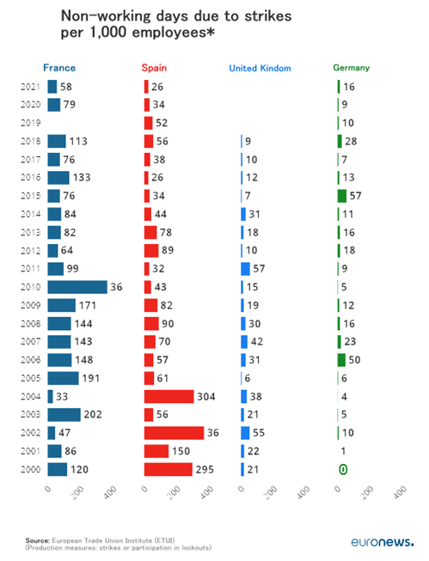
Statistics on the number of days spent on strikes per 1,000 workers [31]
The three most common reasons for strikes in 2023 were wages, working conditions, and workload [32]. Notably, in many European countries with a high standard of living, there is also a high strike activity.
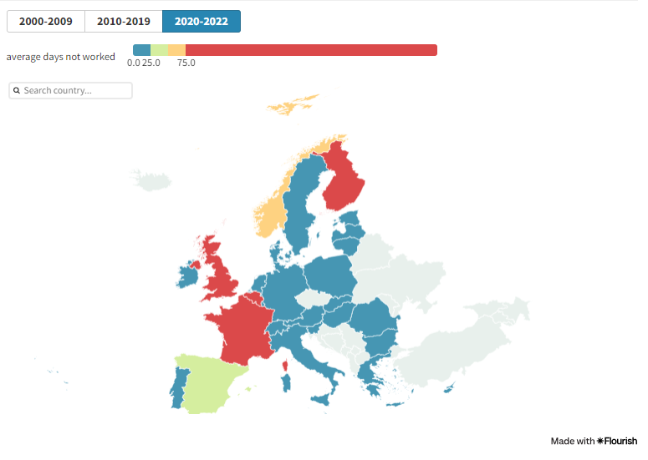
Strike activity in European countries during the period of 2020-2022 [32]
The high standard of living in Europe is gradually declining due to rising prices, inflation, and cuts in social benefits:
Labor disputes arose even in countries with historically low levels of strikes, such as Austria, Ireland, and Luxembourg. In Austria, a week of protests took place in May demanding limits on food, energy, and housing prices, and in September, a large demonstration organized by the Austrian Trade Union Confederation (ÖGB) was held under the slogan "Down with prices, let’s have wages." In Luxembourg, a country where strikes are rare, two strikes in the education, healthcare, and social services sectors, as well as in transportation (air, road, and rail), in 2023 impacted the entire country, leading to calls for the government to intervene as a mediator in one of them. In Ireland, where strikes are infrequent due to the industrial climate, two notable strikes occurred in 2023 related to insufficient government funding and low wages for workers. [31]
The scaling back of social welfare systems, which were once the hallmark of many European countries, is a logical and inevitable process. We have dedicated a separate piece to the study of this topic.
We see that European workers feel the encroachment of capital on their rights and are ready to defend them in an organized way. They are well organized in the unions and coordinate strikes, including nationwide ones.
However, these actions, despite small individual victories, do not stop the process as a whole. Recently, a wave of pension reforms swept across Europe, raising the retirement age. Despite strikes, jobs are still being cut and factories closed. The European labor movement cannot stop either the transfer of capital to other countries or the process of cutting social services.
Ultimately, the European trade unions, like most trade union confederations elsewhere in the world, are bound to collude with the authorities sooner or later.
For example, Luca Visentini, the former General Secretary of the ETUC, called for cooperation among governments, employers, and workers in almost every speech:
We urge governments to develop national anti-crisis support measures to protect incomes and jobs in industry, the service sector, and the public sector. [33]
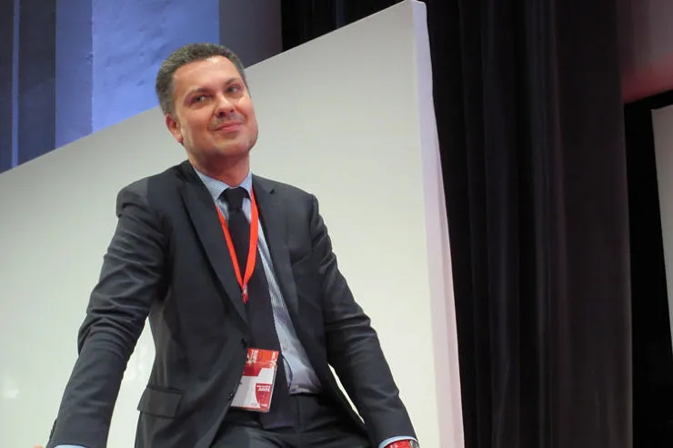
Luca Visentini
However, in December 2022, shortly after being elected as the General Secretary of the International Trade Union Confederation (ITUC), Visentini was arrested and removed from his position alongside several Members of the European Parliament for accepting bribes from Qatar’s ruling elite.
The current head of the European Trade Union Confederation (ETUC), Esther Lynch, expresses a similar sentiment:
I am convinced that trade unions and collective bargaining are the best way for workers to improve their lives, and that by working together, we can engage politicians and employers in creating a fairer Europe for workers. [34]
If the leadership of European trade unions so persistently calls for class solidarity, it is not surprising that European workers' protests are always focused on economic struggles and very rarely on political ones. Even when workers are urged to make political demands, it is exclusively within the framework of bourgeois politics.
For example, the trade unions in Spain, particularly UGT and CCOO, actively support the current government led by Prime Minister Pedro Sánchez [35]. Can this government be called working-class or socialist? Let's take a look at its achievements.
The "leftist" government of Spain, formed in 2020, is no different from any other European government:
- It lacks internal unity and is a coalition of different forces: the broad-leafed alliance "Together We Can," formed by the Podemos party, and the Spanish Socialist Workers' Party (PSOE). These two forces struggled for a long time to agree on cooperation, and even now, their only commonality is the shared opportunity to remain in power. There is no talk of any ideological unity.
- Within the framework of political conjuncture, the Spanish government has supported the Ukrainian army with $300 million in arms and is also training Ukrainian soldiers — despite numerous internal problems of its own.
- The standard of living for workers in Spain has not changed: unemployment remains high at 12% [37] (compared to an average of 6% in the EU). At the same time, Spain continues to gradually raise the retirement age — by 2024, it will have increased to 66 years and 6 months, and the required work experience for receiving a full pension has risen to 38 years [38].
- The Spanish government does not even formally aim for a transition to socialism.
Finally, under the "leftist" government, there are 1.1 million dollar millionaires [39] and 29 billionaires in Spain [40]. In comparison, in Russia, a country well known for its oligarchs and wealth inequality, with a population three times larger than that of Spain, there are three times fewer dollar millionaires — only 350,000 [39].
At the same time, 13 million ordinary Spaniards — one-quarter of the country's population — live on the brink of poverty [41].
The leftist government is incapable of bringing about a qualitative, fundamental change in the situation because the bourgeoisie remains the ruling class.
Most of the other European left political parties operate in the same way, using the workers for their immediate political goals.

4.2 Why are there no strong communist parties in Europe?
We see that the European labor movement is a large and well-organized force.
But a trade union in itself is not a political organization. The task of a trade union is the economic struggle of workers against capitalists for better conditions in selling labor power. This struggle, on its own, does not mean that the workers have adopted communist positions.
This is how V.I. Lenin addresses this issue in his work "What Is to Be Done?":
"We have said that there could not have been Social-Democratic [i.e. Communist – PS] consciousness among the workers. It would have to be brought to them from without. The history of all countries shows that the working class, exclusively by its own effort, is able to develop only trade union consciousness, i.e., the conviction that it is necessary to combine in unions, fight the employers, and strive to compel the government to pass necessary labour legislation, etc." [42]
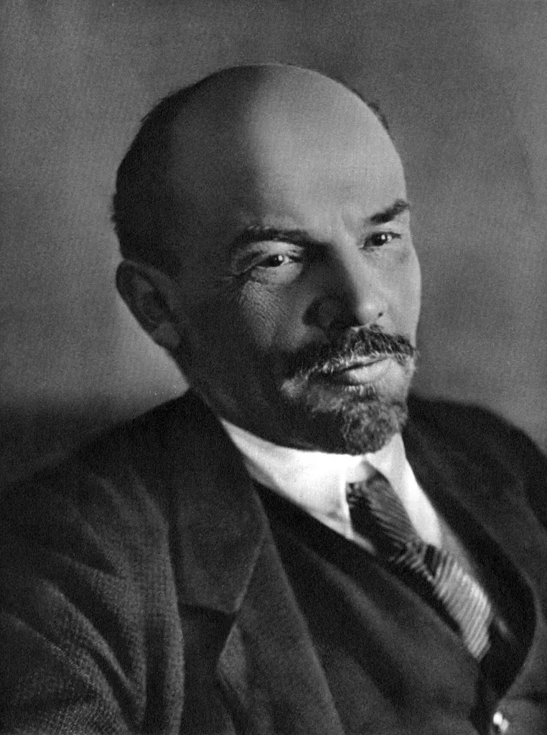
This is precisely the situation we observe in Europe: the labor movement has strong, ramified trade union structures that coordinate the economic struggle. Politically, this struggle is limited to the demands of the day in the spirit of opportunism and trade unionism.
The interests of such a workers' movement are expressed by the social democrats and their similar movements: the Labour Party in the UK, "Die Linke" in Germany, Mélenchon's "La France Insoumise", and the aforementioned socialist parties in Spain, among others. The representatives of these parties control, above all, the trade union structures.
These parties engage in opportunism, turn the workers into an instrument of bourgeois politics, and fail to address their fundamental problems and tasks as a revolutionary class.
In general, due to the crisis of the communist movement, the labor movement in European countries is largely dominated by social democrats, broad leftists, liberals, and even the right.
Formally, they all claim to protect workers' rights and defend their interests under various slogans. Occasionally, measures are still taken to improve living conditions and meet workers' immediate demands. Often this happens at the end of a term, before new elections. But such a policy is no different from the usual policy of the bourgeois authorities.
As experience shows, protests organized by the trade unions are not enough to improve their lives. Even legislative reforms and representation in parliament are not enough.
All these measures are meaningless if they are not subordinated to one goal – the establishment of a socialist system. All European mass-left organizations have long since abandoned this goal. A reformist engaging in a parliamentary game of politics has no need for an organization of communists. In fact, such an organization would be detrimental to their cause, tarnishing their image of "respectable parliamentarians".
The workers need a political organization, but not one that turns them into a simple electorate for the bourgeoisie. We need a communist party – a vanguard party that will lead the working class in a struggle both to solve everyday problems and to destroy capitalism as a whole, i.e., the system that causes these problems.
The ultimate answer to these problems is impossible without solving the problem of capitalism.
Such parties do not arise of their own accord. Communist political consciousness does not arise on its own in the masses; it must be brought into the already existing workers' movement as it requires a scientific study into the social relations in which we exist.
Is this happening in Europe? Of course, they are trying. In almost every country there are several "communist," "workers," "revolutionary," etc., parties.
But these organizations are parties in name only. Many of them are remnants of the communist movement during the Cold War. These structures are characterized by vague theoretical positions, extreme formalism in work, opportunist actions, and adaptation to the interests of one or another imperialist bloc. With a few exceptions, they have no influence among European workers.
We see that a strong working-class movement alone does not create communist parties. This process was examined in detail by Lenin in his work "What Is To Be Done?" and his analysis remains relevant today.

4.3 What should communists do?
Despite the existence of a strong, organized labor movement in Europe, the European communists remain weak. How can this situation be rectified?
1. It is necessary to work on creating their own organizations. A spontaneous workers' movement is not a condition for the creation of real communist organizations.
On the contrary, at the beginning of the upsurge of the workers' struggle, the communists must have their own organization, armed with modern Marxist-Leninist theory and with a core of experienced and reliable communists. The tactic of waiting for the rise of the workers is nothing more than an attempt to justify one's own opportunism, and unwillingness and inability to engage in organizational work. It is simply a refusal to work.
The absence of organizational work in periods between upsurges in the workers' movement can only be explained by a subjective factor, the unwillingness of the left to engage in such work.
But only such work makes it possible to educate the workers to a communist understanding of the class struggle and their interests in it, to awaken their class consciousness.
No party has ever been built "automatically," by itself. It is precisely subjective factors – ideological and organizational principles – that lead to splits and further extinction of all kinds of communist organizations. No upsurge of the labor movement will help these organizations.
2. A clear ideological platform is necessary for successful organizational work and the creation of a communist party.
Communists must raise the consciousness of the working class to their level, not follow the spontaneous labor movement.
There is no need to portray workers as people who are supposedly not ready for communist theory. This idea is essentially an indulgence in bourgeois delusions and prejudices imposed on the workers by the ruling class.
Aforementioned Alexander Batov, speaking about his organization "Russian Labor Front," even manages to boast that he indulges the misconceptions of the working class about communism:
By abandoning the "red" uniform, the RTF more effectively conveys class content to those workers who still do not understand communist ideas or have some prejudices about them. [44]
It is impossible to build a party without educating conscious communists. The concept that presupposes the development of an abstract workers' movement in the hope that in some indefinite future, the workers will "mature" for communist work is opportunist. Its ineffectiveness was demonstrated more than 100 years ago, during the period of Lenin and the Bolsheviks.
Let the real communist parties be in the minority for now, let them not yet unite the entire working class under their banners. This is not necessary. The main thing is to begin real communist work.
The working class exists and will exist as long as the capitalist system exists. The task of the communists is to continue to expose and explain the class contradictions, to resolutely oppose the disagreements, vacillations, and various deviations in the workers' movement, to strengthen the class consciousness, and to organize the workers not only in the workers' movement but also in the communist movement.
3. The current main task of communists in each country is the organizational work of creating their own party.
We are already participating in this long but necessary process. Join us in this work, and become a member of Politsturm.

Sources
[1] RIA Novosti — Borrell compared the world surrounding Europe to jungles. — October 13, 2022.
[2] Bell Daniel. The Coming of Post-Industrial Society A Venture in Social Forecasting / Translated from English. 2nd ed., revised and expanded. — Moscow: Academia, 2004. — pp. 161-162.
[3] Wallerstein Immanuel. World-Systems Analysis: An Introduction / trans. N. Tyukina. Moscow: Publishing House "Territory of the Future," 2006. (Series "University Library of Alexander Pogorelski") — P. 186.
[4] The Theory of Chairman Mao Zedong on the Division of the Three Worlds — a significant contribution to Marxism-Leninism. Editorial of the newspaper "Renmin Ribao" (November 1, 1977). Beijing, Foreign Languages Press, 1977 — P. 4
[5] Boyarkina, A. V. Foreign Policy Concepts of the PRC: Theoretical Design and Practical Implementation: Monograph / A. V. Boyarkina, scientific editor V. F. Pecheritsa; Far Eastern Federal University. — Vladivostok: Publishing House of the Far Eastern Federal University, 2023. — pp. 55-56
[6] Lenin V. I. A Great Beginning // Collected Works. — 5th ed. — Moscow: Publishing House of Political Literature, 1970. — Vol. 39. — P. 15.
[7] Rutube channel “Leningrad Internet Television” — “#3 | What is the Proletariat? Popov's Dictionary”
[8] K. Marx. Capital. A Critique of Political Economy Volume One. — State Publishing House of Political Literature, 1952. — P. 512
[9] K. Marx and F. Engels. To the International Congress of Socialist Students // Collected Works. — 2nd ed. — Moscow: Publishing House of Political Literature, 1962. — Vol. 22 — P. 432.
[10] Intelligentsia // Great Soviet Encyclopedia: [in 30 volumes] / chief editor A. M. Prokhorov. — 2nd ed. — Moscow: Soviet Encyclopedia, 1953. — Vol. 18 — P. 270.
[11] Eurostat — Population projections in the EU — March, 2023.
[12] Eurostat — Employment - annual statistics — April, 2024.
[13] Statista — Number of employees in the European Union (EU27) from 1st quarter 2009 to 1st quarter 2023
[14] Statista — Number of employees in the European Union in quarter 1 of 2023, by sector
[15] Eurostat — Employment and labour demand — September, 2016.
[16] Trading Economics —European Union - Employed Population
[17] Statista — SMEs in Europe - Statistics & Facts — September 23, 2024.
[18] Eurostat — EU small and medium-sized enterprises: an overview — June 27, 2022.
[19] Eurostat — Living conditions in Europe - income distribution and income inequality — October, 2023.
[20] WeAreDevelopers — Average Salary in Germany — June 12, 2023.
[21] GermanPedia — Income Distribution in Germany [2024] — August 24, 2024.
[22] ETUC — Real wages falling despite inflation-busting profits — November 15, 2023.
[23] Euronews — Wealth of nations: Gap between rich and poor in Europe widens — June 4, 2024.
[24] Euronews — Mind the Gap! The unfair distribution of wealth in Europe — April 1, 2024.
[25] Fortune — Fortune 500 Europe
[26] Deutsche Welle — Volkswagen clashes with workers over cuts — April 9, 2024.
[27] The German Times — Before passing away, Ferdinand Piëch exhorted his heirs to keep the Porsche-Volkswagen Group intact — October, 2019.
[28] EUreprter — European Union - Employed Population The wealth of the five richest people in the EU has been increasing by nearly €2020 million every hour since 2006 — January 14, 2024.
[29] Pelo Anti-Imperialismo — Interview of Loukianos Stathopoulos to Alexander Batov of the Russian Labor Front — January 3, 2024.
[30] ETUC — National Trade Union Confederations (list of member organisations
[31] Euronews — Which countries have the most strikes in Europe and what impact does it have on the economy? — March 7, 2024.
[32] Eurofound — Labour disputes across Europe in 2023: Ongoing struggle for higher wages as cost of living rises — July 29, 2024.
[33] ETUC — Tripartite Social Summit for Growth and Employment - Trade Union Speeches — October 19, 2022.
[34] ETUC — New European trade union leader to prioritise pay rises and solidarity — December 8, 2022.
[35] IndusrtriAll — Why unions must resist the far right in Spain and elsewhere — July 17, 2023.
[36] TASS — Spain provided military aid to Ukraine amounting to €300 million — January 17, 2023.
[37] Trading Economics — Spain - Unemployment Rate
[38] 1prof.by — How many years do you need to work in Spain to receive a pension? — January 9, 2024.
[39] Data Pandas — Millionaires By Country
[40] World population review — Billionaires by Country 2024
[41] Últimas Noticias — They calculate that there are 13,1 million Spaniards at risk of poverty — October 25, 2022.
[42] Lenin V. I. What Is to Be Done? // Collected Works. — 5th ed. — Moscow: Publishing House of Political Literature, 1963. — Vol. 6. — P. 30.
[43] Batov — Russian Labor Front

Original article

