Disney World Workers Win $15 Minimum Wage Starting in 2021
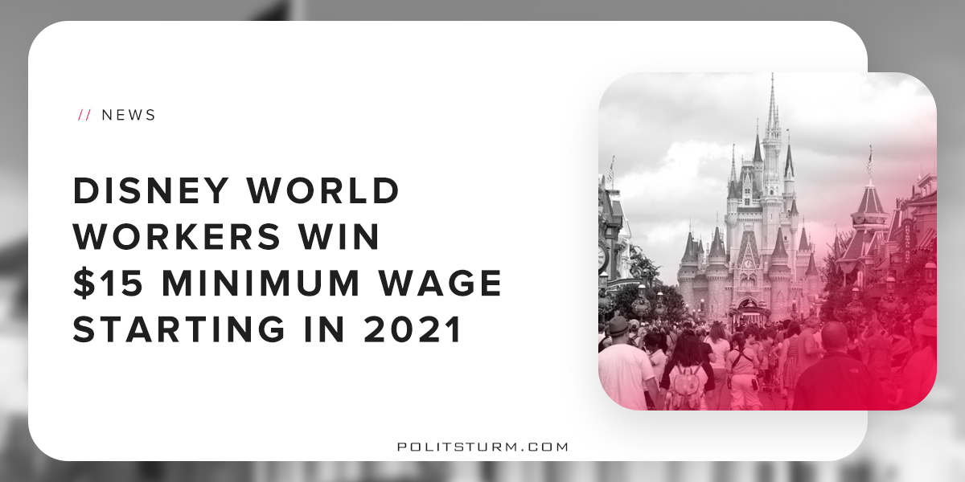

Original article
2018-09-03
1 min read

Walt Disney World workers in Florida reached a tentative deal that would raise the starting pay to $15 by 2021. The deal would also retroactively increase the pay for all hours worked since September 21st, 2017 by $0.50 per hour or by 3%, whichever is greater.
The minimum pay at Disney World is going to increase incrementally for all workers. Every year up until 2021 workers will have a $1 per hour increase in hourly wages. This will represent a 50% increase in wages by 2021 for these workers.
The deal was significantly better than what was initially proposed by Disney. Disney had proposed a 2.5% pay increase and to freeze starting pay for new hires at $10. The Services Trade Council Union, which represents more than 38,000 workers, achieved a much better deal than what was initially proposed.
After the massive corporate tax cut earlier this year, DIsney stated that it was giving employees a $1,000 bonus. It would not, however, give unionized employees this bonus while contract negotiations were still ongoing. The union filed a grievance with the National Labor Relations Board (NLRB) , which unsurprisingly sided with Disney over the workers.
The logical explanation as to why this is the case is rooted in the class nature of the government. The role of bourgeois government is to create and enforce the laws necessary to protect the capitalist class. The National Labor Relations Board, as an “independent” agency of the US government, will always side with capital over labor. This is the essence of the dictatorship of the bourgeoisie.
Despite the adversity and overwhelming odds this victory for the Disney workers shows that a unified working class can achieve tangible concessions from the capitalist class. However, only a government that represents the class interests of the workers will provide safety, security, and well-being to the working class in the long run.
https://www.nytimes.com/2018/08/25/business/disney-world-minimum-wage-union.html
http://www.orlandosentinel.com/business/tourism/os-bz-disney-unions-start-20170828-story.html
http://www.local385.org
https://www.wsbradio.com/news/national/disney-unions-representing-000-workers-reach-deal-raise-starting-pay-2021/xylMOUmYFLzMHsj54ksxpM/

Original article

