Disney Announces 32,000 Employee Layoffs
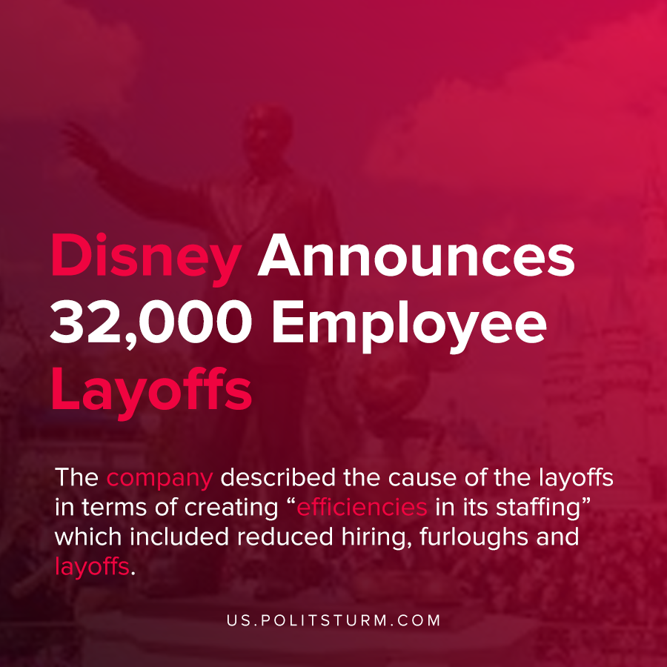

Original article
2020-11-27
1 min read

Disney previously announced that it would be laying off 28,000 workers as a result of the COVID-19 pandemic. In a recent 10-K filing, the company announced that it will be increasing the number of layoffs to approximately 32,000 workers by the first half of fiscal 2021.
Disney’s “Parks and Experiences” segment has been hit particularly hard by the coronavirus pandemic which has closed theme parks or reduced capacity for much of the year. As a result, Disney’s revenues have been negatively impacted and the company has gone on to reduce expenses on labor.
The company described the cause of the layoffs in terms of creating “efficiencies in its staffing” which included reduced hiring, furloughs and layoffs.
The capitalist economic system and the private ownership of the means of production necessitates that corporate executives maximize profits, regardless of the impact on workers or the larger society. Workers will lose their livelihoods in order to generate profits for a small number of oligarchs, the major shareholders.
The anarchic, unplanned nature of capitalist production creates recurrent instability and precarity for the workers. Only under a planned, socialist economy will society be able to eliminate unemployment and provide workers with stability and security.
Source: 1

Original article

