Deutsche Bank Wants to Tax Stay-At-Home Workers 5%
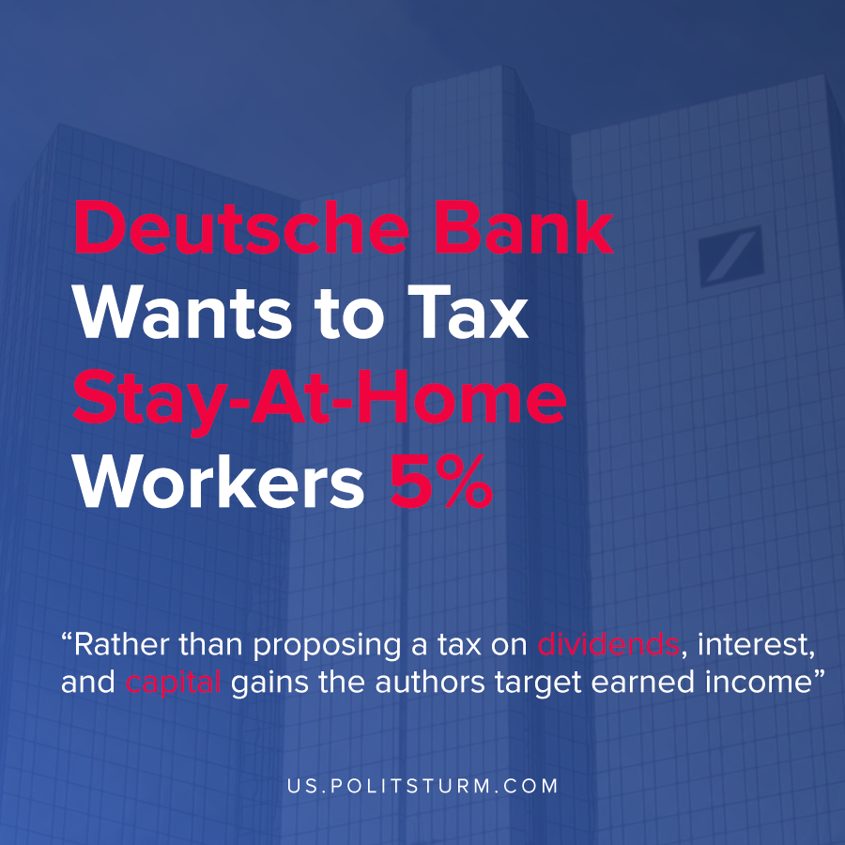

Original article
2020-11-14
1 min read

New research from Deutsche Bank entitled “What We Must Do To Rebuild” made a suggestion on how to recover from the economic crisis and coronavirus pandemic. The prescription for economic revival included a tax on stay-at-home workers which was suggested at 5% of the worker’s income.
In the editorial accompanying the research, Global Head of Fundamental Credit Strategy and Thematic Research Jim Reid detailed the precarious state of global capitalism.
“Democratic capitalism is under threat as increasing numbers of young people view the system as rigged against them. The pandemic has only exacerbated their economic disadvantage”, said Reid.
One of the solutions presented to mitigate this threat, according to the authors, is to tax stay-at-home workers 5%. The idea behind the tax is to redistribute wealth from the higher paid workers to lower paid workers through a tax on working from home.
To justify this position, the authors state that stay at home workers have reduced expenses such as commuting and socialization expenses and therefore they will not be worse off.
In reality, the proposed taxes are an uncreative attempt for the capitalist class to mitigate the contradictions of the capitalist economic system by targeting the higher paid workers. Rather than proposing a tax on dividends, interest, and capital gains the authors target earned income by a certain segment of the working class. As a result of the crisis, even the higher paid workers of the labor aristocracy are eligible targets for the capitalist class.
Source: 1

Original article

