Honduran Trans Advocate Deported by Biden Murdered in Home Town
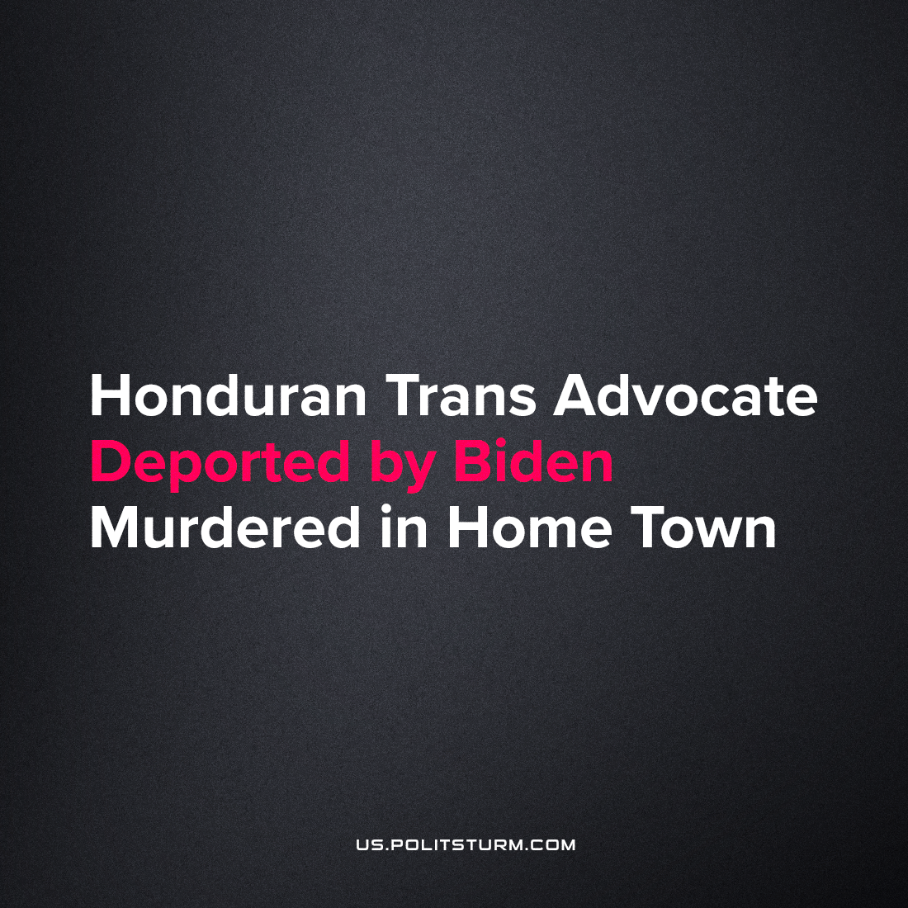

Original article
2022-10-21
2 min read

Trans woman Melissa Núñez was a long-time resident of Miami and citizen of Honduras who was recently deported by the Biden administration despite filing for asylum due to the dangers she faced in Honduras. Núñez was a public figure for the rights of queer sexuality and trans identity, with 20 thousand followers on TikTok where she spoke out on these issues. It has been reported that Núñez was residing in the U.S. for the purpose of seeking gender-affirming medical treatment. After visiting Honduras in late 2021, she returned to the United States but was deported in July of 2022.
On Tuesday night, Oct. 18th, hooded gunmen in a vehicle shot her to death at the entrance to a neighborhood in her home city of Morocelí. She had planned to travel to Puerto Rico, a US territory, in the near future. Honduran authorities are calling the drive-by murder a ‘personal dispute’.
Honduras has the 4th highest national murder rate in the world, largely due to the US puppet regime installed in a coup d’etat in 2009. This regime in Honduras has seen the mass killing and exodus of endless Hondurans, ejecting them from their lands and homes to find work in slavish conditions in factories in major Honduran cities, in Mexico City, and the US. The terror which US administrations impose on this mass of people fuels the American economy, which is completely reliant on this under-class of labor to feed regular Americans and produce profit through monopoly agro-business sales worldwide.
The current Honduran government recently accepted responsibility for the murder of a trans prostitute by police, which shows the legal outline for the legitimacy of Núñez’s application for U.S. asylum. Biden’s Vice President Harris, who was assigned to ‘border issues’, has publicly recognized the role that rampant anti-trans and homophobic violence has played in pushing the Honduran emigration crisis.
The killing of Nunez typifies Biden’s use of oppressed, particularly trans, people to boost his polling numbers only to throw them away by the tens of thousands when he’s done with them – leading to uncounted murders like this one. We reported previously that Biden has deported more people than his predecessor, Trump. Biden and his associates sickeningly call themselves “left-wing radicals”, amplifying anti-communism and anti-trans fervor by adopting these issues publicly while discretely facilitating the killing of the real subjects of their fake progressiveness.
Source: 1

Original article

