Department of Defense Authorizes $820 Million in Additional Security Assistance for Ukraine
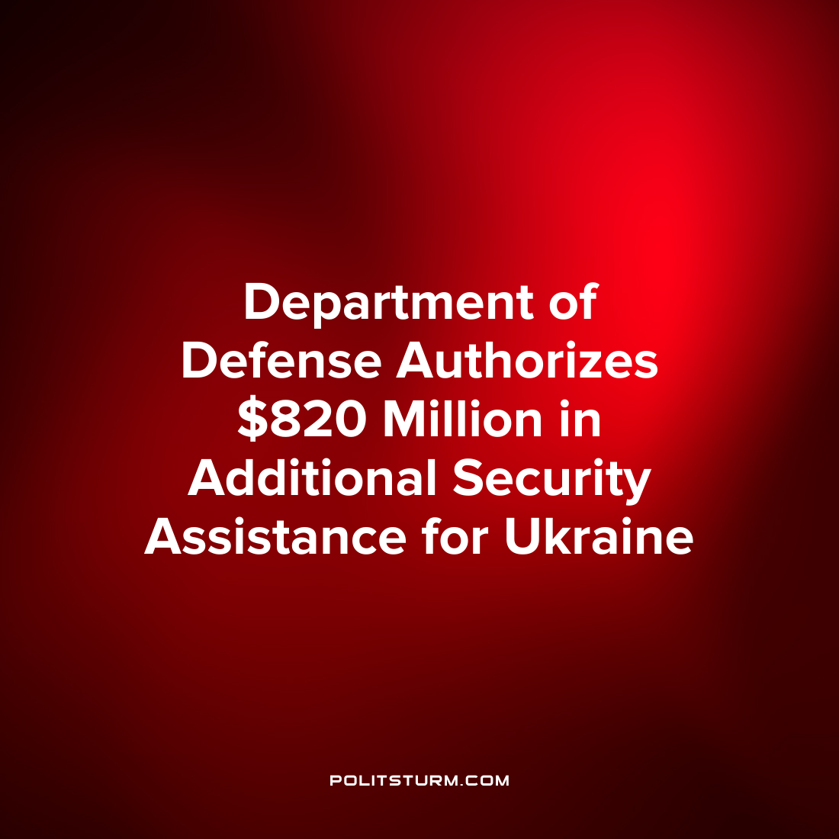

Original article
2022-07-01
1 min read

The U.S. Defense Department announced that it will be providing an additional $820 million in “security assistance for Ukraine. This $820 million includes $50 million through the authorization of a Presidential Drawdown of security assistance and $770 million in Ukraine Security Assistance Initiative (USAI) funds.
The Presidential Drawdown of Security Assistance is the fourteenth authorization to use such funds which are a drawdown on the existing Department of Defense inventories. This provides additional ammunition for high Mobility Artillery Rocket Systems.
Under the Ukraine Security Assistance Initiative Fund the provisions include:
- Two National Advanced Surface-to-Air Missile Systems (NASAMS);
- Up to 150,000 rounds of 155mm artillery ammunition
- Four additional counter-artillery radars.
The USAI does not draw down an existing stockpile but rather is “procures capabilities from industry”. According to the Department of Defense the United States has provided more than $8.8 billion in security assistance to Ukraine.
The defense contractors stand to reap massive profits from the procurement of capabilities from industry. The capitalist class benefits massively from war as the national bourgeoisie of different countries utilize nationalism and chauvinism to pit the workers of different countries against one another for their own material gain. It is necessary to understand Marxism-Leninism to expose the lies of the capitalist class and end the exploitative system of capitalism.
Source: 1

Original article

