Demographic Decline in Russia as Estimated by British Statisticians
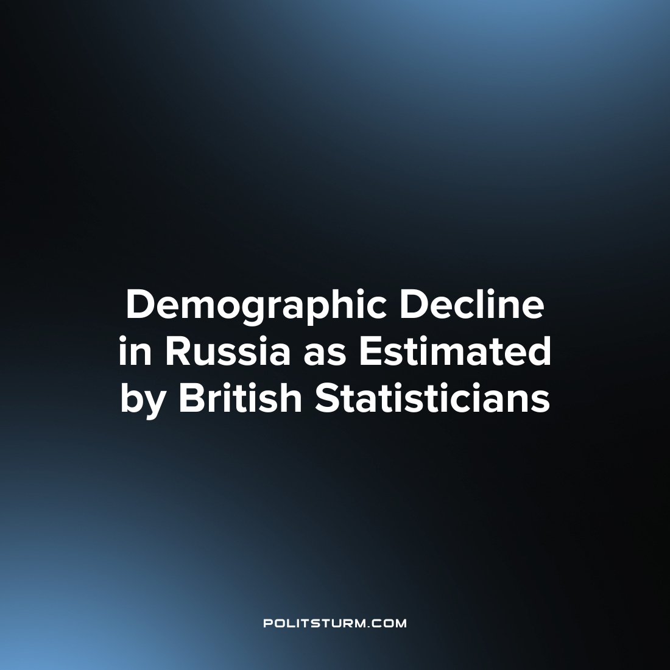

Original article
2023-04-07
2 min read

According to estimates published in the British magazine The Economist, the Russian Federation is facing a real demographic catastrophe. Namely:
- Average life expectancy for men aged 15 and over has fallen to the level of Haiti (to 64.2 years). Considering that the retirement age in the Russian Federation for men is now 65;
- The female population exceeds the male population by 10 million people;
- People in Russia die 6 years earlier than in Bangladesh and 18 years earlier than in Japan;
- In the last 3 years, the country has lost 2 million more people than it used to due to disease, military conflicts and migration.
The demographic decline has been ongoing in Russia for quite some time, but it has accelerated in the past few years. Apart from the demographic consequences of the military conflict, the magazine claims that between 500,000 and 1 million people have left the country since Spring 2022. The loss of so many people in such a short period of time would be very painful for the country as a whole.
The roots of the problems trace back 30 years - in 1994, the country's population peaked at 149 million. Since then, there has been a downward trend. In 2021 there were 147.4 million people, including 2.4 million residents of Crimea. If the trend continues, according to British scientists, in 50 years the population will be 120 million. By then, the Russian Federation will only be among the first 15 countries in terms of population, while in 1995 it was in the top six.
According to Alexei Raksha, a demographer referring to the State Statistics Service, if we look at peacetime statistics, the number of newborns in the Russian Federation in April 2022 was the lowest since the 18th century.
The COVID-19 pandemic had a major impact on the demographic situation. The official death toll from the disease in the Russian Federation is 388,091. However, the magazine estimates the number of deaths between 2020-2023 as 1.2 to 1.6 million. This compares with the figures for countries with larger populations, such as the U.S. and China. Russia, according to estimates by British statisticians, could lose the most from COVID-19 in the world (if India is not included) and could have the highest mortality rate of any country, around 850-1100 deaths per 100,000 people. When all these negative factors are taken into account, it turns out that Russia has lost 1.9 - 2.8 million people in 2020 - 2023 in addition to worsening demographics. This could be even worse than the catastrophe of the 1990s, when the population shrank by half a million a year.
Nicholas Eberstadt, a demographer from Washington DC, argues that the situation in Russia is a specific combination of mortality as in the Third World and education as in the First World. It has one of the highest levels of education in the world among those aged 25+. But the exodus of large numbers of these educated people negates this advantage. According to the Ministry of Communications, 10% of all IT professionals left Russia in 2022. Many of them were young men. Their exodus further reduced the percentage of men in the country's population. As of 2021, there were 121 women for every 100 men over the age of 18.
As we can see, the conclusions and statistics of British and American demographers are quite disappointing. The ruling class in the Russian Federation will do anything to stay in power. Raising the retirement age, shifting the burden in the midst of sanctions and military conflict all fall on the shoulders of the working class. Hence the strong decline in the country's population, especially among men.
Source:
The Economist - "Russia's population nightmare is going to get even worse" 4 March 2023

Original article

