Democrats Use Trump's Personality Cult to Promote Anticommunism
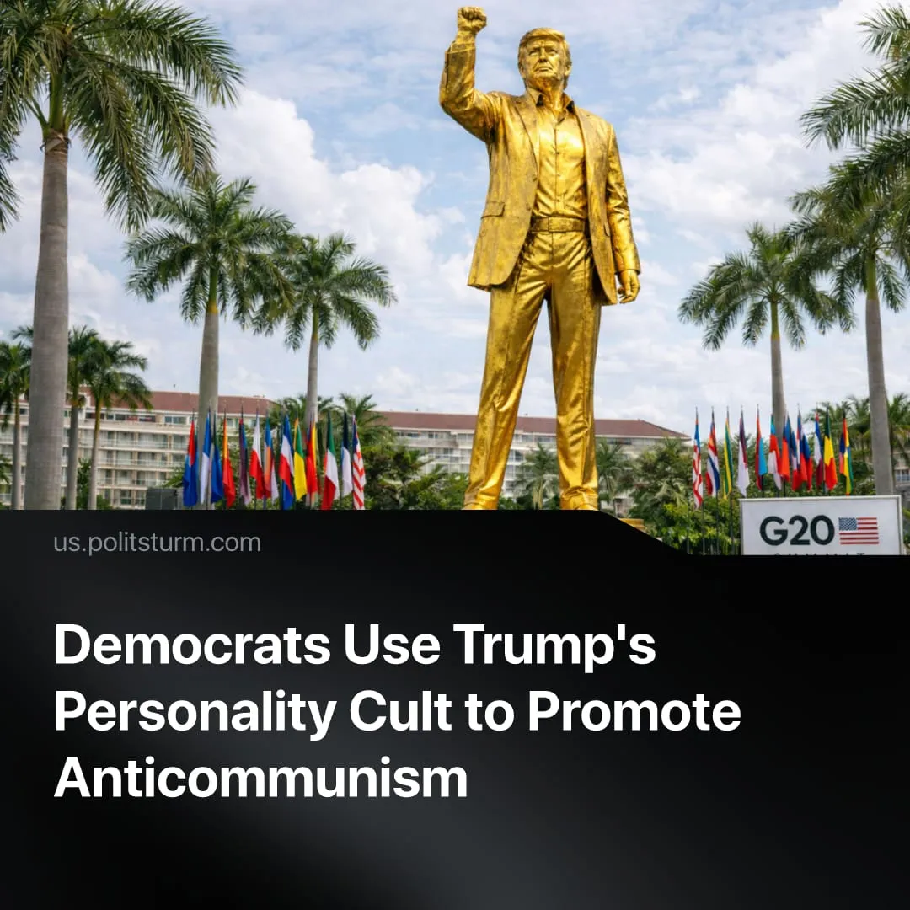

Original article
2026-06-08
2 min read

Trump issues branded passports, orders “Trump-class” battleships and accepts golden statues. Democrats claim this is “Stalinist.”
Details. Democratic leaders have seized on Trump's growing personality cult to score political points. Chuck Schumer declared that democracy "will prevail over cult of personality." Others have made more deliberate anticommunist comparisons. Bernie Sanders accused the Republican Party of "Stalinism", former Obama aide David Axelrod called Trump's cultural policies "Stalinist", while Kamala Harris compared Trump to "communist dictators."
► This rhetoric is political theater in which both capitalist parties exchange accusations of communism to slander each other. Republicans brand Democrats as "radical Marxists" while Democrats call Trump a communist.
► In reality, Stalin openly rejected individual worship. When a publisher attempted to print a biography of his youth, Stalin opposed it, writing that a personality cult of infallible heroes is dangerous. For his 50th birthday in 1929, Stalin redirected all personal praise to the working class party. In an August 1930 letter, he declared that devotion to individuals completely contradicts Bolshevik principles.
► Trump's cult of personality far more closely resembles those of fascist leaders. Mussolini's Ministry of Popular Culture controlled his image across all art and press, while Nazi Germany enforced public display of Hitler's portrait and staged mass spectacles like the Nuremberg Rallies. These regimes had no consistent ideology, instead they relied on the promise that a great man would save the nation from ruin.
Context. Trump's administration is aggressively pushing his likeness onto public life. His image now appears on official passports, national park passes, new dollar coins, and massive banners across federal buildings. The US Navy plans to buy fifteen "Trump-class" battleships by 2055, and allies have launched a campaign to rename the Strait of Hormuz the "Strait of Trump." In May, a spiritual adviser led a ceremony dedicating a 22-foot golden statue of Trump at his Miami golf club.
► The Trump family has also turned his image into a commercial operation, selling branded phones, crypto coins, watches, and sixty-dollar Bibles printed in China.
► Today's far right in America and Europe uses these same personality cult tactics. Reactionaries weaponized a memorial for Charlie Kirk to promote nationalism, while right-wing groups in France turned an extremist into a political martyr. This is part of a broader trend of fascisation across the West.

Original article

