Democrats May Look to Harris to Mirror Trump’s Success
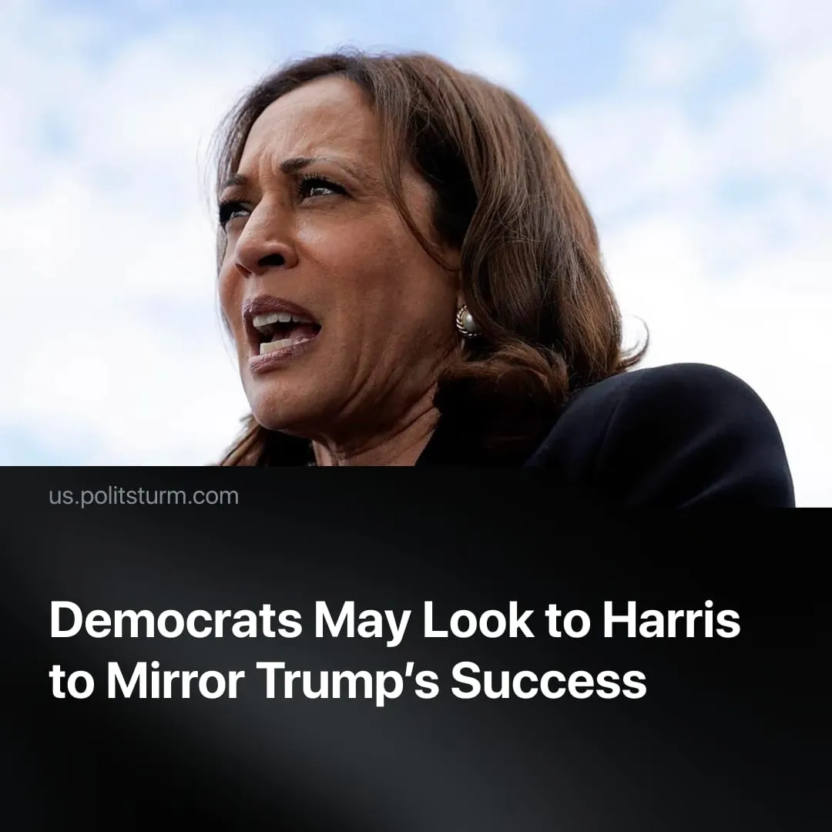

Original article
2025-11-01
2 min read

Kamala Harris's return could be an attempt by Democrats to replicate Trump's success
Details. Kamala Harris recently hinted at running for office again during a Washington press event, saying, “I’m not done.” Her remarks, following months of silence, were seen as a test of public and party reaction to a possible 2028 campaign.
► Around the same time, California Governor Gavin Newsom, in a CNN interview, suggested he might also run if “the party needs leadership.” His statement underscored uncertainty over who will lead the Democrats after Biden.
Context. The Democratic Party remains formally led by Joe Biden, but in practice, it is effectively without an active leader. Biden’s approval ratings are at record lows, and reports of an aggressive cancer diagnosis and a reduced public schedule suggest he is no longer exercising any political leadership.
► Within the Democratic Party, some establishment figures are pushing for closer coordination with “progressive” Sanders and Ocasio‑Cortez. However, moderates and centrists are openly critical. Veteran Democrat strategist James Carville argued that “people like Bernie Sanders and AOC should not be defining the party.”
► Public dissatisfaction with Donald Trump is increasing. Polls show his overall job approval is around 38 %, with economic approval near 35 %, amid the ongoing cost-of-living crisis.
Important to Know. Kamala Harris had previously stated she did not intend to run again. Her renewed consideration appears tied to the Democratic Party’s inability to produce a compromise candidate. Newsom remains little known nationally, while AOC is viewed by party elites as too “radical” to unify the party.
► Kamala may be trying to repeat Trump's success story. After the 2020 election, he lost popularity and was under multiple investigations. Within just a year, he had returned, garnered support from other Republican Party leaders, and gained popularity amid the Biden administration's failures.
► In this dynamic, the “progressives’” supporters may become “useful idiots,” generating attention that will later be redirected toward Harris once she secures the nomination—similar to Bernie Sanders’ role in 2016, when his campaign ultimately reinforced Hillary Clinton’s candidacy.
► This strategy also recalls Biden’s own ascent. Like Harris, he served as vice president to a more popular figure – Barack Obama – before presenting himself as a continuation of Obama’s “progressive” legacy, thereby repeating the same cycle in US bourgeois politics.

Original article

