Democrats Continue Labelling Trump a Communist
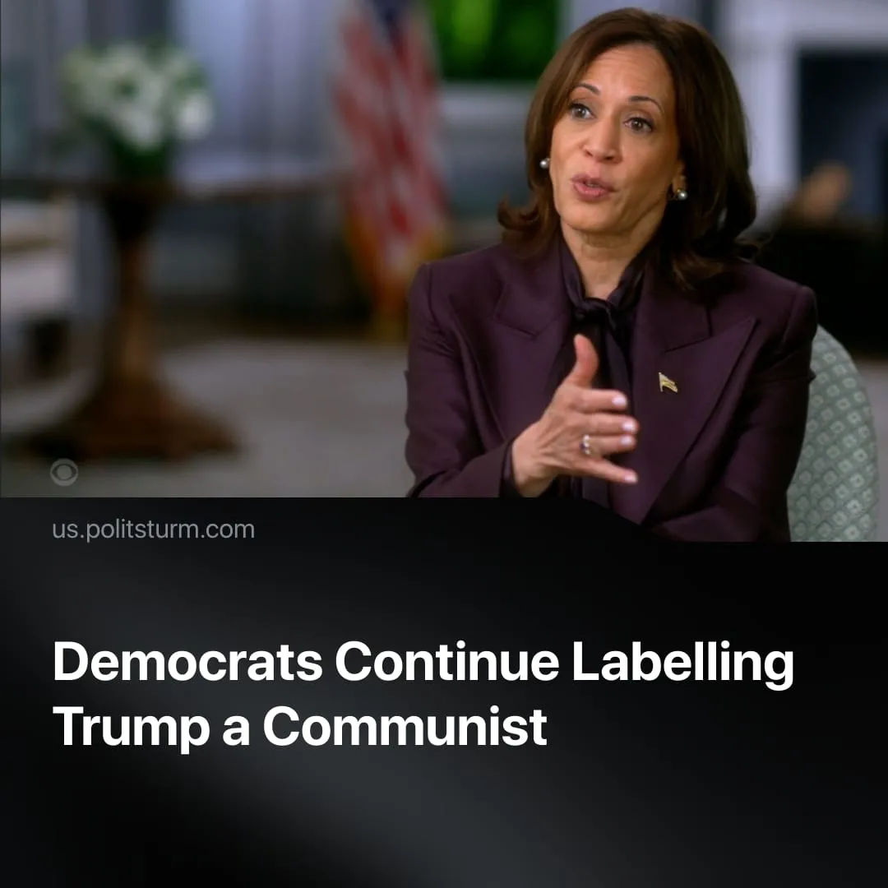

Original article
2025-10-08
2 min read

After calling Trump a communist, Kamala Harris expressed surprise that major corporations have not resisted his centralisation of power.
Kamala Harris gave her first interview since leaving office to promote her newly written memoir, titled "107 Days," about her 2024 election campaign. She claims that American billionaires have individually made bad choices in ceding to blackmail from President Trump:
Quote: “I always believed that, if push came to shove, those titans of industry would be guardrails for our democracy […] and one by one by one, they have been silent. [...] We used to compare the strength of our democracy to communist dictators. That’s what we’re dealing with right now in Donald Trump. And these titans of industry are not speaking up.”
Context. This is not the first time Democrats have labelled Trump a communist for his autocratic tendencies; for example, Bernie Sanders compared him to Stalin. Trump himself has also called the Democrats “Marxist” and “communist.”
In reality, Trump is not a communist. He is a defender of big business and acts in its service. He represents his class, preparing for economic crisis, civil unrest, and intra-imperialist conflict with the Chinese bloc. The President is slashing regulations on Wall Street finance capital, granting further tax cuts for the wealthy and gutting welfare for the poor by $120 billion to fund massive rearmament spending.
► American capitalists worth $1.35 trillion attended Trump’s inauguration and raised record funds for his ceremony. In September, the White House hosted a dinner with 33 Silicon Valley executives to coordinate further deregulation and state contracts. Tech leaders from Palantir, Meta, and OpenAI have been commissioned as advisers to the US Army.
► Capitalists have never been bastions of democracy. When their interests are threatened, big business has historically supported the concentration of power and repression — for example, the 1973 Chilean coup, which dismantled liberal democracy and was backed by Chilean capitalists to protect their profits.
► The same occurred in Germany, where leading industrialists financed and enabled the Nazi Party’s rise to power. Media magnate Alfred Hugenberg, steel monopolist Fritz Thyssen, and banker Hjalmar Schacht were among those who bankrolled Hitler. Monopolies such as Krupp, IG Farben, and Allianz profited from fascist rule and collaborated closely with the regime.

Original article

