"Democratic Socialists" Make Electoral Gains
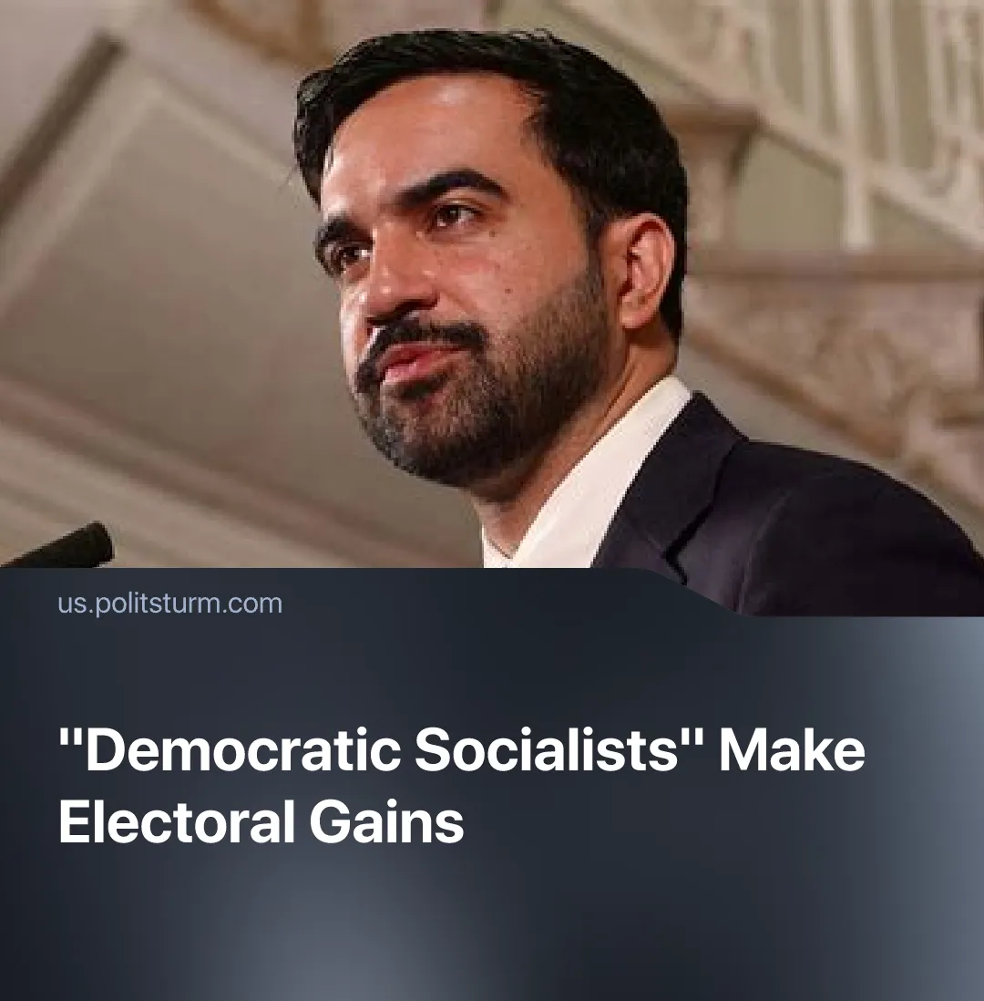

Original article
2026-08-26
2 min read

"Democratic Socialists" set to face Trump’s MAGA in upcoming Midterm elections, as establishment Democrats and “anti-interventionist” Republicans suffer setbacks across the primaries.
Details. In the lead-up to Midterms, the "left" has strengthened its position in the 2026 Democratic Senate primaries. In Michigan, progressive populist Abdul El-Sayed, who campaigned for Medicare for All, defeated a more moderate rival. In Texas, James Talarico did the same, running as a progressive populist. In Florida, DSA member Angie Nixon defeated an establishment rival despite his significant financial advantage. Janeese Lewis George, a DSA member, won the Washington DC mayoral primary, beating a more moderate opponent.
► In the Republican primaries, the anti-MAGA "groyper" faction suffered several defeats. In Florida, congressional candidate Bilzerian and gubernatorial candidate Fishback campaigned on anti-Israel sentiment but received just 10–20% of the vote, losing to Trump-endorsed warhawks. Thomas Massie, a Republican critic of Trump, was pushed out of Congress in an organised MAGA campaign. The faction promotes "anti-war" rhetoric mixed with antisemitism and conspiracy theories about "Jewish control" of US foreign policy.
► The elections had the active participation of internet influencers. On the right, fascist streamer Nick Fuentes endorsed Fishback, while left-wing populist Hasan Piker backed DSA-endorsed candidates. The social chauvinist The Deprogram also supported the DSA, arguing that victories for left-wing parties would facilitate socialist organising and soften the “Red Scare”, though subscribers criticised them for reformism and "sheepdogging" for the Democratic Party.
► But the Democrats’ new "left" wing is not isolated from the party establishment. There is already talk surrounding DSA member Alexandria Ocasio-Cortez (AOC) of a potential presidential campaign in 2028, with rumours circulating about her possibly running alongside Kamala Harris.
Context. The rise of populists, opportunists and openly scandalous politicians reflects a clear crisis in bourgeois politics. Traditional parties and their leadership are losing credibility, whilst political rhetoric is becoming increasingly crude and demagogic. This is especially noticeable on the right, where chauvinism, neo-fascism and conspiracy theories are rising, often masked by seemingly "anti-elitist" and pseudo-"working-class" rhetoric, as Trump employed in his campaigns.
► A left-wing social-democratic opposition is also rising, fueled by dissatisfaction with capitalism, particularly among young people. The most notable example is the victory of Zohran Mamdani and other democratic socialists in local elections. However, their time in power has revealed their opportunism: once inside the bourgeois state apparatus and Democratic Party, they quickly broke some election promises and joined bipartisan support for growing anti-communism.
► The British social-democratic "Your Party", which is similar to the American DSA, became consumed by internal disputes and organisational chaos almost immediately after its formation. Consequently, the party failed its first serious electoral test, revealing the weakness of its unprincipled and amorphous opportunistic political stance.
► Following the Republican split over the Middle East war, Trump has further strengthened his cult of personality and control over MAGA. He has maintained the dominance of his pro-Israel, nationalist and militarist line within the Republican Party. Despite internal instability and the departure of anti-war opportunists and far-right figures such as Tucker and Marjorie Taylor Greene, MAGA remains the dominant Republican faction. Trump continues to receive backing from major capitalists who see his policies as the most effective means of maintaining American imperialist positions and profits.

Original article

