The Democratic Party Plays "Left Opposition"
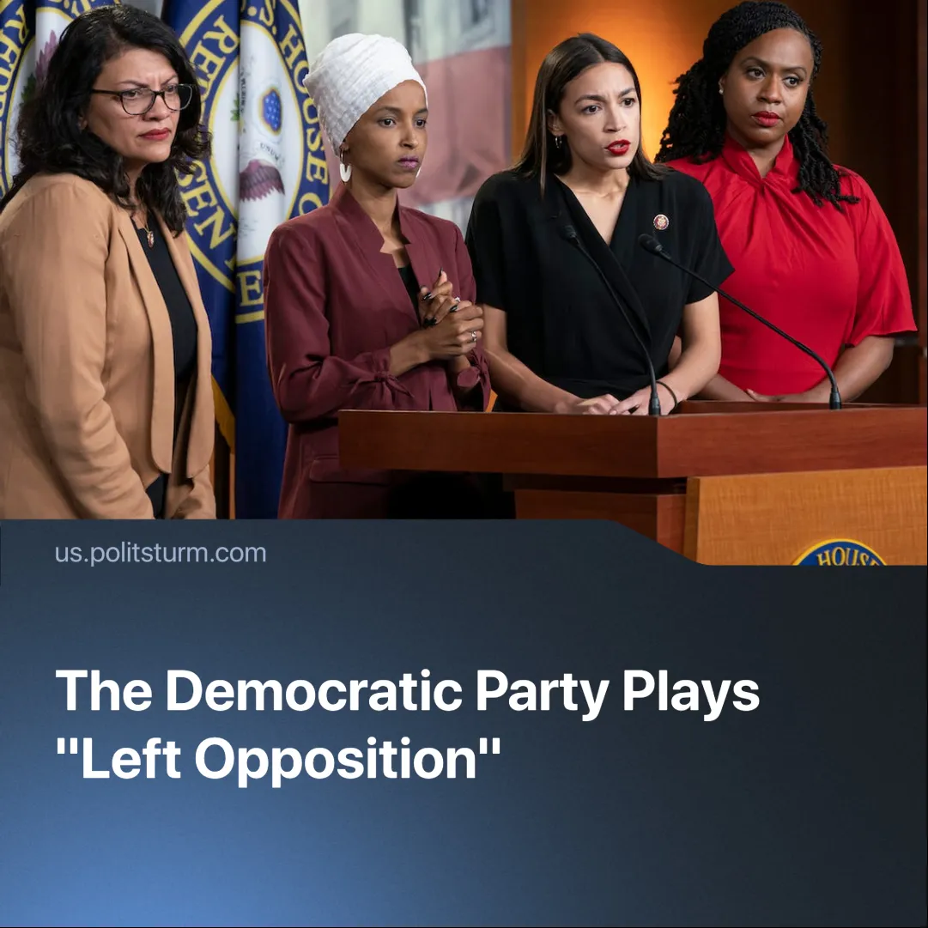

Original article
2025-02-19
2 min read

After Trump's inauguration, Democratic Party figures started to play the role of "left anti-Trump opposition," making populist claims in their speeches and statements, professing to defend "the working class," "our freedoms," and "democracy."
Details. The Democrat National Committee has declared that Trump “will screw over Americans at every turn in order to benefit himself and his billionaire friends.”
► Democratic Party Congresswoman Alexandria Ocasio-Cortez noted: “We're supposed to be a party of the working class, and I think working-class people have not been seeing government work for them, despite a lot of the things that the Biden administration did do”.
► Both AOC and Bernie Sanders accused Trump of consolidating power among unelected billionaires and undermining constitutional principles.
Context. President Trump's executive orders have slashed spending on social programs and state employees.
► The U.S. Department of Education faces significant expected budget cuts, and even calls for its closure, under Trump's administration.
► Former President Biden's approval rating sank to 36% in his final year, with widespread criticism over handling inflation and foreign policy.
Important to Know. Democratic leaders are attempting to whitewash themselves by portraying the Democratic Party as “defenders of democracy” and the party of “common people”. In reality, there are no major differences between them.
► Both parties are actively supported by capitalists. While AOC and Bernie Sanders accuse Republicans of oligarchy, their own Democratic Party donors include billionaires as well, such as Michael Bloomberg, Simons’ family and Reid Hoffman, co-founder of LinkedIn.
► Many of policies that they blame Trump for were initiated or continued under Biden's administration. The Biden administration allocated $10 billion from the American Rescue Plan for public safety, including hiring more police officers and purchasing surveillance technologies. Leftist activist groups faced FBI surveillance and suppression during Biden's term, echoing prior crackdowns. Biden's foreign policy continued imperialist interventions, including escalating sanctions on Venezuela and supporting military aid to Ukraine.
► Democrats aim to channel public dissatisfaction with the current system into safe, controlled opposition, diverting attention from the root causes of oppression. By presenting themselves as the "better alternative," Democrats reinforce the illusion that the system will improve under their rule, a claim debunked especially by Biden's presidency.
► The Democratic Party plays a crucial role in preserving the two-party illusion, camouflaging the true capitalist essence of the U.S. state.
In Conclusion. The Democratic Party is fundamentally a party of capitalists and cannot transform into a "workers' party." Figures like AOC and Bernie Sanders serve to placate and mislead the working class. The only viable path for American workers is to organise under a strong, Marxist-Leninist-guided communist party, dedicated to dismantling the capitalist system and achieving true emancipation.

Original article

