Delta CEO Promotes More Unpaid Leave
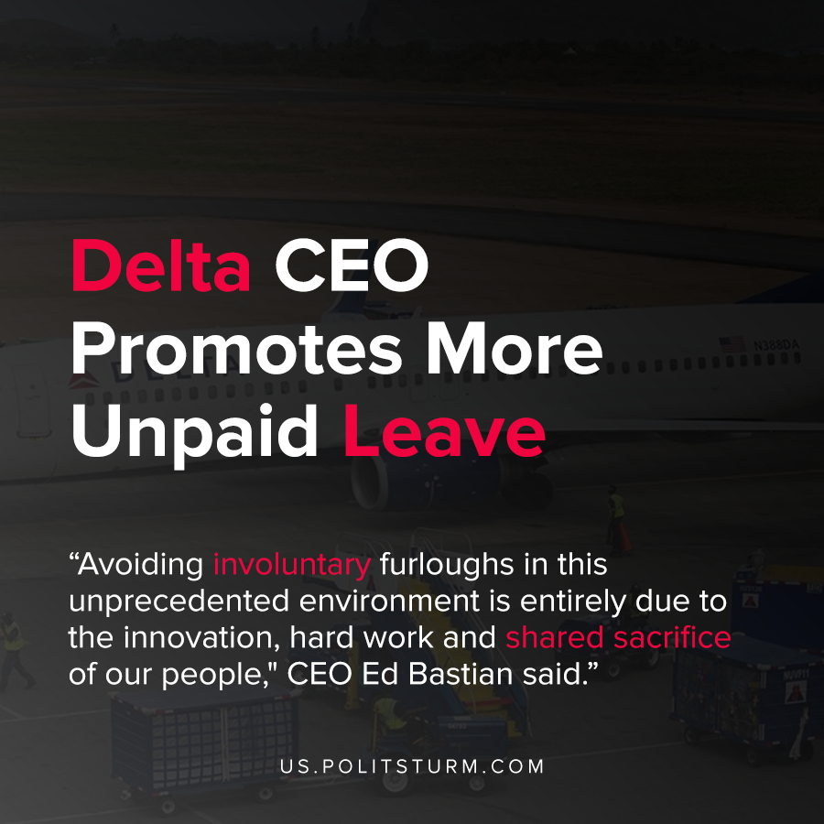

Original article
2020-12-11
1 min read

Delta Chief Executive Officer Ed Bastian announced that more Delta workers are going to be asked to take unpaid leave from work due to the recent decrease in air transportation demand. In order to avoid formally furloughing employees, Delta employees are being “voluntarily” asked to take unpaid leave.
According to Delta, nearly 40,000 employees had taken unpaid leave as of September 15, 2020 and more than 17,000 employees took early retirement buyouts.
“Avoiding involuntary furloughs in this unprecedented environment is entirely due to the innovation, hard work and shared sacrifice of our people,” Bastian said.
The sacrifice is borne by the workers who will now have to go without income and work, however the executive describes the sacrifice as “shared”.
Under the capitalist economic system the brunt of the crisis is inevitably borne by the workers while the executives and shareholders profit.
Source: 1 , 2

Original article

