Decapitation Attacks on Capitalist Leadership Become Normalised
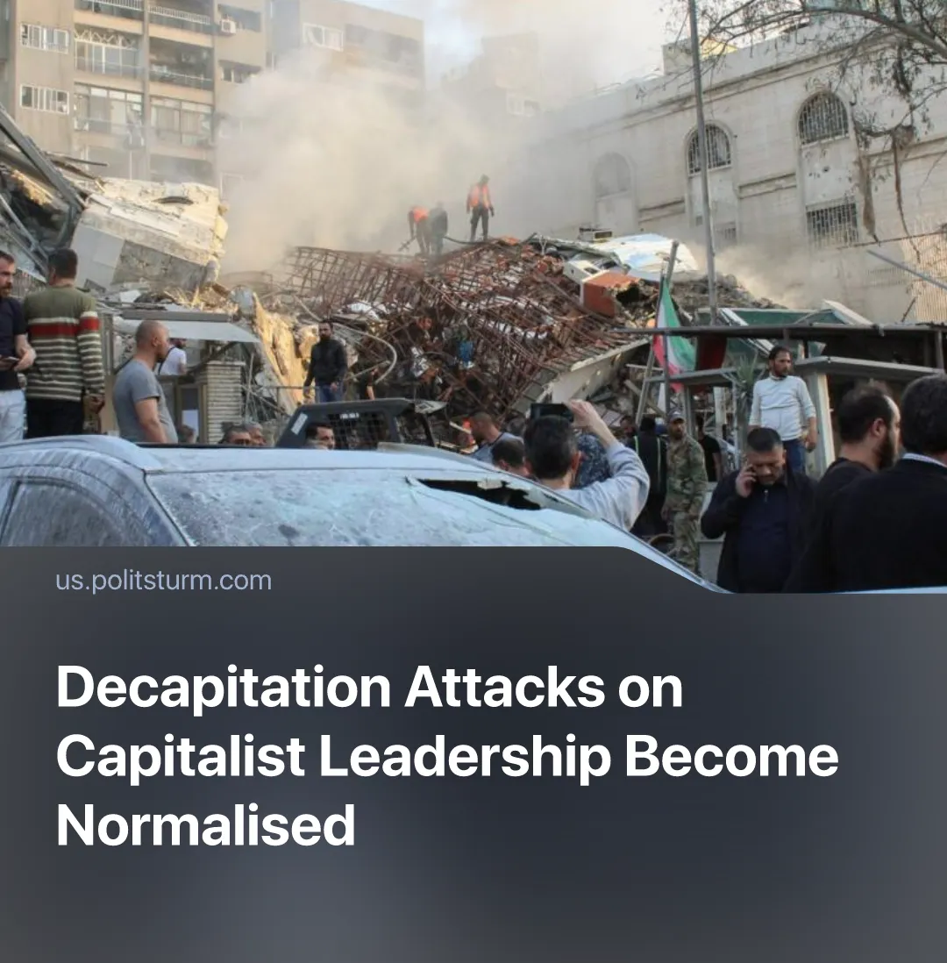

Original article
2026-04-22
2 min read

Dozens of political and military leaders have been eliminated or captured since 2020, as decapitation-style attacks on capitalist leadership become frequent and normal.
Details. Decapitation strikes and assassinations of high-level officials have become increasingly normalised since 2020 as a result of the imperialist crisis. 2026 began with major attacks by the USA on rival leaders: the kidnapping of Venezuela’s President Maduro in January and the elimination of Iran’s Supreme Leader in February, at the start of the Iran conflict.
► The use of this tactic has escalated in recent years. In 2020, Iranian General Qasem Soleimani was eliminated in a US airstrike in Baghdad, and the head of Iran’s nuclear program was assassinated by Israel. In 2024, the Israeli Air Force struck the legally protected Iranian consulate in Syria, eliminating multiple officials.
► Israel targeted the leadership of Hamas and Hezbollah, attacking officials in Qatar and Iran, despite being formally at peace with those countries. In Lebanon, Israel launched the “pager attack” on thousands of enemy officers and eliminated Hezbollah’s chief by striking his command bunker. This strategy was repeated during the 12-Day War and the 2026 conflict, eliminating dozens of Iranian leaders.
► On the opposing side, Iranian intelligence allegedly plotted to assassinate US President Trump and Israeli Prime Minister Netanyahu. Iran’s military launched missiles at Israel’s Defense Ministry HQ, and its proxies targeted PM Netanyahu’s residence with drones.
► In Russia, at least 10 senior commanders have been eliminated over the course of the “Special Military Operation”. Multiple high-ranking capitalist figures have also been targeted, including the nationalist academic Alexander Dugin. The leadership of the Wagner PMC group, including Yevgeny Prigozhin, died in a 2023 plane explosion under unclear circumstances.
► Moscow has accused Ukraine of two attempted drone attacks on Russian leadership, targeting the Kremlin in 2023 and President Putin’s residence in Valdai in 2025. Similarly, Dmitry Medvedev has made threats against Zelenskyy.
Context. As of 2024, the world has experienced the highest number of conflicts globally since WWII as a result of the crisis in the capitalist system, with 61 active state-based armed conflicts across 36 countries.
► Strikes on neutral states have become normalised under the pretext of “harbouring enemies”, as seen in Israel, Iran, and Turkyie’s strikes on Syria, Pakistan, Qatar, and Iraq. After striking Venezuela, the US has threatened other Latin American countries with similar coups.
► The UN has repeatedly proven incapable of preventing escalation. In 2025, ahead of US strikes on Iran, UN Secretary-General António Guterres called on all parties to “give peace a chance”, yet the attacks proceeded regardless. Similarly, the UN Security Council issued condemnations following Israeli strikes on Hamas leadership in Qatar, but no enforcement followed, and operations continued uninterrupted.

Original article

