"Cyber Front Z": How Capitalists Promote Pro-Russian Propaganda
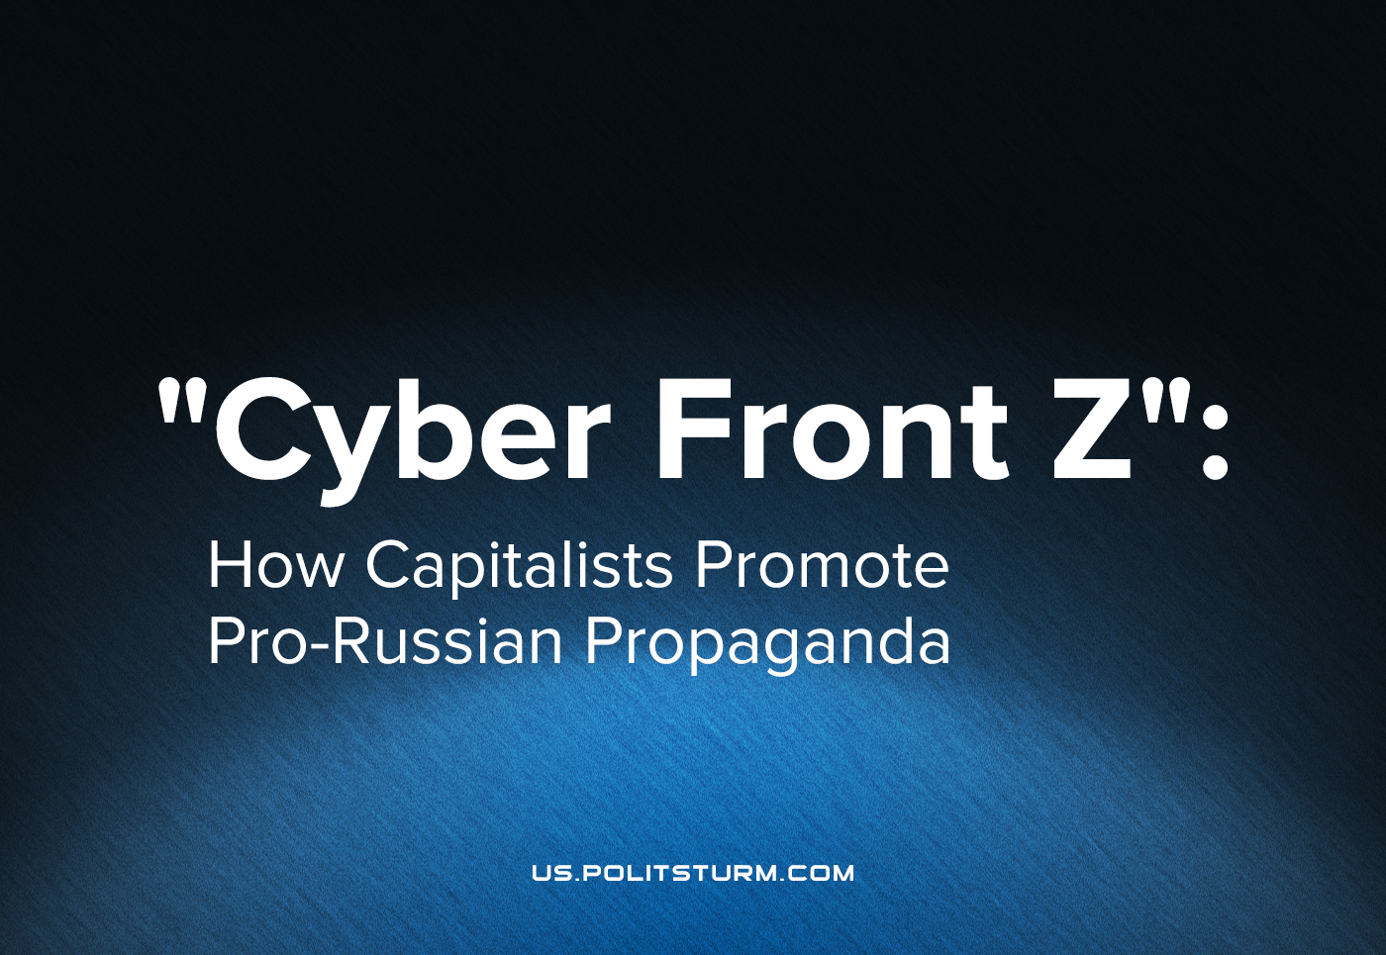

Original article
2022-08-18
22 min read

Since the escalation in Donbass a lot of pro-Russian posts filled the social networks. There are people who believe Russia is definitely progressive. And there are people who are paid to make these posts. We translated an article from Russian news project named “Fontanka”. The original material named “You don’t believe these are real reviews, do you?” How Fontanka looked at the front line of information fronts Z” was published in March, 2022.
As shown in this article, Russian big capital actively creates its own media space to promote pro-Russian capitalist views. Enjoy!
On March 11, the channel “Cyber Front Z” was created on Telegram. The first post in it was published the next day with a recruitment announcement for the cyber army. It read:
“The more successfully our soldiers fight the plague in Ukraine, the more fakes and information attacks appear on you and me. The machine of Ukrainian propaganda has been promoted to the fullest. They wish us death and wish for Russia — collapse. Only together we can resist these attacks! We are opening the Cyber Front of Operation Z to fight back in the information field against the propagandists of the Kiev junta, who are funded by the Western world”.
Error loading image
The “front” required spammers, commentators, content analysts, designers and programmers. For those who wished to join, it was suggested to contact Alexander, who, according to his profile description on Telegram, is the self-declared “kombat (abbreviation for “battalion commander” – Politsturm) of the cyber front”. A Fontanka (Russian St. Petersburg news service) correspondent tried to join “Cyber Front Z” and was interviewed by the organization. After successfully passing the interview and working for a day for the “cyber forces”, she prepared a report. What was this experience like and what do the famous “Olgino trolls” have to do with it?

Mobilization
Despite the late hour of the night on March 15-16, Alexander (the leader of the “Cyber Front Z”) responded to my message immediately: “The salary is 45,000 rubles per month. The schedule is two days’ work, then two days’ break. If you are ready to work with us, I can make you an appointment for an interview.”
The next day, there was a free window for 2 PM. The meeting was held in the “Bloody Bones” grill bar on Korablestroiteley Street. However, it could hardly be called a bar. The room consisted of the main hall, several tables, and a bar counter — all this in a detached one-story building of a nondescript appearance.
Error loading image
At 2 PM, the bar was already full of “Cyber Front Z” members. I saw a dark-haired young man explaining to two guys: “Now there is a lot of fake information online, which, for example, led to spontaneous rallies in the Gostinka area (in St. Petersburg, where people protested against the government in early 2022 – Politsturm). This has regrettable consequences because any conflict with the police always ends with 5 to 7 years in prison. That is why our movement is designed to block this fake information.”
Yana – a red-haired woman – offered for me to sit next to another interviewee, a woman in her 50s, and gave us both questionnaires. The questions were quite normal: workplace, education, residential address, social network account handles, COVID-19 vaccination status. Yana was waiting for us as we were filling out the questionnaires, and said: “We are working to expose fakes in the agenda of Ukraine. As you probably read the news, you can see that there is a lot of misinformation, including civilian casualties. We are the patriotic Z movement. This project has appeared recently, but the [patriotic] movement itself has been around for a long time.” When asked about what exactly participating in the movement entails, she hesitated, but quickly found something to say: the participants would write comments on the internet like those that can be found reviewing products on Russian online stores, like Ozon or Yandex. “You don’t believe those are real reviews, do you?”, she said with a smile. The 50-year-old woman shook her head in understanding. Yana continued to say that the work would be simple, that it would require writing comments in Telegram and on other sites (except VKontakte — which apparently has “more or less neutral information” ). Yana went on to say that their curators will find chats and channels. How to write refutations and what meaning they should have, is up to the curators as well. Yana said that there would be no need to write a wall of text: “two or three sentences would suffice.” She explained: “Our guys, who have been doing this for several years, will work with you, they will be able to help if you have any queries”. About 200 comments were required to post every day.
There are 100 people on each shift. The first two shifts started just the other day. This project is long-term: the first month you will need to work from the office on Lenin Square, then you can do it remotely. This work is off the books. The 50-year-old woman asked: “And what is the guarantee that you will pay us?” Yana threw up her hands in response; we would have to take her word for it. She continued: “There is no competition, we take everyone. If you agree with our terms and are ready to join our war against disinformation, write down the following address: “Arsenal” factory, at the factory checkpoint you must say that you need to go to “IP Nekrylov” (IP is an abbreviation for “Individual Entrepreneur” in Russian – Politsturm). Your first shift is on March 18, and your first break is the 20th. Work starts at 9 AM”.

Offensive
On Friday morning, at the former “Arsenal” factory, there was a queue at the checkpoint. Several dozen people were trying to get a new job. The guard took a long time to take down everyone’s passport details. The newcomers were collected by Viktor, a dark-haired man of about 30 in a black down jacket with a small American flag pasted on the sleeve under the tag, produced by one of the brands that recently left Russia. Victor called himself the Tiktok curator. A girl in black tight leggings caught his attention, and she said: “Oh, and will I need to post something from my own personal account? I have several thousand subscribers there. There have been so many negative comments there lately, I don’t understand where they all come from”. “No, they will give you accounts,” Victor replied. The girl took a drag of her e-cigarette. Next to her was a hardy man, about 50 years old, in khaki pants and wearing a knitted hat. He stood out strongly in the crowd of young people, most striking of all was his sullen silence.
In just half an hour, those who wanted to work in the cyber forces found themselves in the office. In a small corridor, flags with the white letter Z on black and tricolour backgrounds hang on the wall. There were several offices in the corridor. There was a queue in one of them — which was for those who wanted to get into the Telegram team. “Somehow I’m more used to this social network,” said a guy in worn-out jeans to his girlfriend. A young man peeked out of another office and shouted to those waiting: “There are a lot of you on Telegram, come join me on Youtube, instead.” Three of them left the queue and walked towards his office, and I went with them.
Error loading image
The guy, who called us, was named Sasha. He is the curator of Youtube. He had 23 people working under his leadership during this shift. They were seated in two offices. The experienced workers — in a large one, and beginners were brought into a smaller one. Instead of a warm welcome, Sasha sent an old message to the new recruits on Telegram, apparently pre-written before the new “cyber warriors” came to the office — in the few first lines, the message said that the work will be remote. Sasha’s nickname is patriotic – “Vesti ru” (Vesti.ru is one of the Russian official mass media – Politsturm). “My full name is Alexander (Sasha is a nickname for “Alexander” in Russian – Politsturm), I am your supervisor. Our division will work on YouTube. Since we will all be working with our own equipment, a huge request is to make sure that you download the Youtube application on your computers and mobile devices and ensure that it works properly. Concerning your Youtube accounts: don’t worry, I’ll give them to you. Now about the tasks, this job will involve. The main goal of our work is to create a patriotic atmosphere in the comments under trending videos and in videos under the category “politics and news” – this was the text of his message. Along with this welcome speech was a link to a post on the “Cyber Front Z” Telegram channel:
“This channel will post brief instructions on tasks, the purpose of which is to: increase the presence of patriotic comments on channels where clusters of Ukrainian bots and trolls are detected, the formation of pro-Russian top comments from bloggers and opinion leaders, as well as strengthening the patriotic agenda in news publications, where a large percentage of ordinary people simply do not understand the goals and tasks of the special military operation. We are convinced that the raids of Ukrainian Nazis into the Russian information field must be stopped and they must not be allowed to mess with the brains of our citizens! Cyber Front Z goes on the offensive!”
Sasha added to what he wrote: “They wish the Russians death, but we wish them to come to their senses. No insults! We will focus on whatever is written in the main channel, of course, everything is hyperbolized there, but it’s true. You can express your opinion to me regarding all this if you like.”

Personnel
Sasha arrived a few years ago from Kazakhstan and said that he understands the situation of the Russian-speaking population of Ukraine, as he experienced similar sentiments in his homeland. He said: “I had a 0.1 per cent chance of finding a good job in Kazakhstan because I am a Russian speaker.” In his free time; when he isn’t a supervisor for the cyber patriots, Sasha told me that he writes articles on an entertainment-oriented website. “It’s not related to this project, and I don’t mix works,” he explained, just in case it wasn’t clear. After talking about himself, Sasha moved on to political topics: “Not all the things are cool in our country, but apologizing for being Russian is a little wrong. I have experienced the news agenda, I also saw the Alley of Angels (a memorial complex erected in 2015 in Donetsk in memory of children who died during the military conflict), saw corpses, dismemberment, and murdered children. I had nightmares after that. I’m not saying that there is anything good in it. Nothing is right there.” Sasha repeated all the postulates known and spoken by the Russian authorities: Kiev refused to comply with the Minsk agreements and instead increased armaments, while Europe financed these military supplies. He claimed: “If there had been no “explosion” on the 24th, there would have been an “explosion” on the 30th, and not from our side. He said that he doesn’t have a full confirmation, but he believes this. In the first week, they (Ukraine – Politsturm) did not target residential areas. And now they prevent ordinary people from hiding in a safe place. The National Security Service of Ukraine locks people in basements and apartments”.
I asked how he knew all this. But Sasha was interrupted by Lyokha (a nickname of “Alexey” in Russian – Politsturm). Alexey has been working for three shifts and is considered an experienced cyber warrior in the team, he searches for videos and sends them in the telegram chat with a suggestion on how to comment on them. On social networks, his name is “Matvey”. He’s under 40. Judging by the photos, he is a former Nazbol. Lyokha said that he knows about everything from friends who were in the Donbas. “They, the Ukrainians, when they retreated, tried to make sure that there were as many civilian casualties as possible,” he said, answering a question about civilians allegedly locked in basements. — But civilians are forbidden to talk about it: they know that if they spill the beans, the guys from Azov will come.
Lyokha once sympathised with the political opposition but became disillusioned with it, he said Alexander Shurshev, being an activist of the “Yabloko” party, declared that he would take a Georgian surname in 2006 to support the Georgians being expelled (in 2006 several thousand ethnic Georgians were arbitrarily deported from Russia – Politsturm), but a month later he changed his decision and kept his original surname. “It was indicative for me: I watched how inconsistent they all are in the opposition. And then I saw how the Kremlin works. They are consistent, and this resilience attracts. You understand: if your interests coincide with the interests of the Kremlin, they won’t fool you,” he said when he was sitting on a pink ottoman while looking at his laptop.
The resulting pause was interrupted by a guy covered in tattoos: “I’m sorry, I’ve listened to your instructions, but I don’t really understand. What should I write in my comments?” Curator Sasha sighed: “Well… I know people who write the word “Russia” with two mistakes. Well, look, it’s written that no one in Russia supports the actions of the authorities, and you should write on the contrary, that people do. It is not even necessary to say that the majority supports the government. I support them. Do you know me? So reply: “But I have friends who support the authorities.” Or, secondly, when someone on the internet wishes death to all Russians, you should write: “I am just a Russian tattoo artist, what do the events in Ukraine have to do with me? I can even draw a swastika on your elbow if you want.” Well, you don’t have to write about the swastika. But in general, your reply should be like this”.
I asked the curator, “Who funds this operation?” “They have nothing to do with the Ministry of Defense, they are just caring entrepreneurs,” Sasha replied. At this moment, Masha entered the conversation. She was in her early 20s, she was a student, and in parallel, she also worked part-time in social media marketing and at personal growth seminars. She seemed to doubt that she had come to the right job. Even before the shift started, she asked Sasha if she could not write in the comments that Navalny was a traitor, as she did not consider him as such. The conversation was mostly hypothetical. Sasha did not forbid it but asked Masha to think about why the money that was sent to the oppositionist as donations was missing. Masha instead wondered why “flags with the letters Z” were placed everywhere, additionally pondering why the military theme as a whole has been planted on them since childhood. She told Sasha that if the boys had not run around with weapons in playgrounds and played with toy tanks, maybe everything would have been different. “Well… your attitude is self-assured. It’s no skin off my nose. And as a child … well, I liked weapons, no one dictated to me which toys to choose,” answered Sasha. Alex supported him, and Masha no longer tried to argue.
Error loading image
In addition to the three of them, in the Youtube team, there was also Yaroslav, who was sitting in the office (and had been asking all day why there is no food in the office), Nikita (who was always silent) and another Alexey (who was also very reserved, describing himself as a multi-faceted personality – he is a Belorussian, who enjoys hacking and owns his own kebab shop).

Tasks
After getting acquainted, everyone was added to a chat, titled: “Youtube 1 Shift Z”. Videos and summaries from patriotic channels were sent there. It was necessary to comment on Yuri Dud’s new interview with historian Tamara Eidelman, the speech of the adviser to the President of Ukraine Alexey Arestovich, the news released by “Nastoyashee Vremya” (“Present Time”) (recognized in the Russian Federation as a foreign agent), a video published by one of the Ukrainian bloggers with Russian military equipment, Biden’s speech, Ilya Varlamov’s video. “You can discard all Varlamov’s claims, as he has shown Russian cities in his videos in recent years as gloomy garbage dumps,” Lyokha wrote in the chat.
“Let’s go to this video. I’m also sending reports to the Defense Ministry for help,” wrote curator Sasha, dropping the link to the video by “Nastoyashee Vremya”. A little later, he sent a screenshot into the chat, titled: “Cyber Warfare on the “Nastoyashee Vremya” stream”. In the screenshot, users took turns quoting stanzas of the Russian anthem. To help with commenting, Sasha sent notes and pictures with the RIA FAN logo (a media website belonging to the “Patriot” media group, whose board of trustees is headed by Yevgeny Prigozhin – a Russian oligarch and close confidant of Putin). Another comment suggestion was the letter Z, made of emojis in the form of white, red and blue hearts.
“All posters! Let’s support the president!” wrote Sasha, as he sent to the chat a link to Vladimir Putin’s speech in Luzhniki, also published in the Cyber Front Z telegram channel. “Pay special attention to the young spectators who came to support the movement and attend the ensuing concert”. Then he sent a screenshot of one of the comments on that video, citing it as a good example: “I am glad that young people celebrate this significant date! Indeed, the return of Crimea is a historic event!” Sasha’s Youtube “cyber warriors” were also encouraged to write the following on relevant videos: “The weapons that the Westerners send to the Armed Forces of Ukraine do not reach the front, but instead are smuggled to the border states of the EU. The weapons fall into the hands of criminal gangs there.” Then Lyokha wrote: “Zelensky is on air. Everyone, go there!”. There were time limits for comments on the streams, so the curator suggested they write a comment on Putin’s speech video, then return to comment on Zelensky’s live speech, and go back and forth like this.
Error loading image
After comments were written from one account, they would log in to another — the curator sent additional login details from more Google accounts. I got the names “Steven Seleznev” and “Melor Lovzansky”. The backup mail for one of these accounts had the “Fabrika” domain, an apparent hint relating this operation with the already well-known organisation: the “Internet Research Agency”, also owned by Yevgeny Prigozhin and colloquially known as the “troll factory” (“factory” is Fabrika in Russian – Politsturm).
After a busy day, I was asked by Sasha to send him screenshots of all my comments made and to count the total number. Sasha told me: “You will be paid your salary on the 15th of each month. We sometimes videotape how we transfer money — so that there are no complaints later. Some of us believe that the project can be completed by May 9, then May shifts will be paid separately.”

Headquarters
The next day I missed my shift. Alexey called me in the afternoon: “I am the curator of the project. Tell me whether or not you are going to continue working for us?” After researching the number, I discovered that his name is Alexey Nekrylov. He was the same person who, on the first day, identified himself as “Viktor”, and had to be called at “Arsenal” factory checkpoint to allow the new recruits in. Viktor (or rather, his true name Alexey Nekrylov), who met the “cyber warriors” recruits on the first day and introduced himself as a Tiktok curator is, according to Fontanka, an employee of Glavset LLC, Mixinfo and Novinfo since 2016.
It is these legal entities that the US authorities determined were among those involved in the project “Lakhta”, better known as the “troll factory” (a $35 million social media operation that used fake Twitter, Facebook and other social media profiles to spread misinformation and discord primarily aimed at influencing the 2016 US presidential election – Politsturm).
“Trolls” entered mainstream discourse for the first time in 2013. This was preceded by a DDoS attack on a number of St. Petersburg media websites, including Fontanka, the phenomenon of “network hamsters” (The Russian equivalent of “Internet sheep” – Politsturm), the infiltration of an employee from the PR department of the Concord group, which is associated with Yevgeny Prigozhin, into the editorial offices of mass-media in St.Petersburg, in order to search for compromising materials. At the same time, a Novaya Gazeta journalist found an advertisement and tried to get a job in an office in Olgino (as one of Prigozhin’s “trolls”), where they met the aforementioned employee of the Concord group. In 2017, RBC magazine reported that the “Olgino trolls” changed their office to a business centre on Savushkina Street and acquired new resources – a network of information portals with an audience of 9 million people. In the same year, RBC journalists found out that during the US presidential election, an American department was opened in the “factory”, with about 100 employees. In addition to posts on social networks, they were also engaged in organizing political protests. In 2018, the US Treasury added resources associated with the “factory” to the sanctions list, accusing them of attempting to interfere in the 2016 American elections and stating that they work for Yevgeny Prigozhin. Prigozhin himself has repeatedly denied this connection.
In addition to Prigozhin, there may be another, no less famous, person in this story. In 2014, Fontanka wrote that Alexander Yanukovych, the son of Viktor Yanukovych, the former president of Ukraine, moved to St. Petersburg and opened a business, he rented the space at the same former “Arsenal” factory in St. Petersburg that “Cyber Front Z” used as their office. However, this appears to be nothing more than a coincidence.
When approached for an official comment, Alexey Nekrylov told Fontanka that he was not recruiting for social networks, while confirming that he was an individual entrepreneur, but refused to elaborate about his business. He also stated that he did not know anything about the companies Novinfo, Glavset and Mixinfo.

Original article

