Cuban Leadership Denies US Pressure Drove Capitalist Reforms
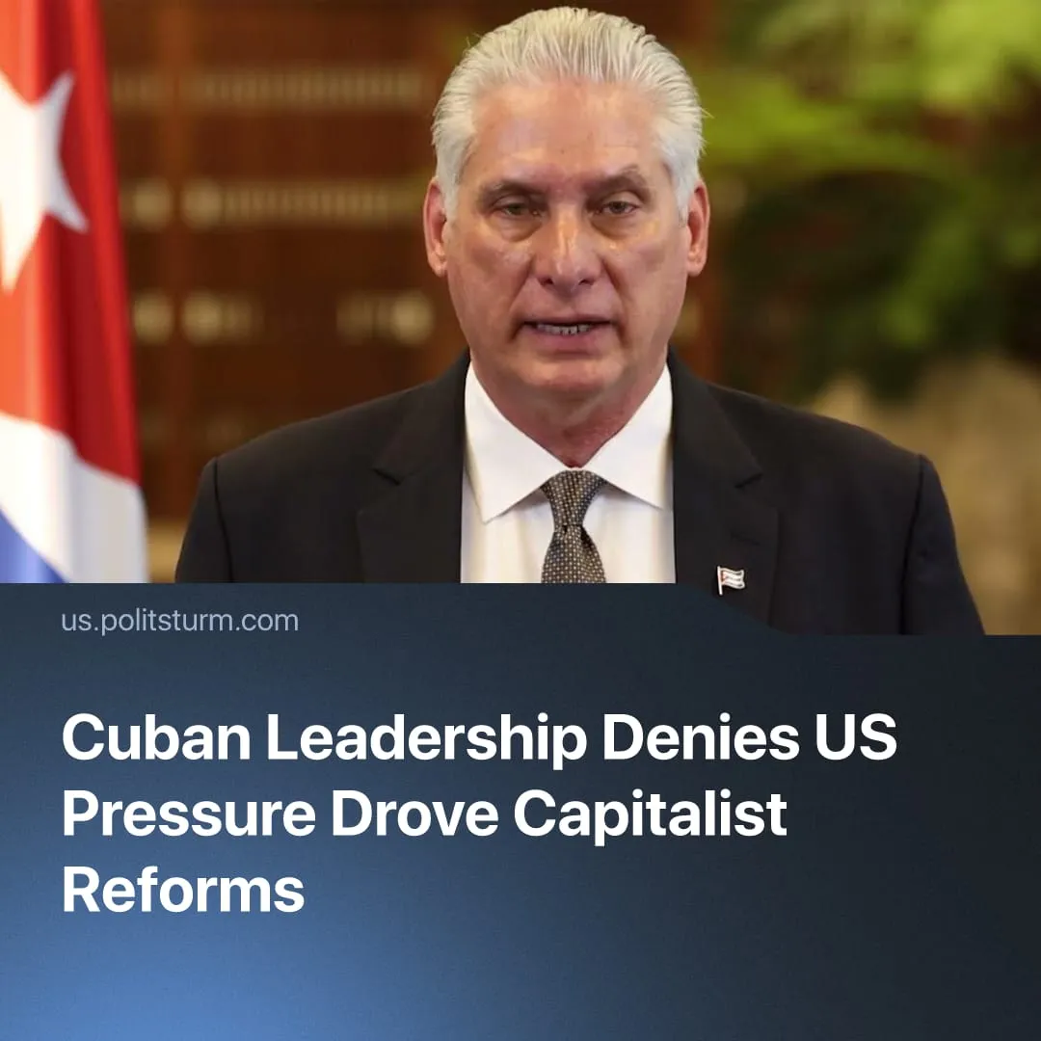

Original article
2026-07-01
1 min read

Cuba's leadership claims that opening the country to foreign capital is not a result of US pressure. Facts refute this assertion.
Details. At the time of the adoption of the package of "economic reforms" that cemented the capitalist nature of the Cuban economy, President Díaz-Canel stated: "We're not doing this under pressure from the Yankees, but because we've reached a moment of maturity".
► This statement is inconsistent with the escalating crisis on the island. In recent months, the US has sharply increased pressure on Cuba.
► In January, the US launched an operation in Venezuela – Cuba’s close ally. The Venezuelan government was transformed into an American puppet. As a result, Cuba lost a regional ally that had supported it with cheap energy supplies. Trump then signed an executive order imposing tariffs on countries supplying oil to Cuba.
► Since the start of the war with Iran, US leaders have repeatedly made statements about the possibility of invading Cuba.
► In March, it was reported that secret negotiations had begun between the US and the Cuban leadership. The negotiations were later confirmed by Cuban President Díaz-Canel and US President Donald Trump.
► In May, US leaders again turned their attention to Cuba. At the end of May, America placed Raúl Castro on the wanted list. Similar measures had previously been used to justify the kidnapping of Maduro.
► Two weeks before the reforms were adopted, Trump declared: "We'll take care of the Islamic Republic of Iran, and as soon as that's done, on our way back, we'll just make a little brief stop over".
► The text of the "reforms" themselves places a strong emphasis on opening the country to American capital.
Context. On June 18, the Cuban parliament approved "economic reforms" in the country. These changes officially enshrine the capitalist nature of the Cuban economy.
► The restoration of capitalism in Cuba has received support from social chauvinists, who have declared the "reforms" a chance to replicate the "Chinese success".
► The American strategy against Cuba is very similar to the measures taken to control Venezuela, which also included a blockade, secret negotiations, the elimination of key leaders, and preservation of the current regime.

Original article

