COVID-19 U.S. Death Toll Topping 1,900 Daily
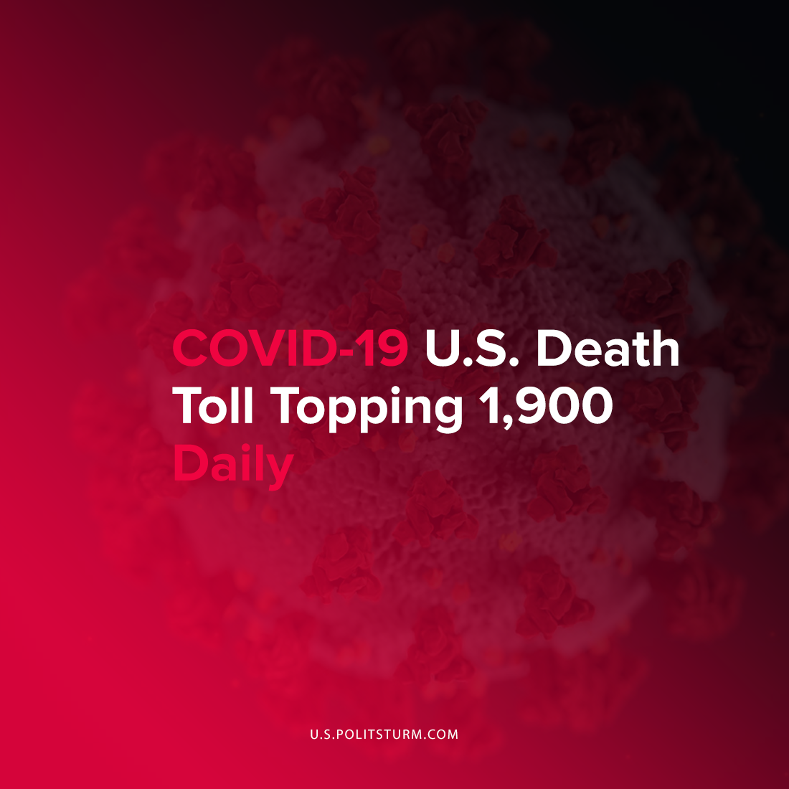

Original article
2021-09-25
1 min read

Nearly 18 months after the onset of the coronavirus pandemic, over 1,900 Americans are still dying every day from COVID-19. Since the beginning of the pandemic 687,106 Americans have died as a result of the coronavirus which is more than any other country. The death toll recently surpassed the 1918 flu pandemic and continues to rise.
“I think this is a real failure of society and our most egregious sin to be at this stage where we have hospitals overwhelmed, ICUs overwhelmed and hitting this mark in terms of deaths per day,” said Dr. William Moss of John Hopkins.
The spread of the virus was not successfully contained at the onset of the pandemic as federal and state governments sought to keep businesses open and maintain profitability. For example, in response to other states imposing lockdowns at the beginning of the pandemic, Massachusetts governor Charles Baker remarked “I’m not going to do it just because someone else did it”. Shortly thereafter Massachusetts had a surge of COVID deaths and over 18,000 in the state have died to this date.
As such, there has not been a coordinated federal and state response to contain the spread of the coronavirus pandemic for over 18 months. Hundreds of thousands of Americans have died and continue to die from the virus on a daily basis. This is certainly a societal failure, however, it would be unwise to ignore that politicians were merely serving their actual constituents, the capitalists, who prioritize their own enrichment above all other factors whatever the consequences may be.
Sources: 1 , 2

Original article

