COVID-19 Deaths To Be Called As "Victims Of Communism"
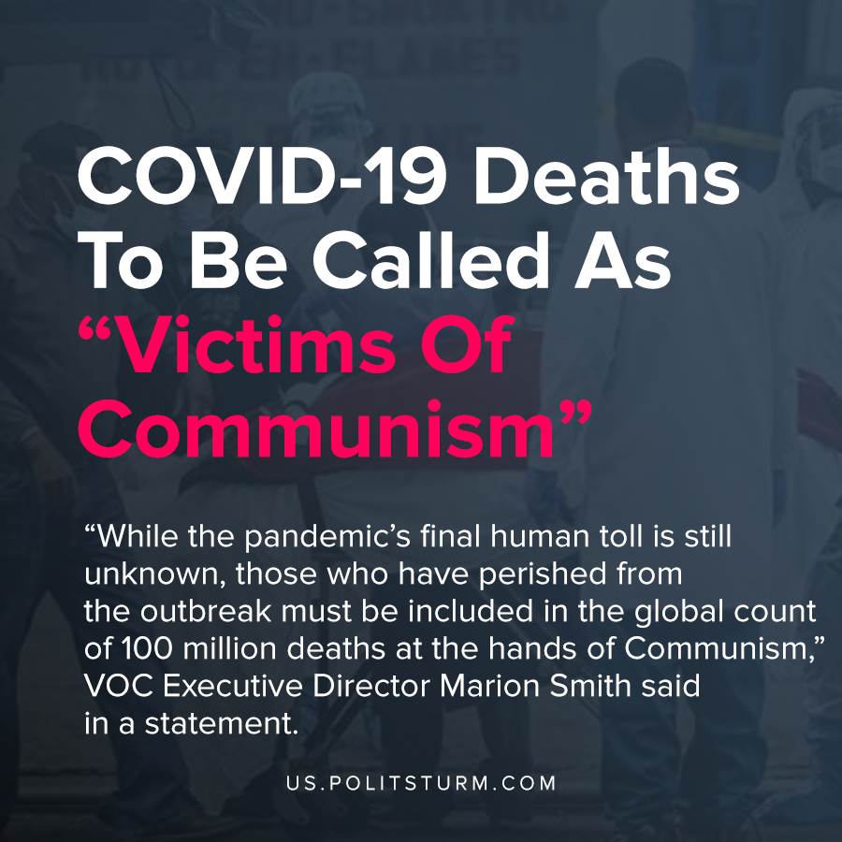

Original article
2020-04-15

“Any cursory look at the facts show that the Chinese Communist Party, Xi Jinping, and WHO Director Tedros are continued threats to global public health. We call on all western media to verify any claims from these discredited organizations before parroting them.”

Original article

