Supreme Court Helps Trump Deport Migrants to “Third Countries”
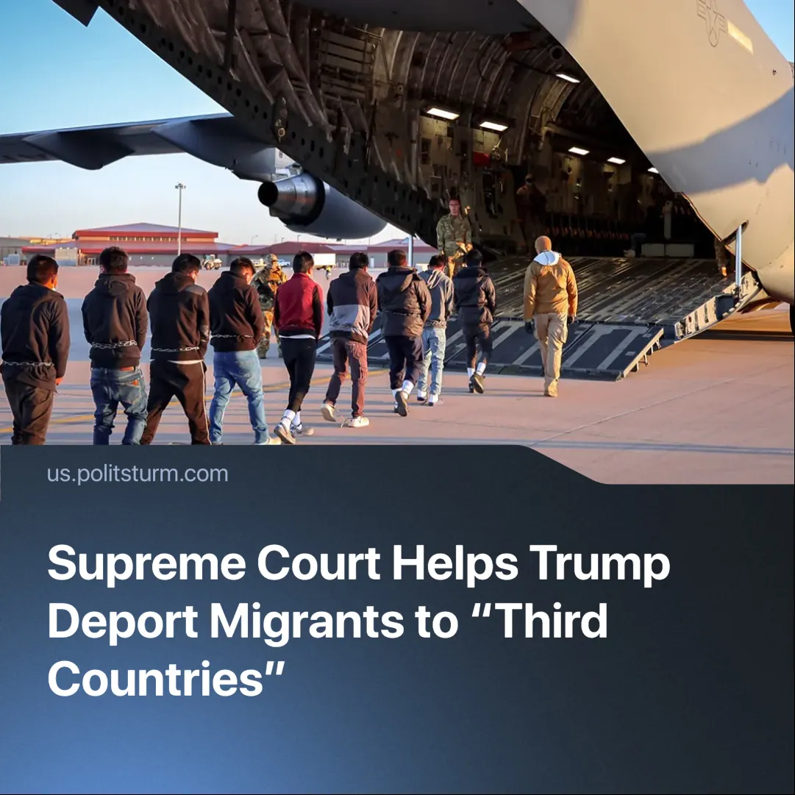

Original article
2025-07-09
2 min read

Trump’s anti-migrant campaign advances with Supreme Court backing, including “third country” deportations and uses as a threat against political opponents.
Details. On June 23, 2025, the Supreme Court put on hold an injunction that prohibited deportations to “third countries” even if these aren’t the migrant’s country of origin or if there’s a risk of prosecution or torture (such as in South Sudan).
►Trump is also planning to reject asylum claims from hundreds of thousands of migrants in the US, making them immediately eligible for deportation.
►Green card holders – permanent residents without citizenship – may also be subject to deportation if they “advocate for violence, endorse or support terrorist activity, or encourage others to do so”.
►To ensure the logistical stability of deportations, low-cost facilities like “Alligator Alcatraz” — named after the nearby alligator-infested marshes, which Trump joked about — are being built to hold deportees.
►Trump’s measures were challenged by civil rights organizations and several lower-level authorities. During the California National Guard incident or Murphy’s injunction, the opposing parties used the courts as a tool of resistance with limited success.
Context. Trump’s election campaign relied heavily on the promise of mass deportations, but once implemented, these measures lost popular support.
►Whilst workplace raids by Immigration and Customs Enforcement (ICE) ceased in certain industries, the overall number remains high.
►In one of our previous materials, we covered how the Supreme Court had already supported ending birthright citizenship, which was met with negative reactions from the American public.
Important to Know. Increasing deportation serves to deepen the exploitation of both immigrants and native workers. The capitalist system divides them into “native” and “foreign” by scaring migrants with the threat of deportation, forcing them to accept worse working conditions, while native workers are then made to compete with cheap immigrant labour.
►The imperialist interventions that provoked conflicts in Syria and Ukraine led to a massive influx of migrants into the West. Yet the EU and the US now rely on anti-migrant rhetoric and call for “returning the migrants”, unwilling to admit that their own actions caused human suffering, and that these conflicts bring them profit. The rise of far-right forces helps mask the deeper contradictions of capitalism by shifting the blame onto migrants.
►Militarized policing and the ability to easily deport can be applied to political opposition as well. Green card holders may be detained or deported for opposing the current administration. Trump's former associate, Elon Musk and Zohran Mamdani, a Democratic mayoral candidate for New York City were threatened with this.

Original article

