County Failed To Help 85% of Lead Poisoned Children In Flint
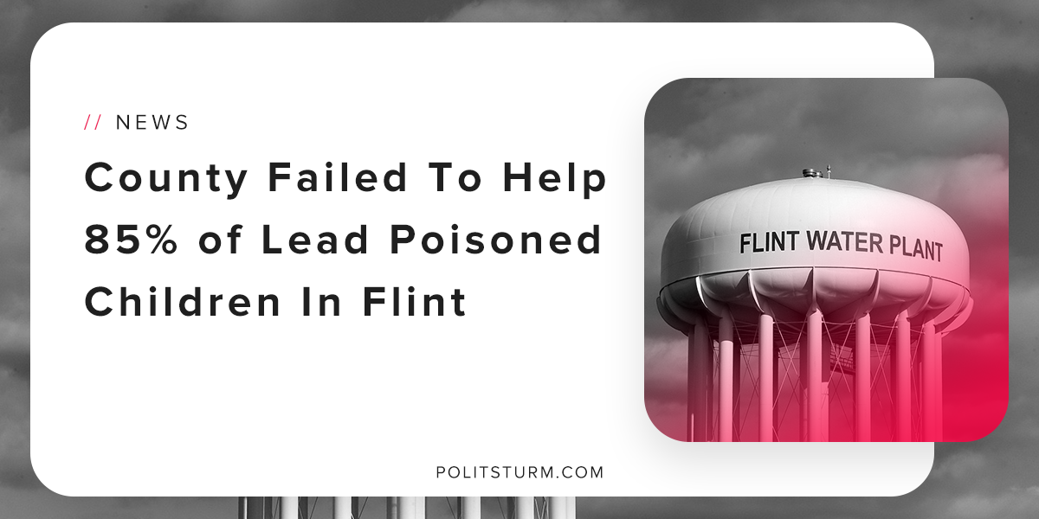

Original article
2018-10-21
2 min read

A Department of Health and Human Services assessment found that the Genesee County Health Department failed to help 85% of children who had elevated levels of lead in their blood.
Flint, Michigan was once a major automobile manufacturing site for General Motors. WIth plant closures, job losses, and a declining tax base the city of Flint was in dire financial straits. A review team was created by the state of Michigan to intervene and address the problems the city faced.
On April 25th, 2014 Flint’s Mayor Dayne Walling turned off the flow of water from Detroit to begin sourcing water from the Flint River.
The Flint Emergency Manager Darnell Earley said, “This is indeed the best choice for the city of Flint going forward.”
“Water is an absolute vital service that most everyone takes for granted,” Walling said. “It’s a historic moment for the city of Flint to return to its roots and use our own river as our drinking water supply.”
Officials raised glasses of water in celebration of the transition. The residents were now exposed to lead and other contaminants infecting their water supply.
Years later, we are now seeing that the vast majority of children with elevated blood levels were not connected to programs to make them better.
The capitalist economic system was at the root of the problem the entire time. The shift of industrial production out of the country led to an outflow of jobs from the region which hurt the working class. The key driver for this decision was profitability.
With less tax revenue, the city of Flint was in a “financial emergency”. This simply means that the municipal bondholders were worried that they would not receive their principal and interest payments as Flint was becoming insolvent.
As a result, an emergency board was created to enforce austerity and uphold the interests of the capitalist class by slashing services to the working class. One of these decisions was to source water in a cheaper way, namely from the Flint River.
At every turn, we see that the crisis was created by individuals who were serving the interests of the capitalist class. Corporate executives were maximizing profits for themselves and shareholders.
Governor Rick Snyder and Flint Mayor Dayne Walling were more concerned with being fiscally responsible than protecting public health. The Flint Water Crisis was not some unavoidable catastrophe, but rather the result of decisions of the capitalists and their political puppets. It is unacceptable that the children of Flint are suffering due to the greed and inhumanity of the capitalist class.
Sources: 1 2 3 4

Original article

