Coronavirus In The US: Numbers Increase
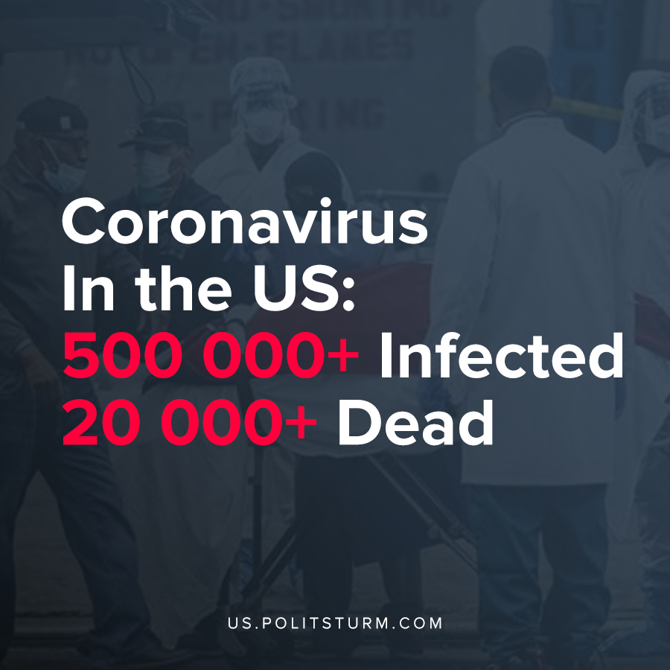

Original article
2020-04-12

America is top 1 in the world – 500 000 infected and 20 000 died during the Covid-19 pandemic.

Original article

