Coronavirus In The US: America Wins Again?
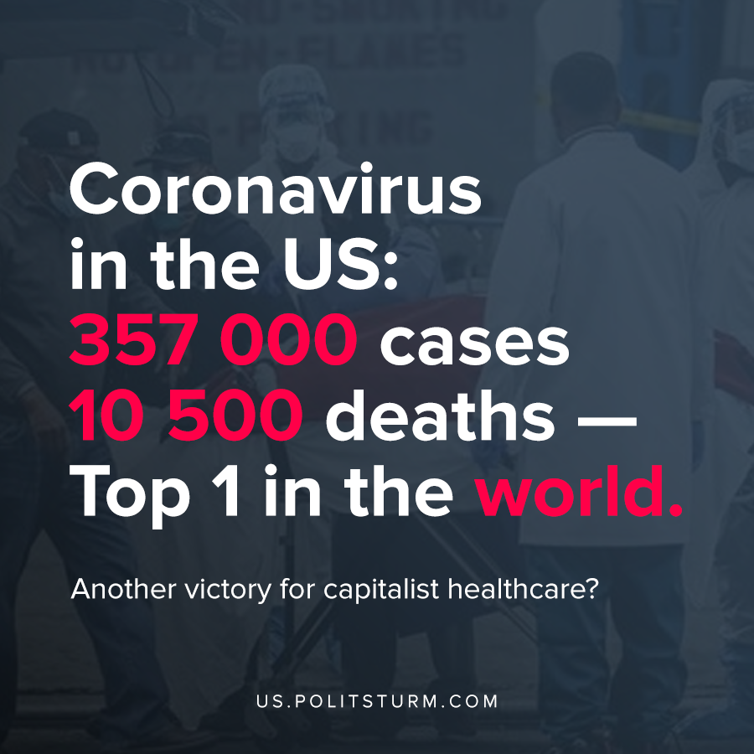

Original article
2020-04-06

At least 10,000 people with the coronavirus have now died in the United States, according to a New York Times database.

Original article

