Cornforth on Socialism
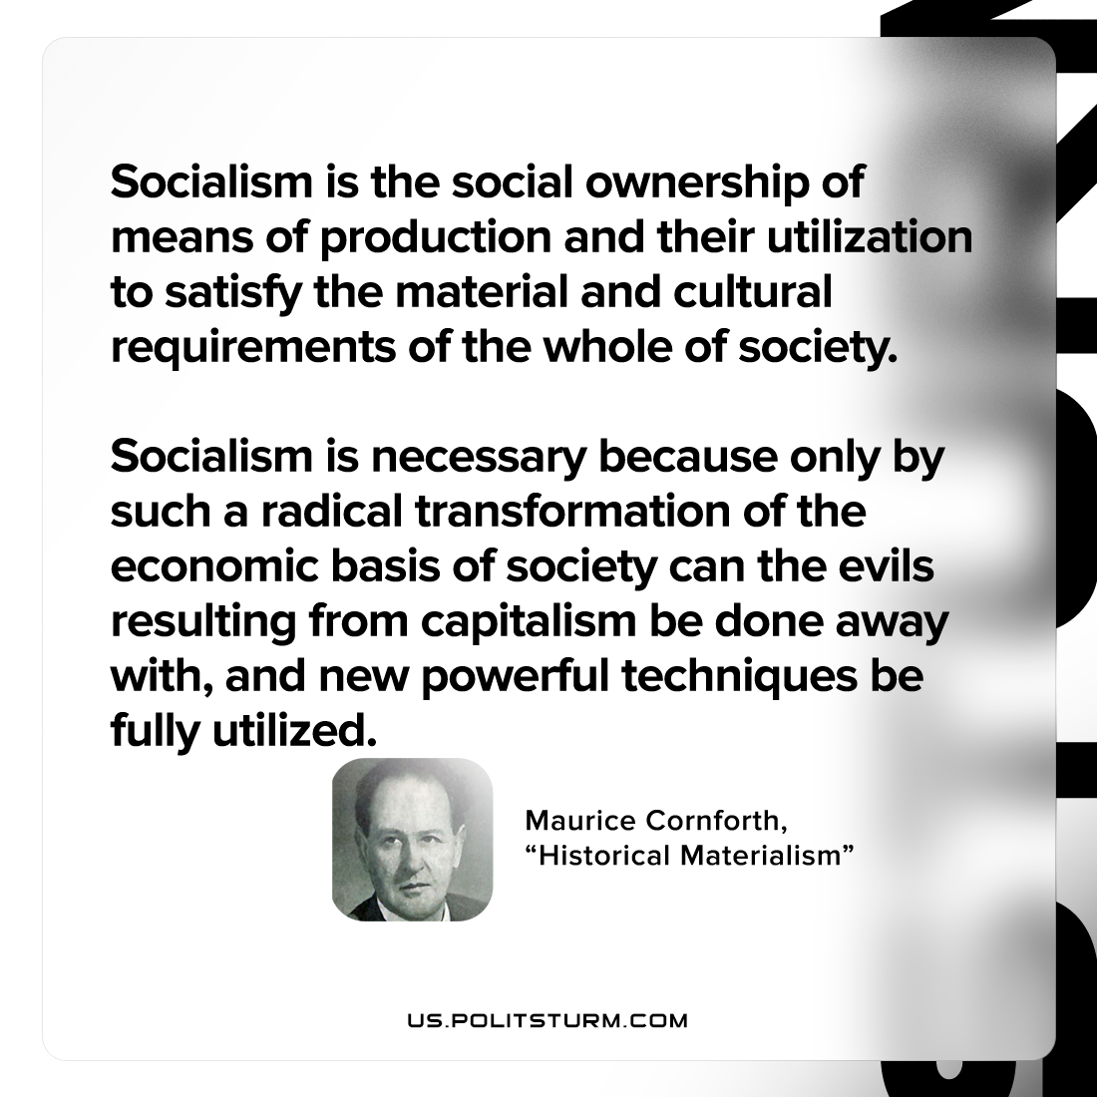

Original article
2022-11-09

Socialism is the social ownership of means of production and their utilization to satisfy the material and cultural requirements of the whole of society. Socialism is necessary because only by such a radical transformation of the economic basis of society can the evils resulting from capitalism be done away with, and new powerful techniques be fully utilized.

Maurice Cornforth, “Historical Materialism”

Original article

