Cornforth on Reactionary Ideas
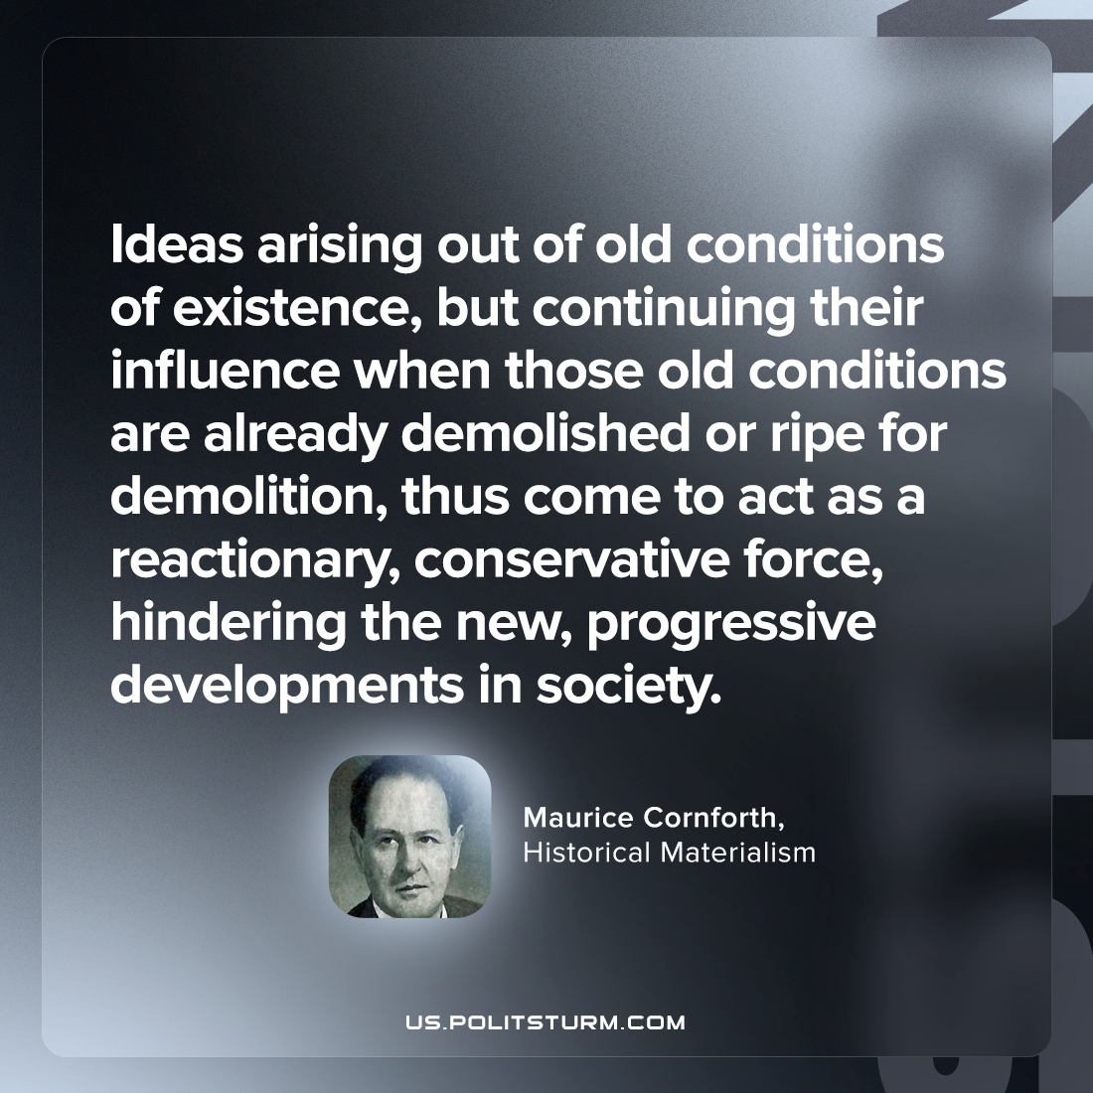

Original article
2023-07-20

"Ideas arising out of old conditions of existence, but continuing their influence when those old conditions are already demolished or ripe for demolition, thus come to act as a reactionary, conservative force, hindering the new, progressive developments in society."
Maurice Cornforth, Historical Materialism

Original article

