Cornforth on Necessity of Revolutionary Theory
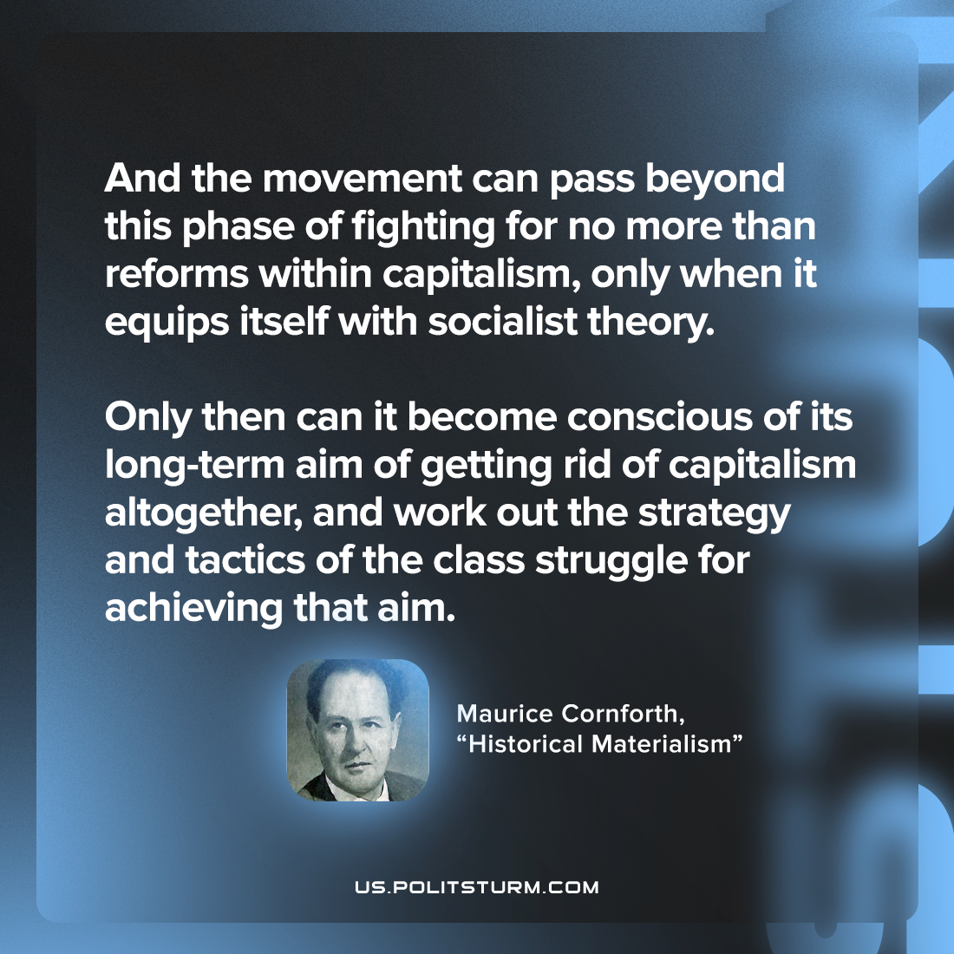

Original article
2022-10-16

And the movement can pass beyond this phase of fighting for no more than reforms within capitalism, only when it equips itself with socialist theory. Only then can it become conscious of its long-term aim of getting rid of capitalism altogether, and work out the strategy and tactics of the class struggle for achieving that aim.

Maurice Cornforth, “Historical Materialism”

Original article

