Corbyn’s Your Party Fails at First Electoral Test
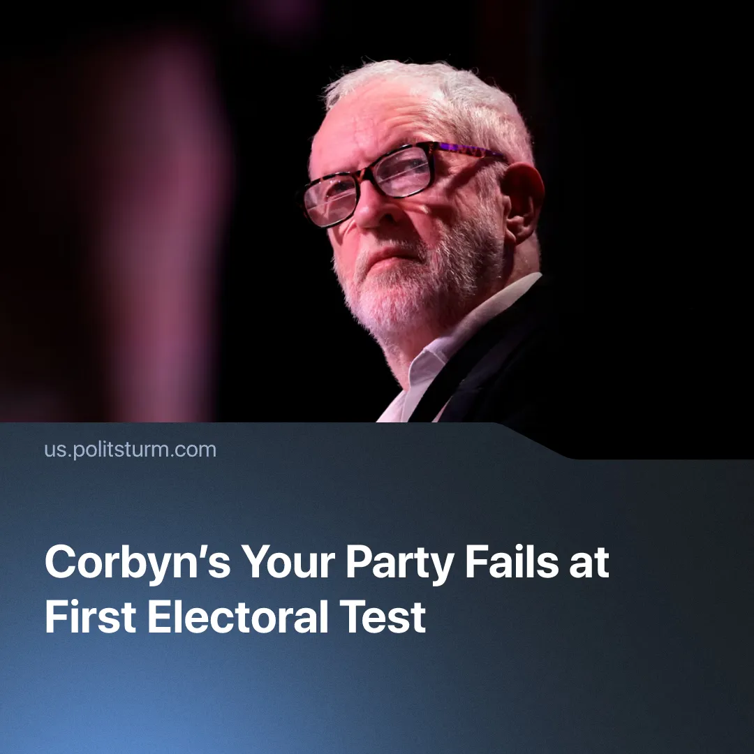

Original article
2026-05-20
1 min read

Corbyn's "socialist" party entered British local elections with a collapsed Scottish branch, 0% in polls, and nothing to show after 10 months of failed organising.
Details. Following the conclusion of the British May local elections, "Your Party" failed to win a majority in any council. The party additionally endorsed numerous independent candidates. Some of them are former Conservatives and small business owners; the party also temporarily endorsed a group of slum landlords.
► Days before the election, a poll showed 0% voting intention for the party, a drop from 1% back in April. In contrast, the left-populist Green Party has grown in voting intention and gained 5 councils and 441 councillors in the recent local elections.
Context. Upon its announcement, the party saw a high 20% voter consideration rate. Despite this, only around 41,000 of its 800,000 mailing-list subscribers became paying members – a conversion rate of roughly 5%. The Central Executive Committee (CEC) elections drew only 25,347 votes out of 40,985 verified eligible voters.
► Internal conflict had paralysed the party since its founding, with public feuding, expulsions, and disputed procedures. Corbyn's "The Many" faction secured majority control of the CEC in February, defeating "Grassroots Left" – a faction of Your Party's co-founder Zarah Sultana. Party insiders described the conflict as a proxy war between the two founders.
► Corbyn restricted dual-membership within the party, even after members voted to allow it, various Trotskyist groups were blocked from joining. Following the restriction, the Scottish branch Central Executive Committee split from the party in April and intended to create its own rival left-wing alternative.
► Under Corbyn's leadership, "Your Party" can be described as having reformist labour politics. His programme remains vague and social-democratic, echoing his 2019 Labour manifesto, after which his internal faction "the Many" is named.

Original article

