Corbyn and Sultana Factions Vie for Control of “Your Party”
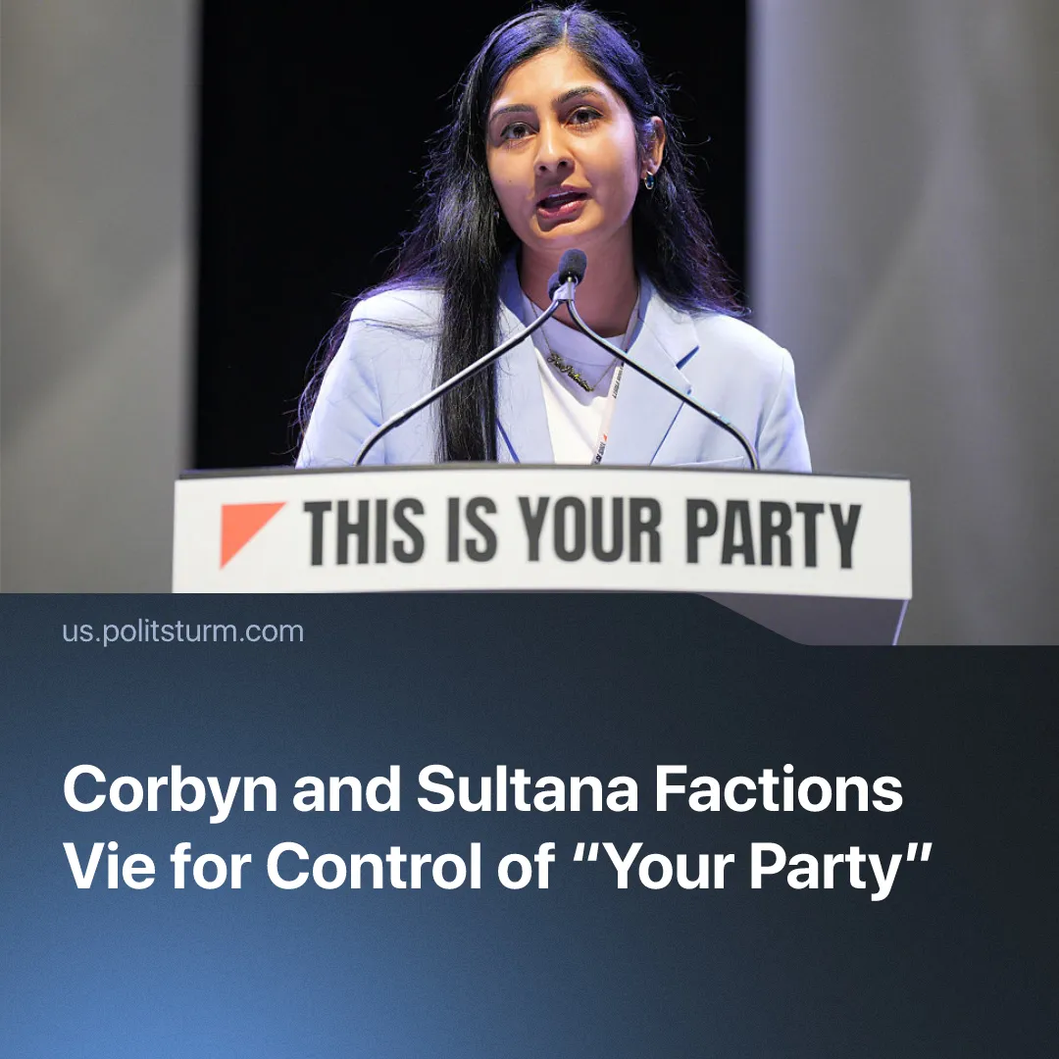

Original article
2026-02-02
1 min read

Corbyn and Sultana rival factions prepare for “Your Party” leadership elections. Both propose vague social democratic programmes.
Details. “Your Party” is preparing elections to its 16-seat Central Executive Committee (CEC), a collective leadership body replacing a single-leader model. The two founders have launched rival slates alongside other candidates. Both factions claim to be “fixing” the party after a disorganised launch.
► Corbyn’s slate, “The Many,” runs on a vague social-democratic platform promising “a more just and equal Britain.” Its stated values centre on “winning people over to their politics” and fighting for “those who have been lied to by establishment parties and are sick of the status quo.”
► Sultana’s slate, “Grassroots Left,” advances left-populist demands, opposing reformism and imperialism, backing a party that governs on a “socialist” programme and calling for the abolition of the monarchy and House of Lords. Yet its programme limits public ownership to “key sections of the economy,” allowing capitalism to continue, while, within YP, advocating “maximum member democracy,” an end to expulsion “witch hunts,” and dual membership to “unite the left."
► Prior to launching his own slate, Corbyn was placed as a candidate on Sultana’s “Grassroots Left” slate without his knowledge or consent. The move reportedly left him “very upset,” particularly at the implication that he endorsed the slate, its policies, and its candidates.
Context. Since its launch in July 2025, “Your Party” has been characterised by organisational incoherence and an unresolved power struggle between its founders, repeatedly spilling into public factional conflict. We have previously covered these disputes in detail.
► At the founding conference, members voted for collective leadership and to lift the ban on dual membership, subject to CEC approval of eligible organisations. As a result, candidates affiliated with unapproved parties were barred from standing in the CEC election, prompting “Grassroots Left” to advance a demand for dual membership.
► The collective leadership model, adopted to contain internal conflict, has instead formalised factional struggle, with rival slates now openly contesting control of the party apparatus.

Original article

