Continental to Close Plants and Lay Off Workers
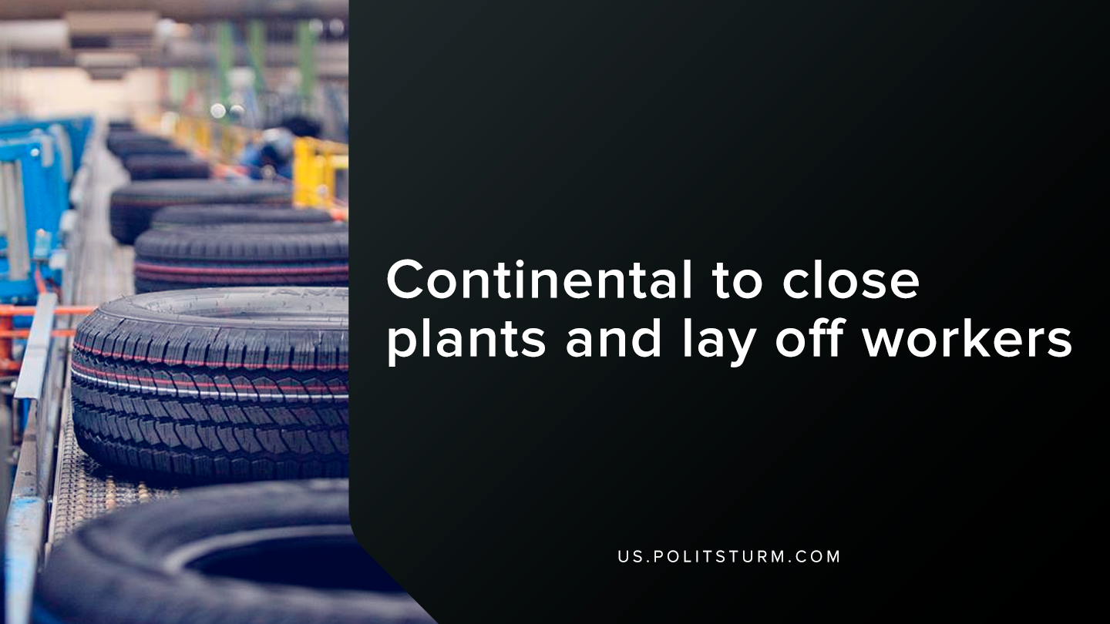

Original article
2019-10-12
1 min read

In a recent press release, Continental, an automotive manufacturing company, announced that it would be reducing 20,000 of the 244,000 jobs worldwide by 2029. The restructuring would save an estimated 500 million Euro in annual costs from 2023.
The company said that there would be job cuts for several reasons such as lower business volumes, corporate spinoffs and the transfer of jobs to “ensure market proximity and/or enhanced competitiveness”.
In the United States, the company announced that they are aiming to close the Newport News, Virginia location which would affect 740 people. This plant manufacturers hydraulic components for gasoline engines.
Also, the supervisory board approved the closure of the Henderson, North Carolina location which will affect 650 employees who produce hydraulic brake systems.
Rather than reducing the length of the working day, the board of directors have rather decided to eliminate jobs and threaten the livelihood of thousands of workers. The company even states in its own words that it aims to “achieve profitable growth” and emphasizes the saved labor costs created by the layoffs.
Capitalism cannot guarantee security to the working class. If the capitalists find it profitable to layoff workers, then they will. The capitalist class serves their own interests and the maximization of profit at the expense of the global working class. The working class must master the Marxist-Leninist theory and practice to achieve security and success.
Source

Original article

