Conservatives Win and Far-Right Surge to Second Place in German Elections
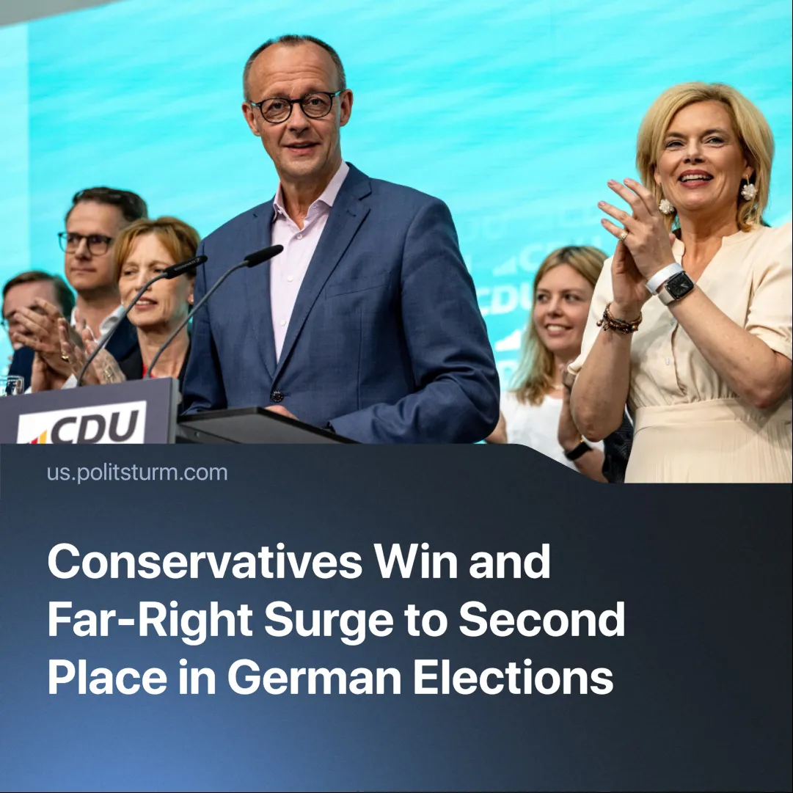

Original article
2025-03-01
2 min read

Merz's CDU party won Germany's snap elections with 28% of the vote, while the far-right AfD (Alternative for Germany) party won a historic 20% - the most votes for the far-right since the Second World War.
Details. The Christian Democratic Union (CDU) replaced Olaf Scholz and his Social Democratic Party (SPD), which got 16.4% - one of its worst election results. The Greens got 11.6% and the left-wing reformist party, The Left (Die Linke), 8.8%. There was a record turnout of 82.5%.
► However, as the CDU does not have enough votes to govern the country on its own, it will have to form a coalition to govern – "ideally with the Social Democrats".
► It will not form a coalition with the AfD because of a German political convention of non-cooperation with the far-right, known as the 'firewall'.
► The vote was split almost exactly between West Germany (mainly CDU voters) and East Germany (mainly AfD voters), with a further clear division between West (CDU) and East (Die Linke) Berlin.
Context. Snap elections were called in Germany after the collapse of the previous coalition between the SDP, FDP and Greens, following a vote of no confidence in Scholz over his decision to sack Finance Minister Christian Lindner of the FDP.
► The German people are deeply dissatisfied with the declining standard of living. Closely linked to this are debates over continued support for Ukraine, immigration and tackling climate change, with Merz stating that he would put economic growth above all else.
► The AfD is known for its extremist positions on issues such as immigration or religion, advocating for the deportation of German citizens with foreign ancestry. They have also begun to trivialise the Holocaust and started using Nazi phraseology.
► The Left, or Die Linke, has been hailed as exploding in popularity. Whilst they remain a small party, they have reached the necessary 5% of votes for parliamentary representation.
Important to know. The main debate that concerns German capitalists is whether it will continue to rely on America – and thus remain subservient to it – or whether it will seek to strengthen itself for the coming imperialist conflict. Merz and the CDU wish to do the latter. Merz has stated that Germany must become independent from the US and that in the future they might have to “establish an independent European defence capability much more quickly”.
► This move towards greater autonomy is likely to be done as part of a larger EU imperialist bloc (France, another dominant country in this bloc, has made similar calls for a more strategically autonomous Europe). This comes as the US has adopted a more aggressive foreign policy.
► In this context, Fascism can be employed to prepare for, or embark on, an openly aggressive foreign war. Additionally, it is the open dictatorship of capital, used to violently quell any dissent. Instead of offering something different, it is only a tool for the capitalists to use to maintain their class rule.
Conclusion. The current international political scenario is leading to sharpening contradictions between different imperialist blocs, and this is reflected in the living conditions of the German working class. The victory of the CDU, the unpopularity of the SPD, the rise of the AfD and the relative growth of Die Linke, are all examples of this. But none of these parties represent real solutions to these issues. Only a vanguard party, that can lead the working class in its complete overthrow of capitalism, is capable of concretely helping the German workers.

Original article

