Connolly on Faith
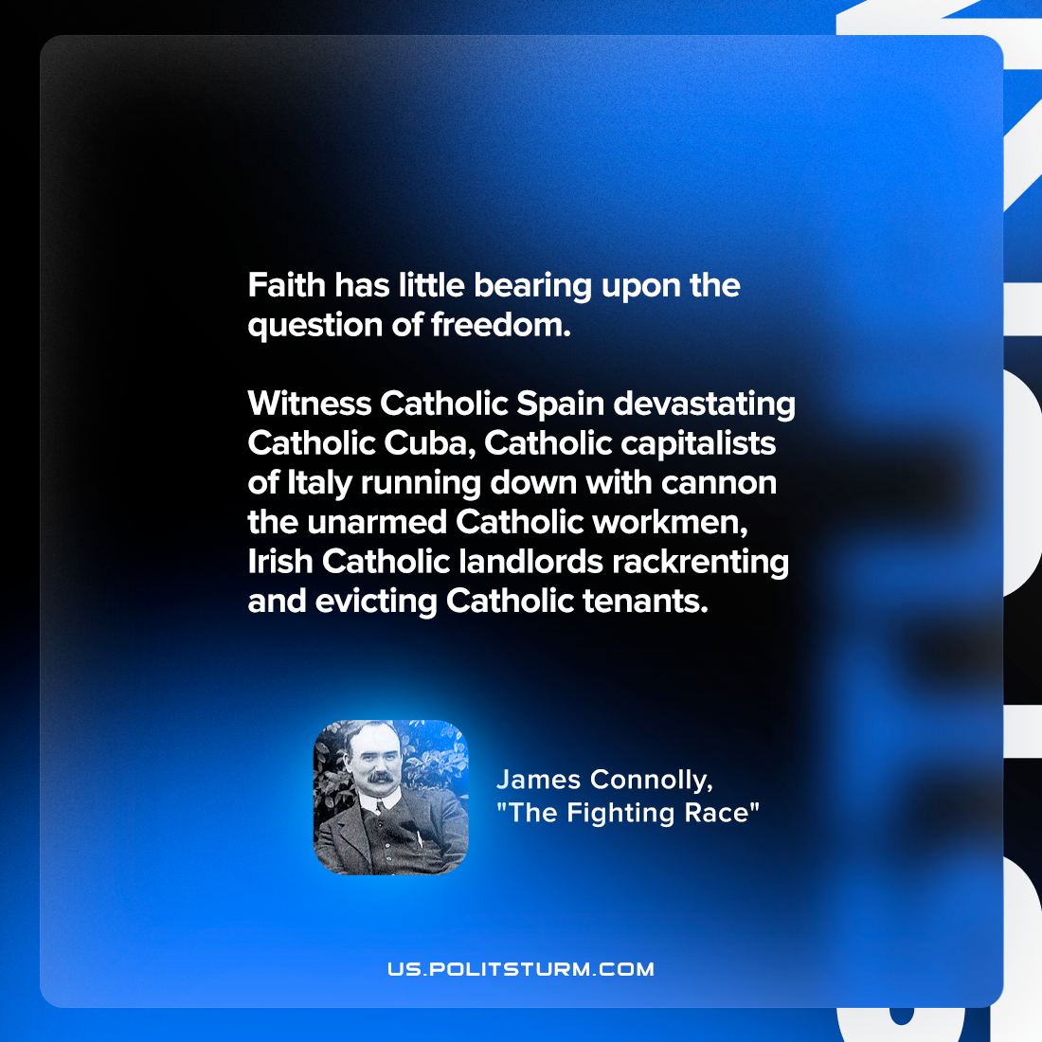

Original article
2022-07-11

Faith has little bearing upon the question of freedom. Witness Catholic Spain devastating Catholic Cuba, Catholic capitalists of Italy running down with cannon the unarmed Catholic workmen, Irish Catholic landlords rackrenting and evicting Catholic tenants.

James Connolly, “The Fighting Race”

Original article

